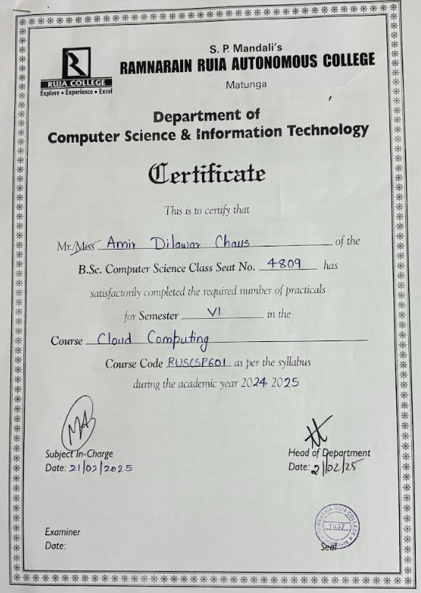

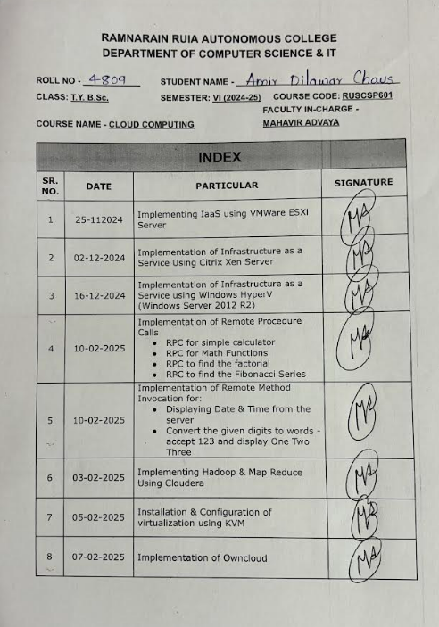

Practical No. 1

Implementing IaaS using VMWare ESXi Server

Q.1] Install Windows 7 virtually using vSphere, VMEXSi and VM Workstation

Steps:

1. Open VM Workstation
2. Click on Create a New Virtual Machine

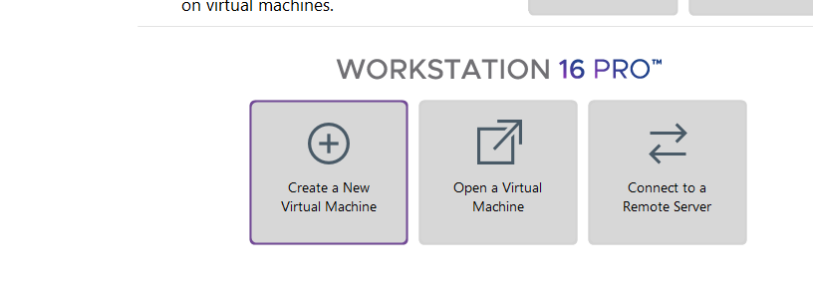

1. Choose Custom option, Click Next

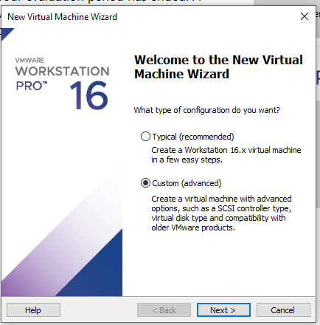

1. Click Next

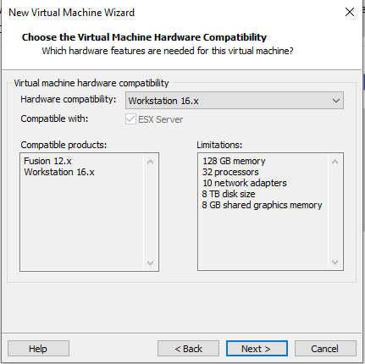

1. Select I will install OS later, click Next

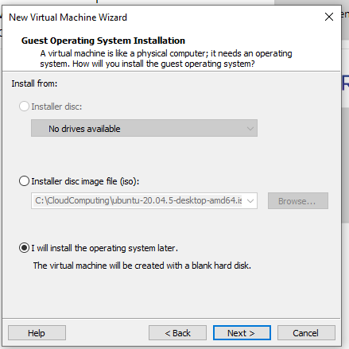

1. Choose VMware ESX, Choose version 5.x, Click Next

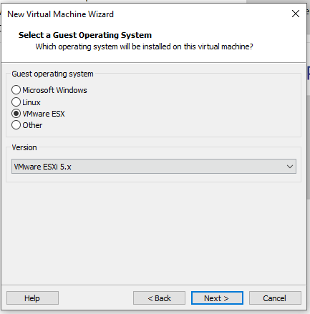

1. Change location and choose anywhere and create a new folder

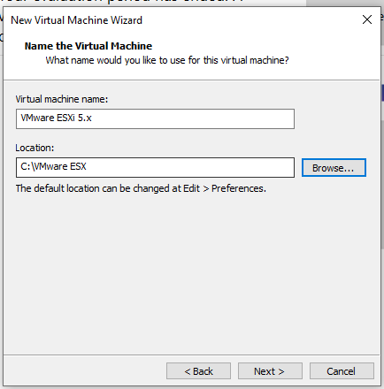

1. Click Next, don't change anything

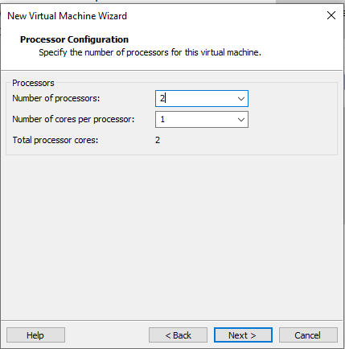

1. Set Memory to 8000 mb and Click Next

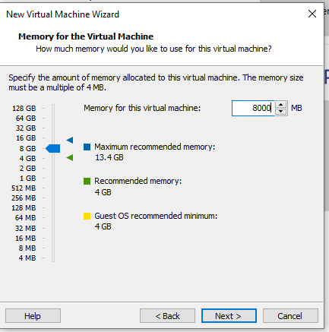

1. Click Next

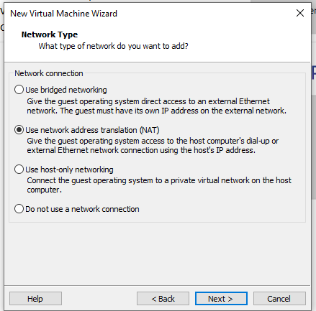

1. Click Next

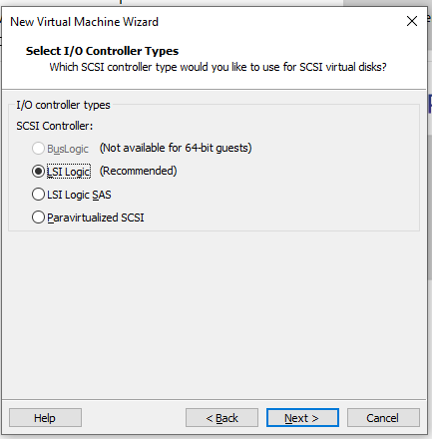

1. Click Next

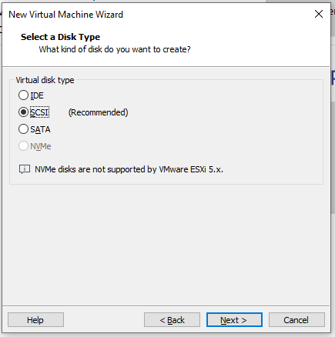

1. Click Next

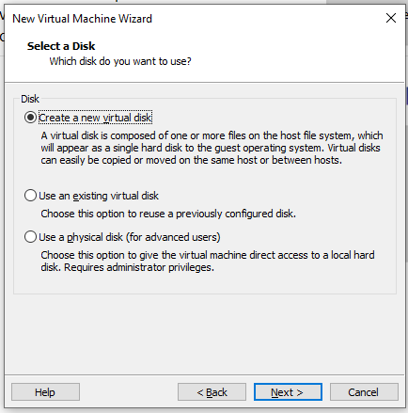

1. Choose storage as 80 GB, Choose virtual disk into single file and Click Next

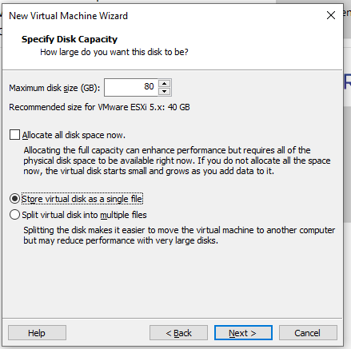

1. Choose the folder you created earlier and click Next

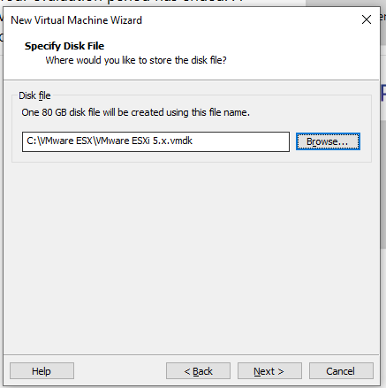

1. Click Finish

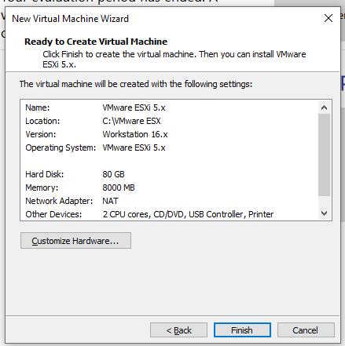

1. Click Here

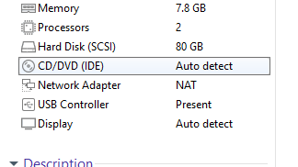

1. Choose ISO image

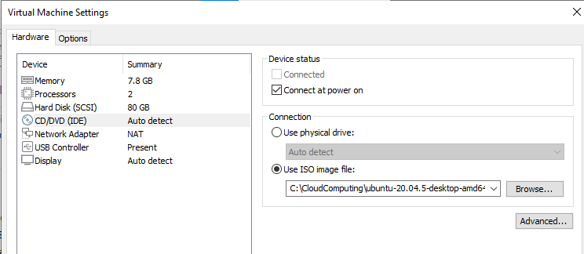

1. Browse the file

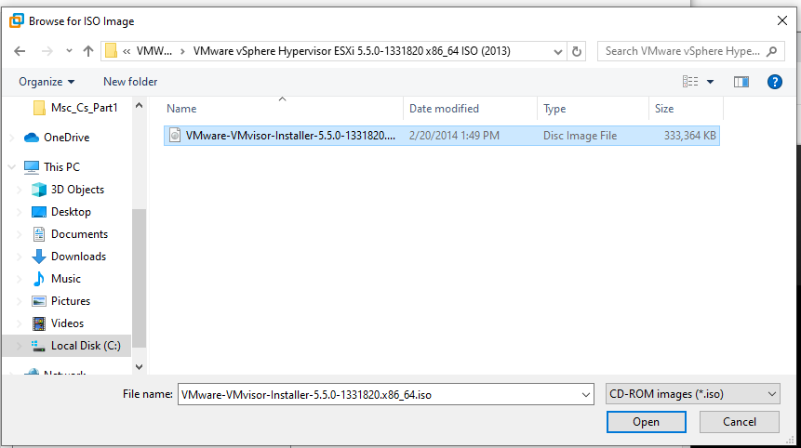

1. Click Ok

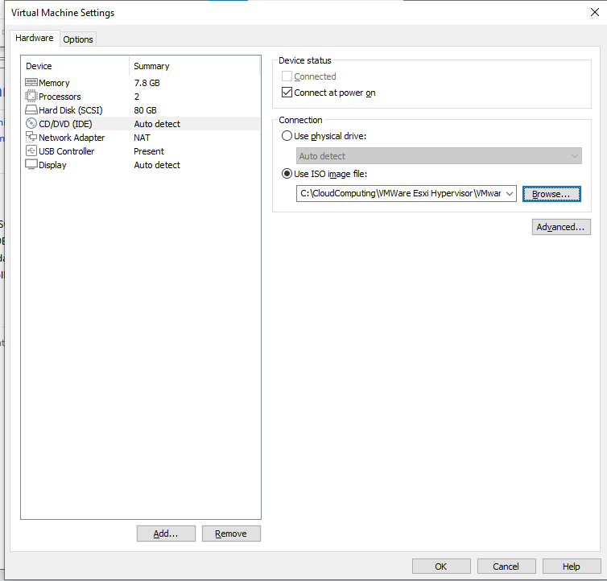

1. Click start virtual machine, it will take some to start
2. It will load
3. Press Enter

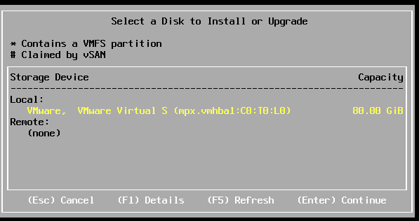

1. Press Enter

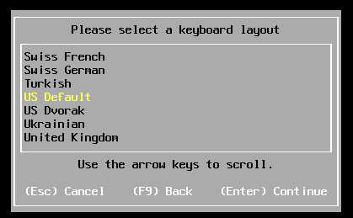

1. Enter password: siddhesh

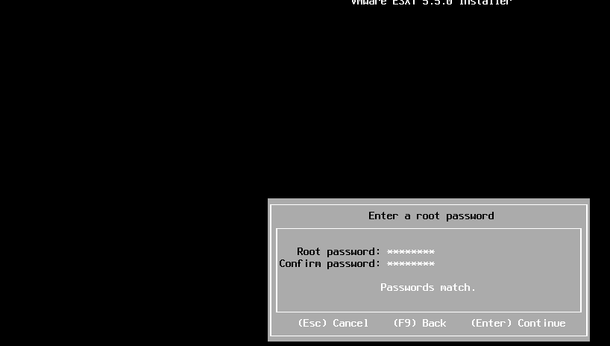

1. Press F11

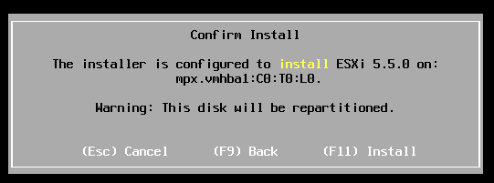

1. The installation will take time

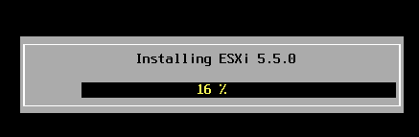

1. Press Enter

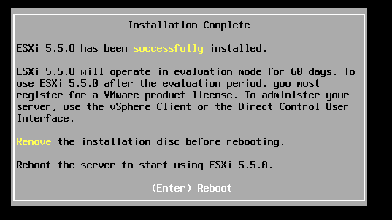

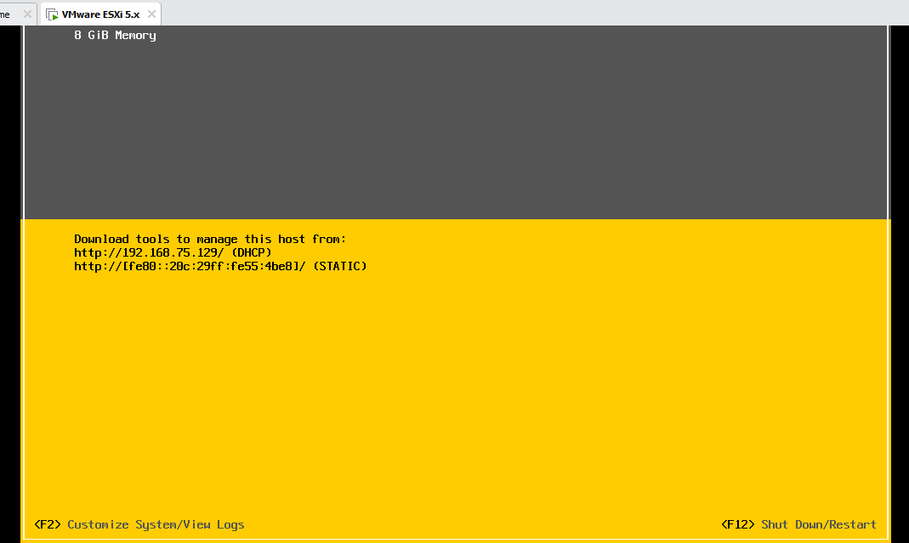

1. Now, Go to Fullscreen and press F2

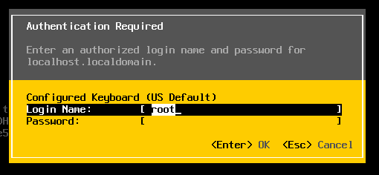

1. Enter the login name: root and Password: siddhesh, After this, the following screen will be displayed

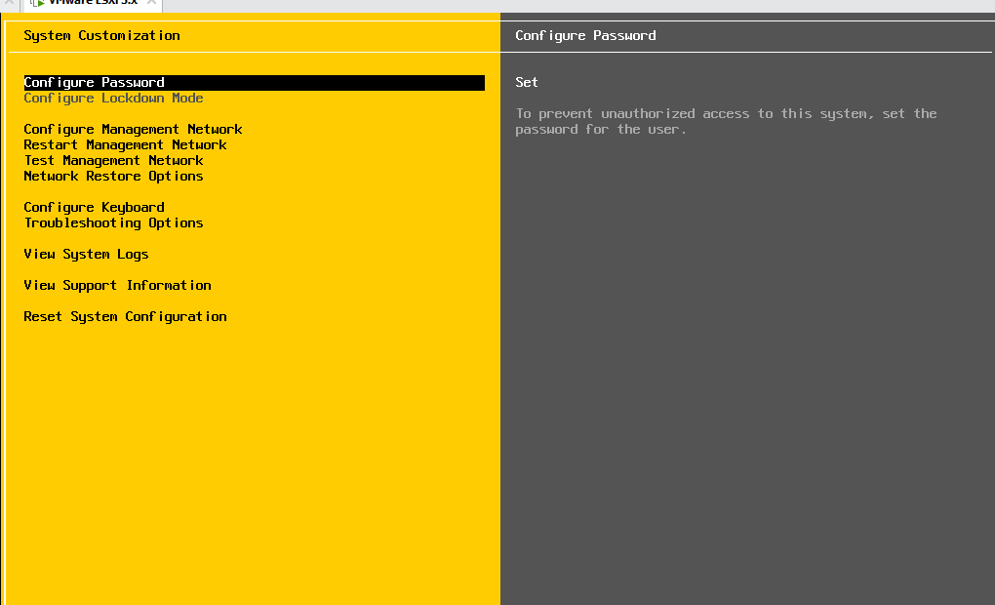

1. Install VMware vSphere Client

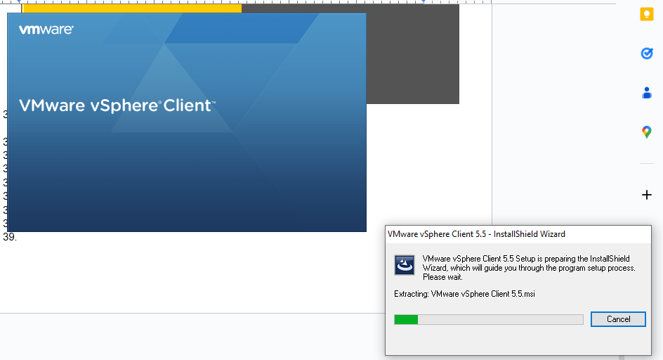

1. The Installation will take some time
2. Open vSphere Client

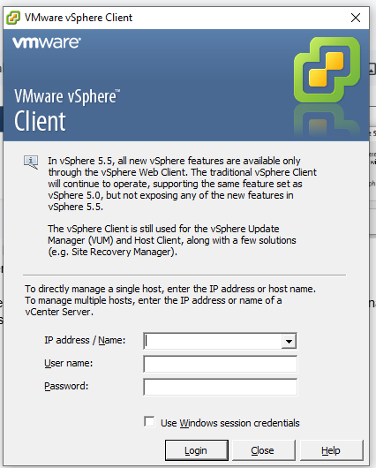

1. Enter the IP shown in the VMware Workstation and credentials (username: root and password: siddhesh), Click Login

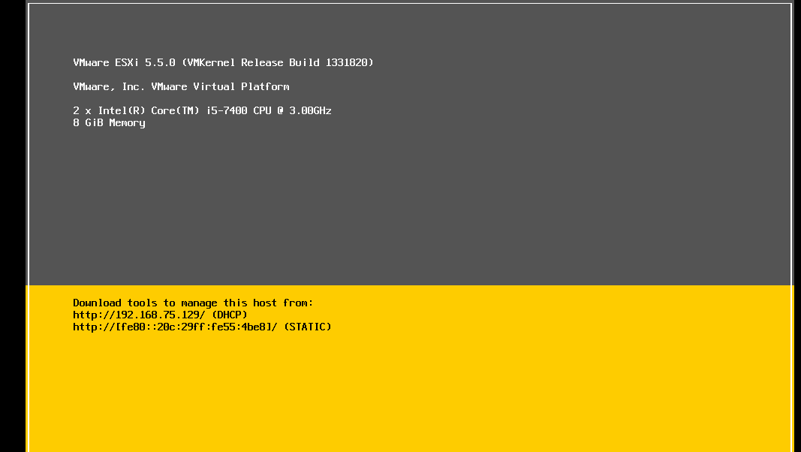

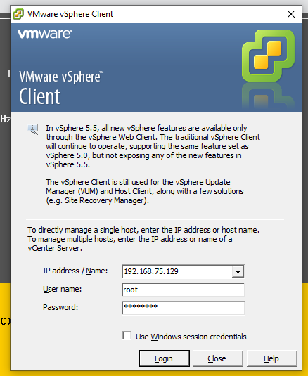

1. Click Ignore and this window will open

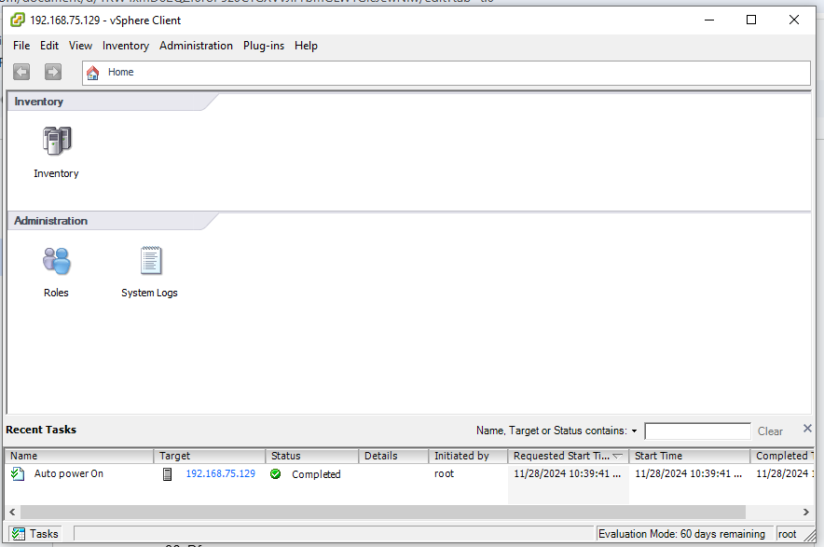

1. Click Inventory

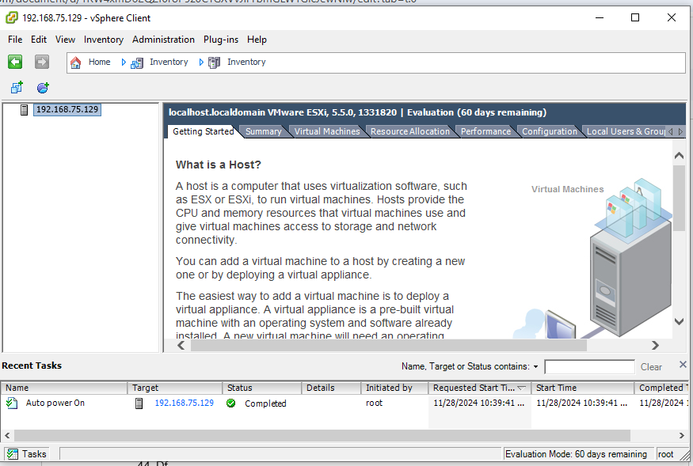

1. Right click the IP and create new virtual machine

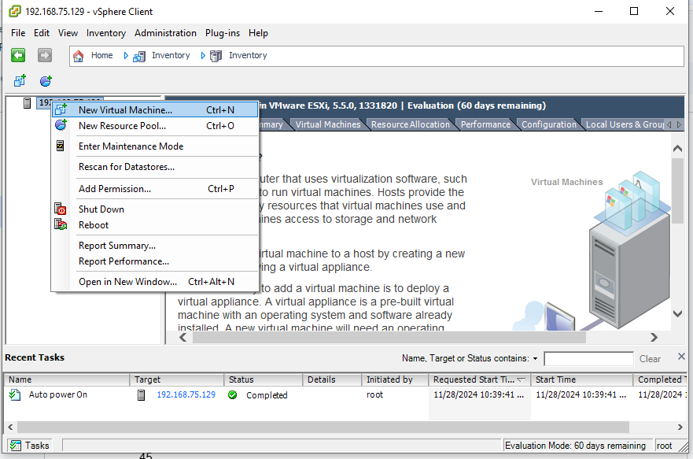

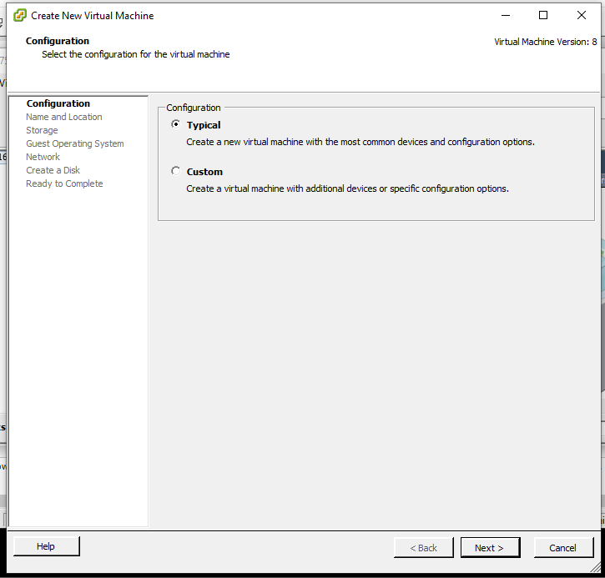

1. Choose custom

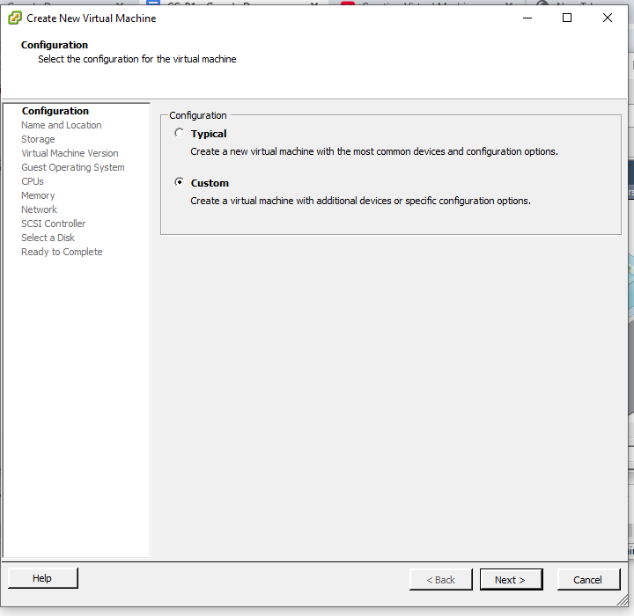

1. Give name as Win7

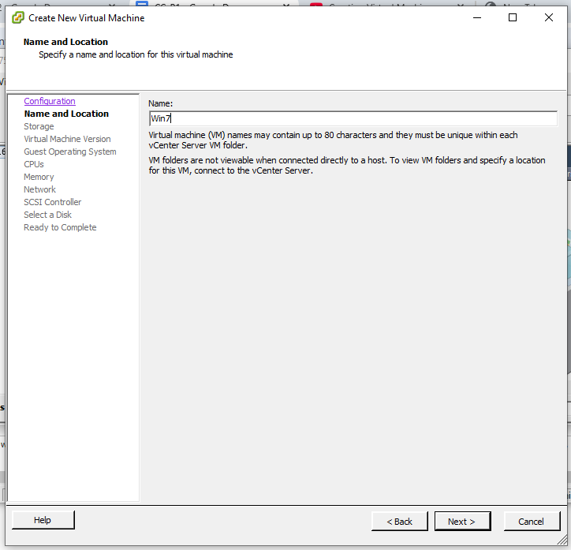

1. Click Next

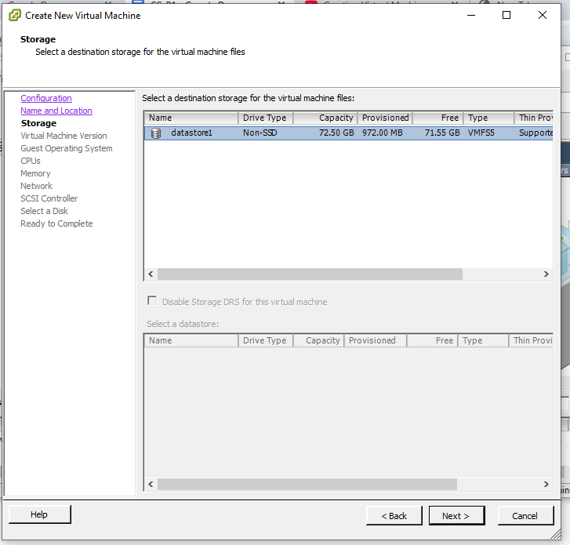

1. Click Next

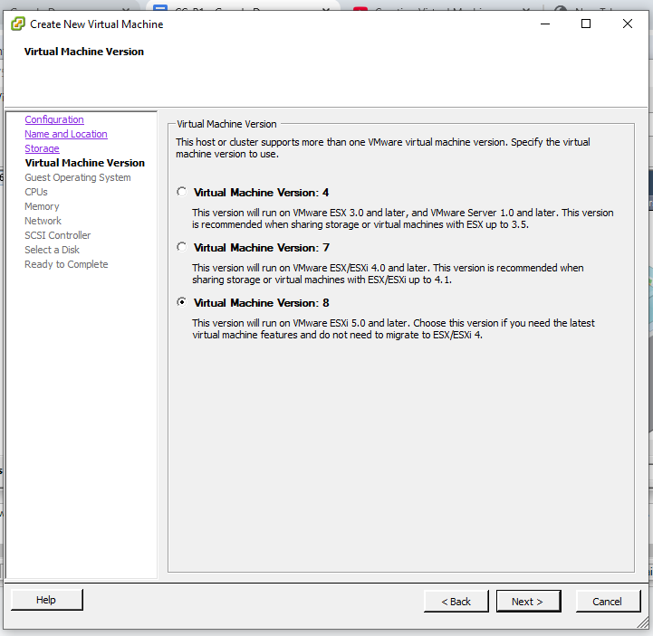

1. Select Windows 7 64 bit

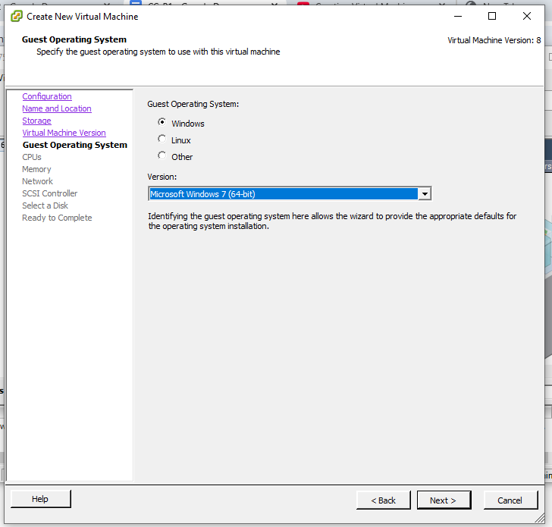

1. Click Next

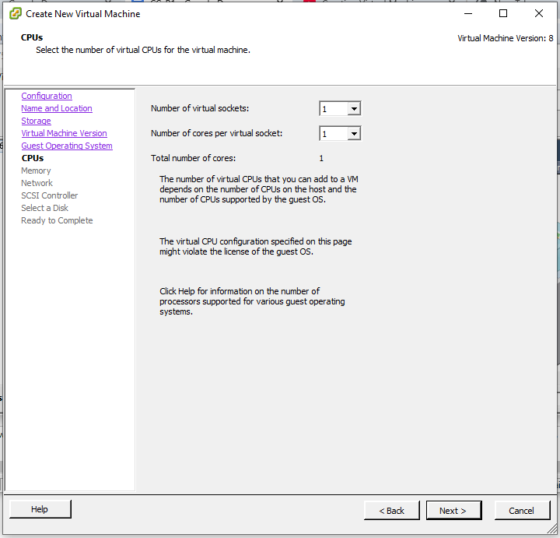

1. Change Memory Size to 4GB

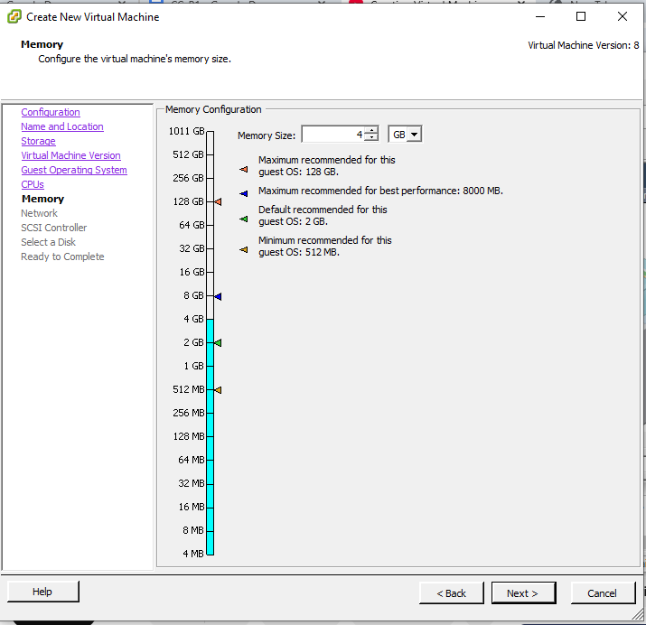

1. Click Next

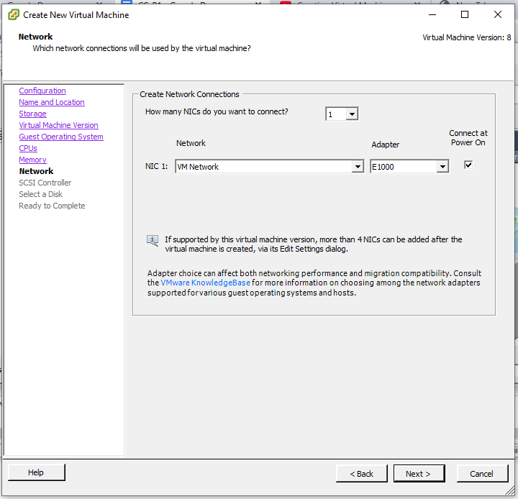

1. Click Next

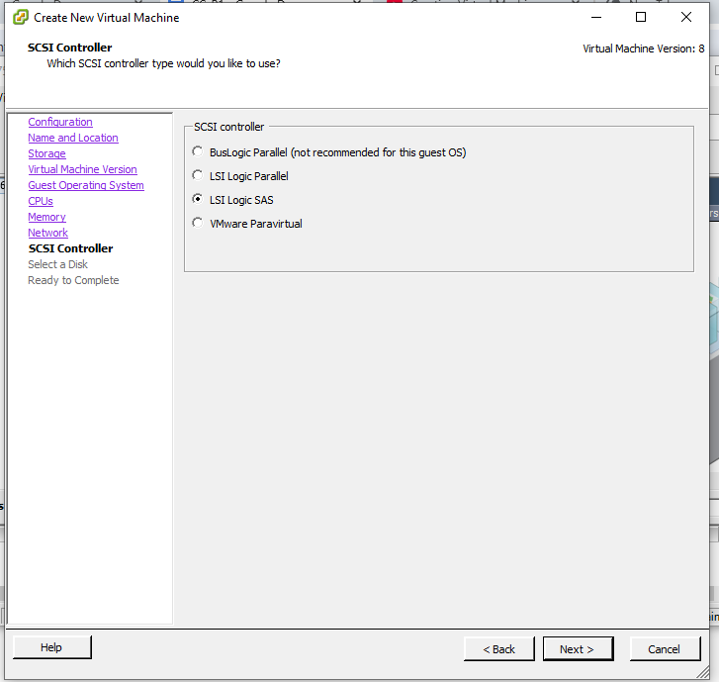

1. Click Next

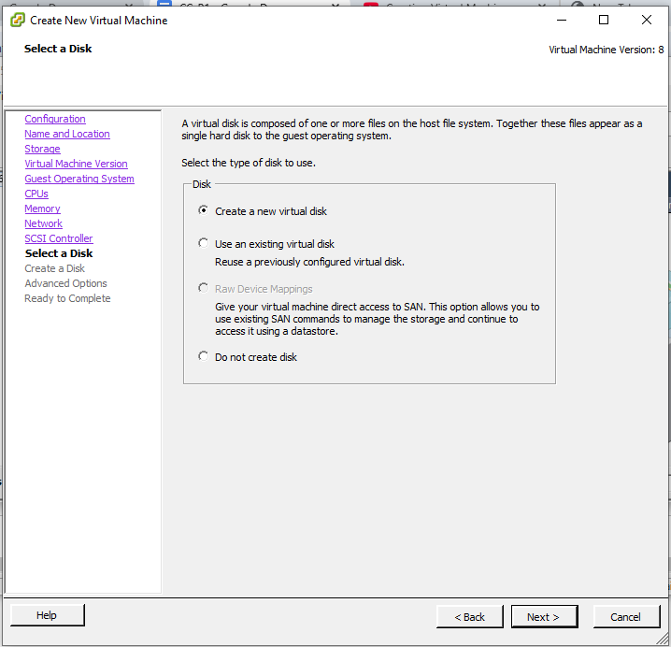

1. Click Next

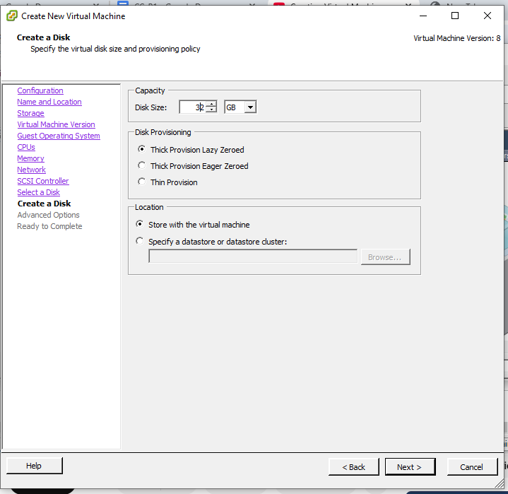

1. Click Next

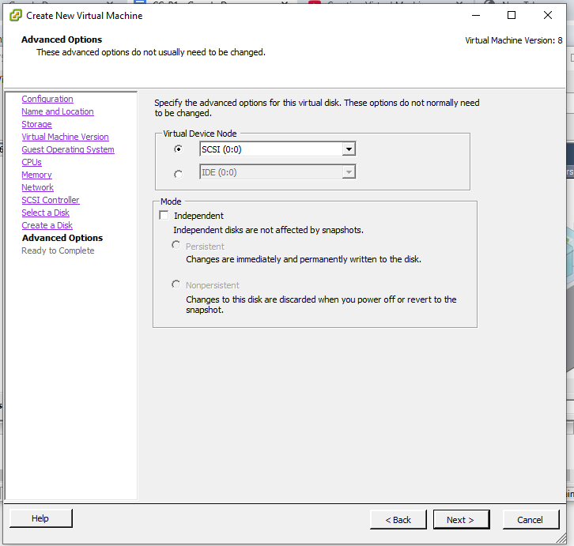

1. Click Finish

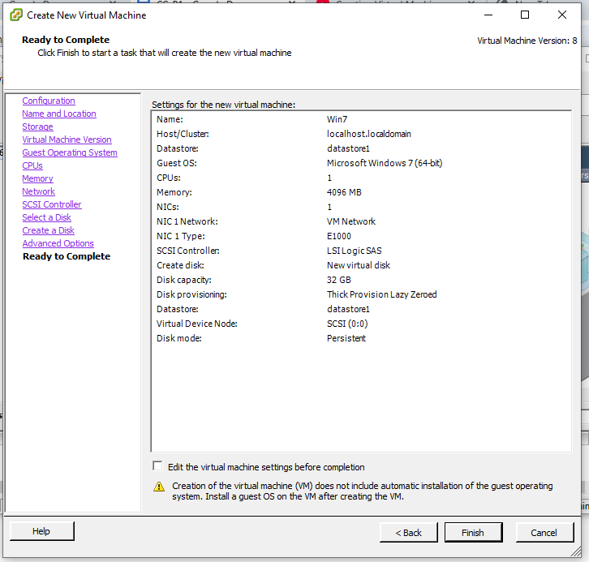

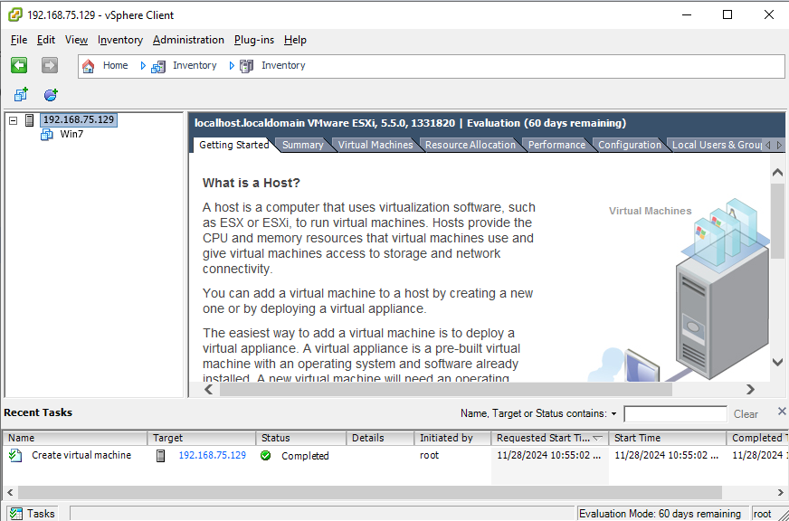

1. Go to summary tab

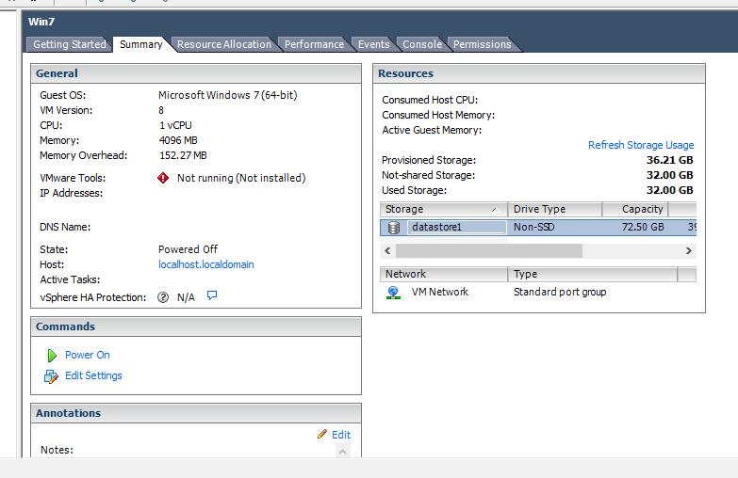

1. Right click on datastore1

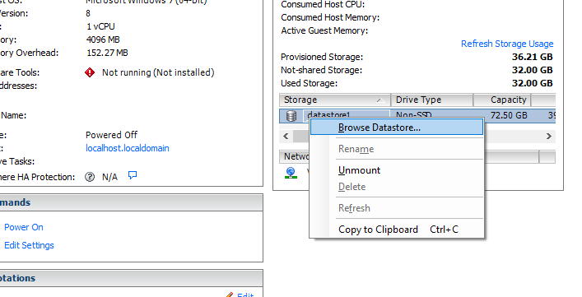

1. Create new folder and give name as ISOFiles

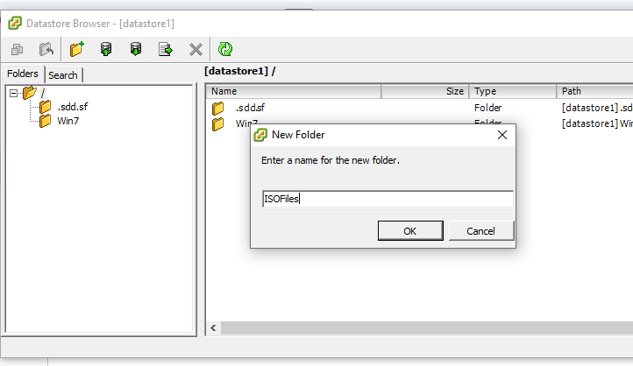

1. Click on ISOFiles and Upload File…

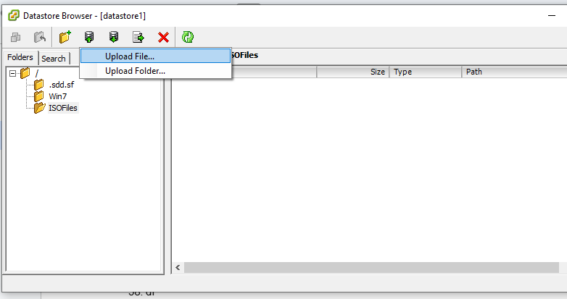

1. Select Windows 7 ISO

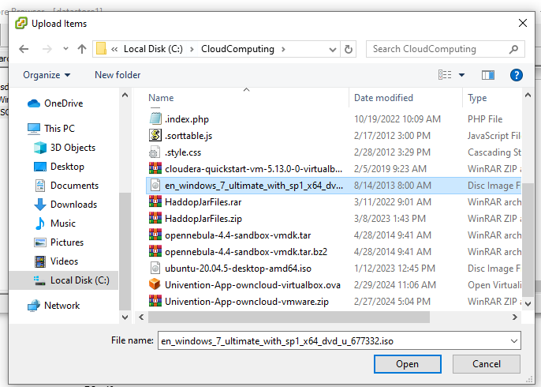

1. Click Yes

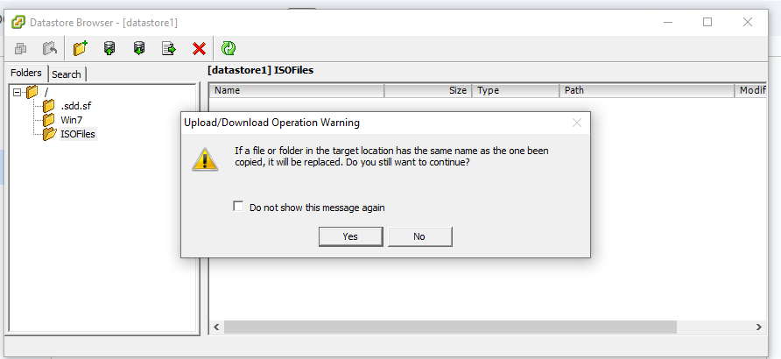

1. It will take some time

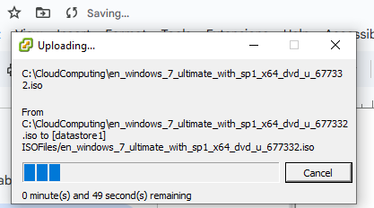

1. Click Edit virtual machine and goto CD/DVD

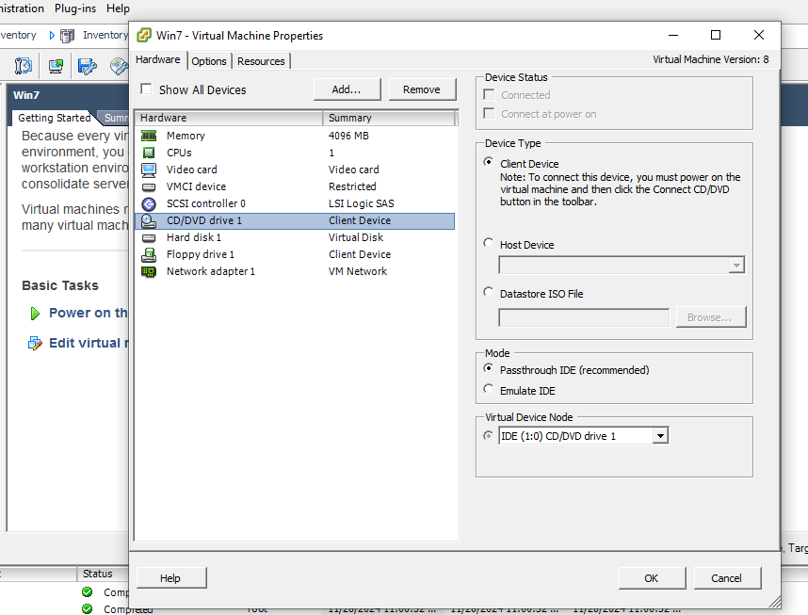

1. Select Datastore ISO

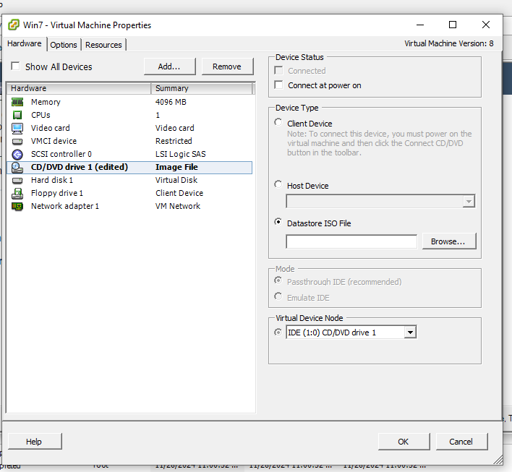

1. Click Browse > datastore1 > ISOFiles > win 7 iso

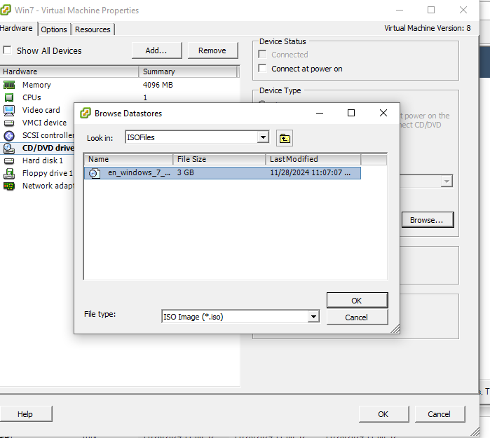

1. Select connect at power on

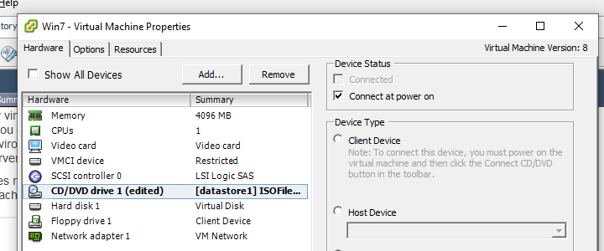

1. Click power on virtual machine

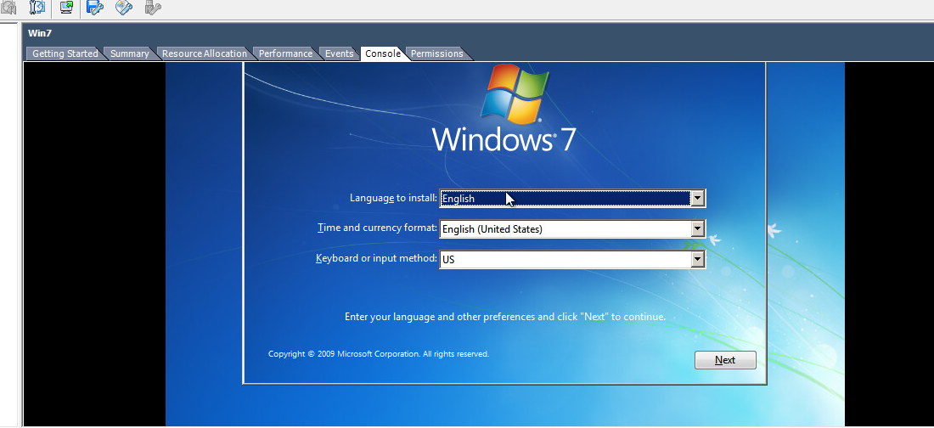

Practical No. 2

Implementation of Infrastructure as a Service Using Citrix Xen Server.

**Steps:**

1. Implementing IaaS Using Citrix Xen Server

Create new VM

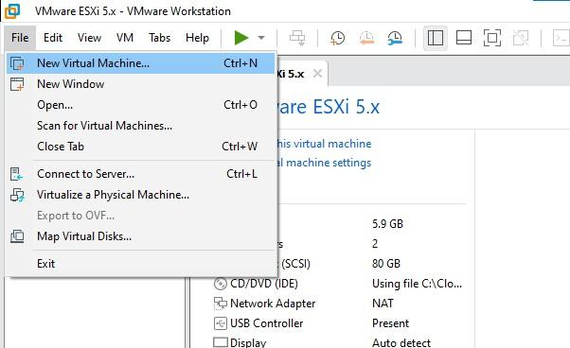

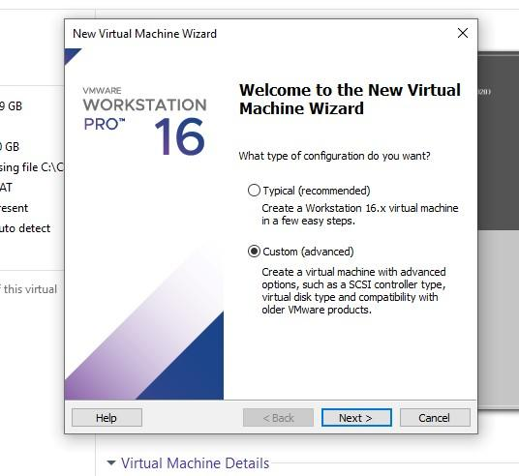

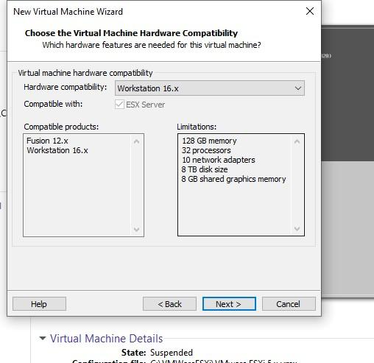

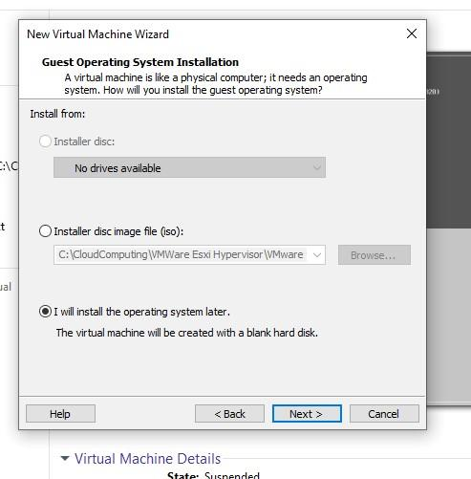

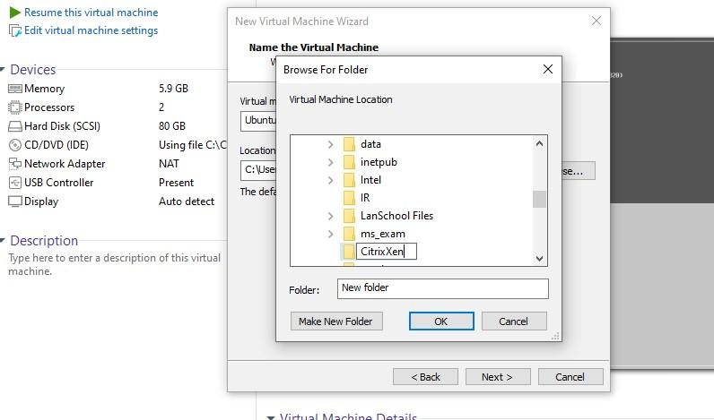Select Linux

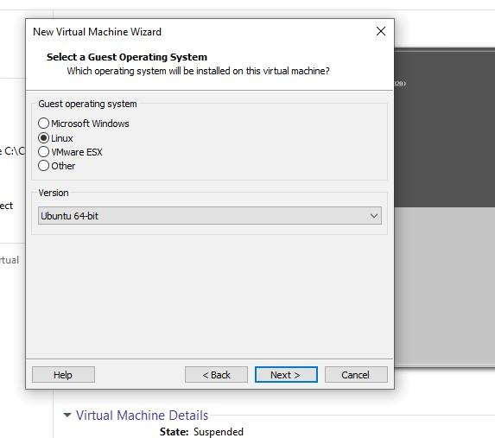

Create new folder where you want to store Change VM machine name & browse and select the path or folder u have created

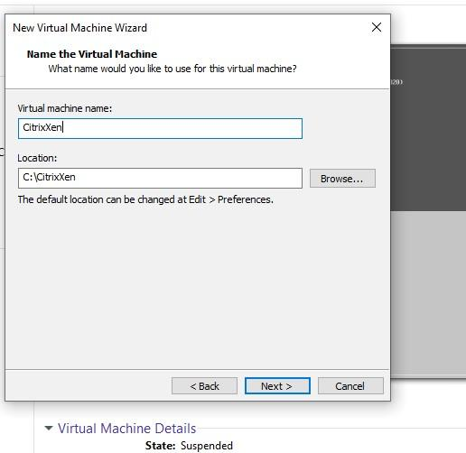

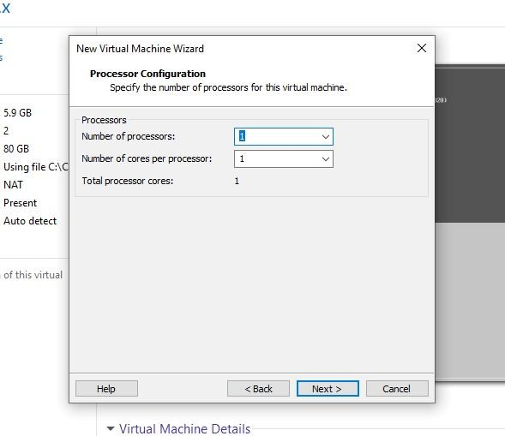

Change to 6000 GB

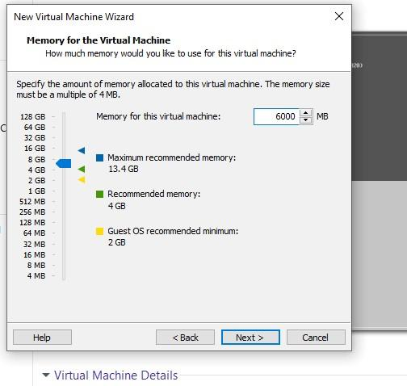

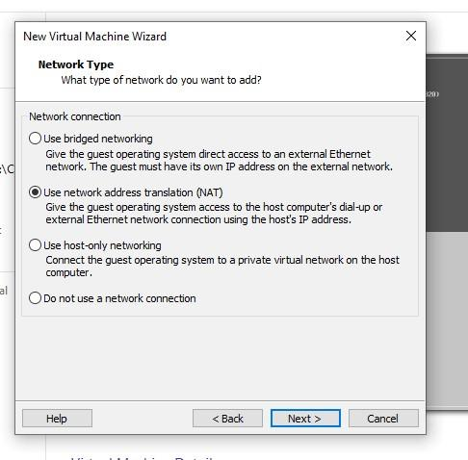

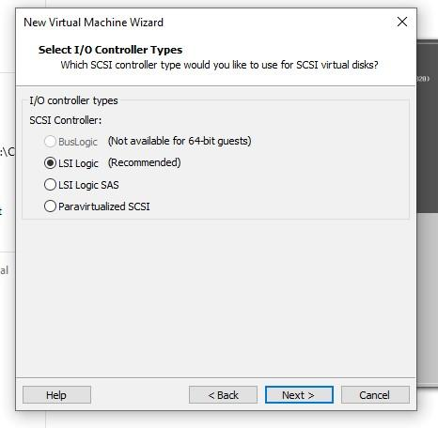

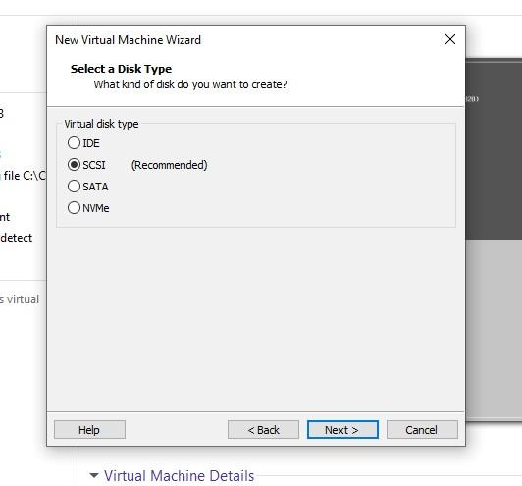

Create new virtual disk

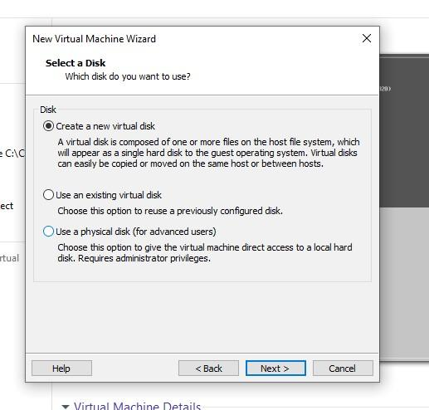

Disk size 60 gb

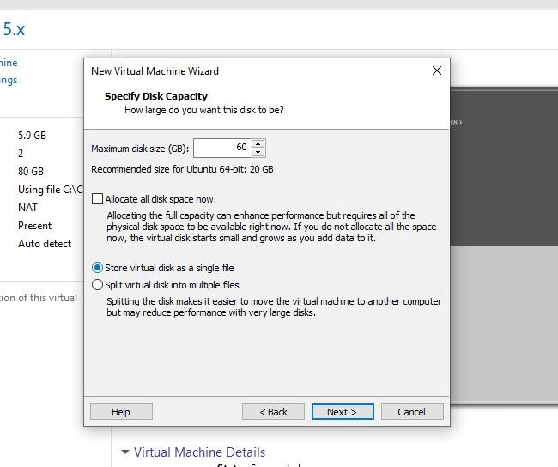

Again select the folder created

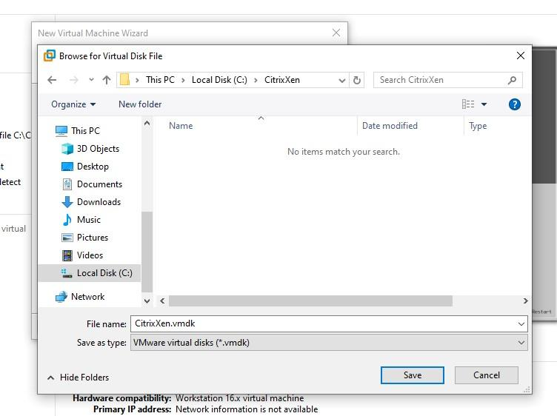

It’s path

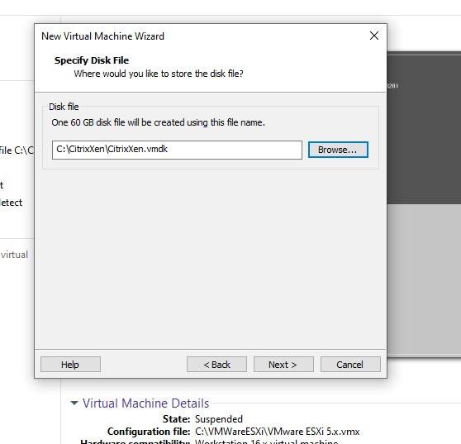

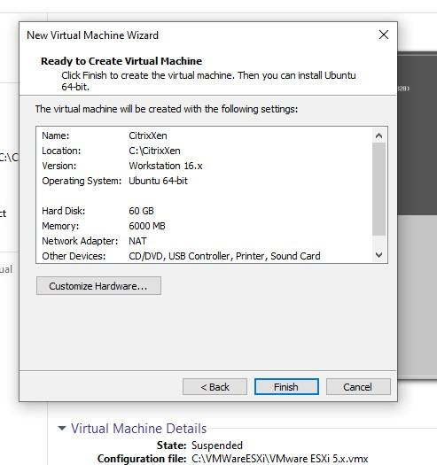

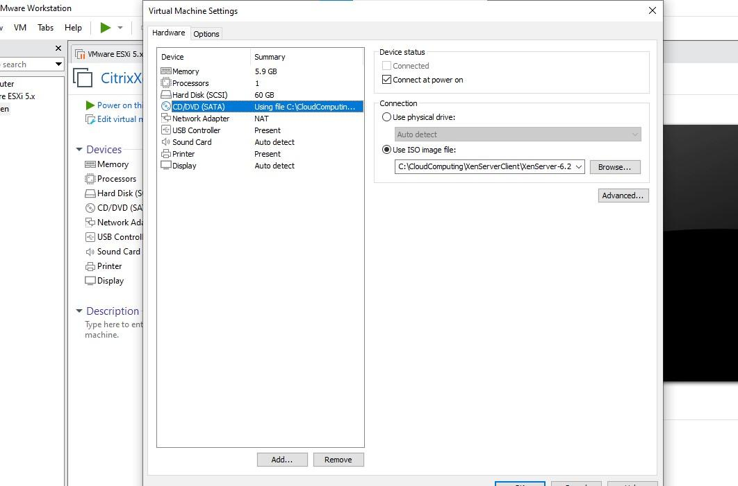In file manager→ select this file and Install

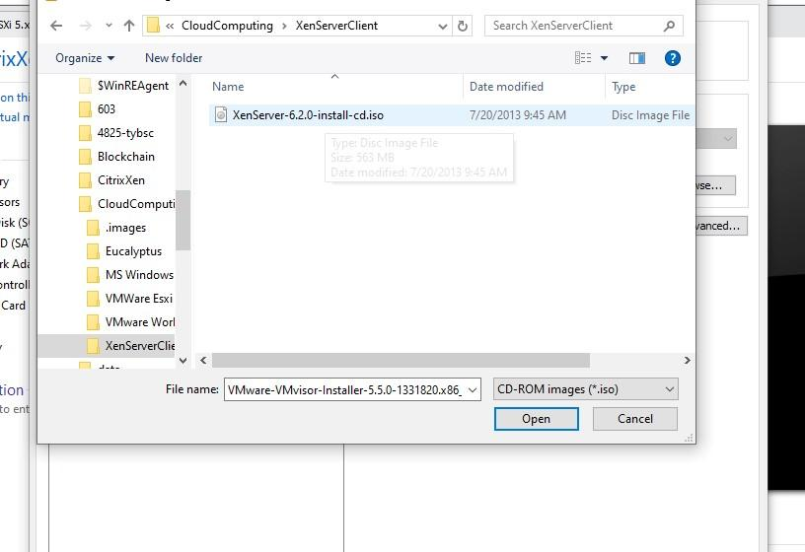

In CD/DVD use ISO file→select isofile frm cloud computing folder

1. Installing Citrix Xen Server

Power on VM

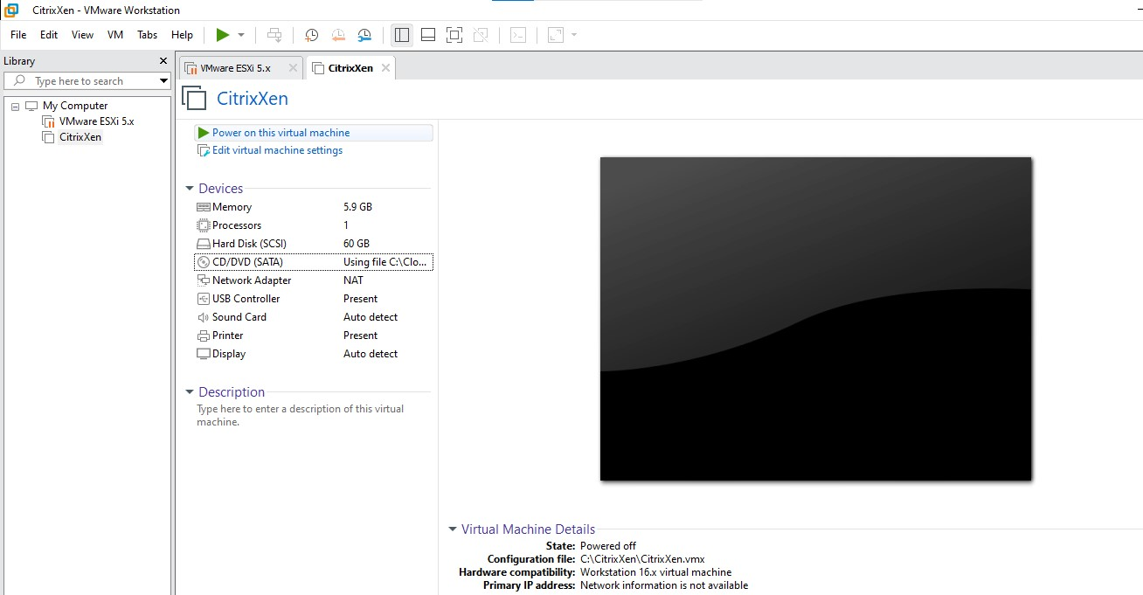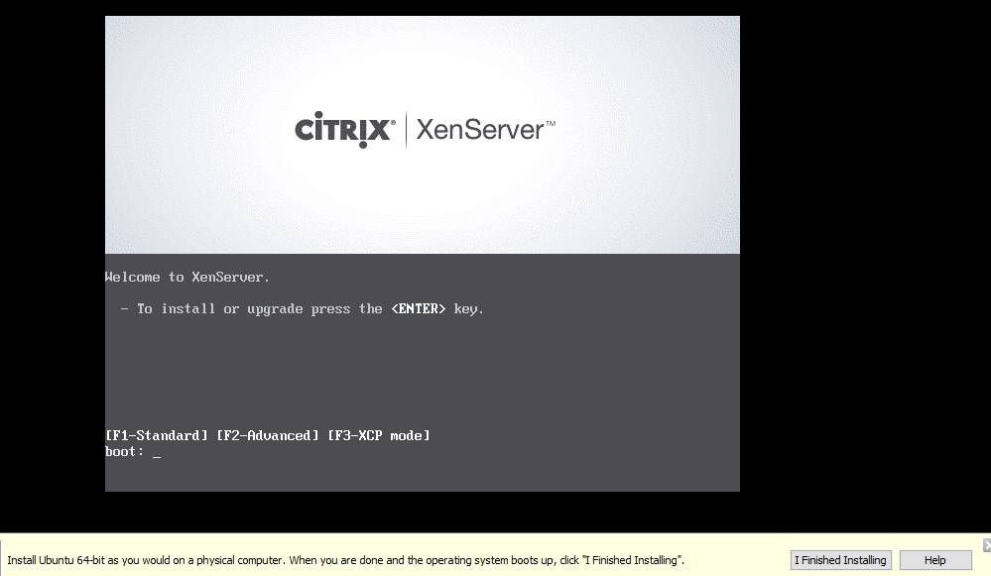

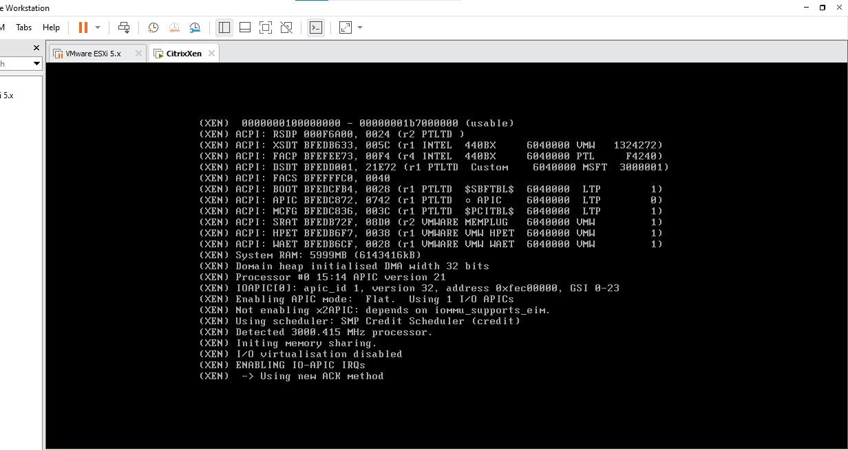

Select qwerty us

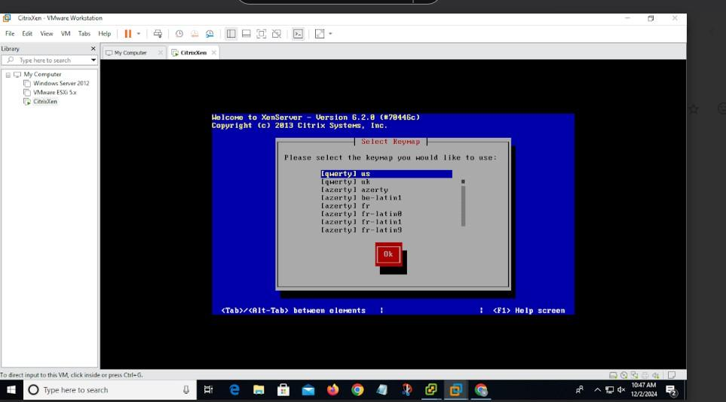

ok

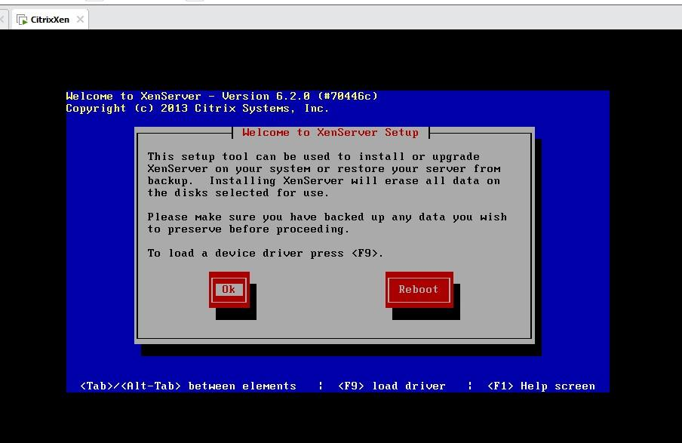

accept

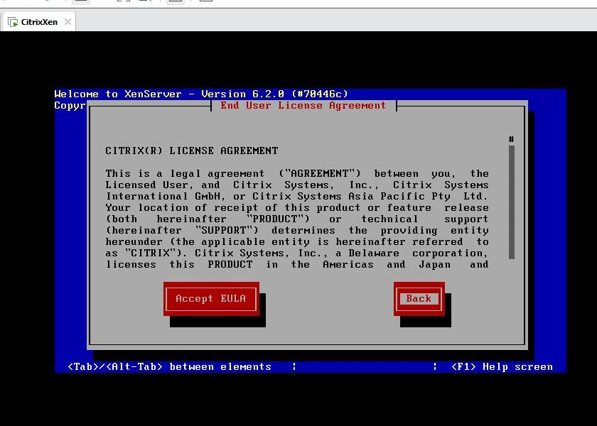

ok

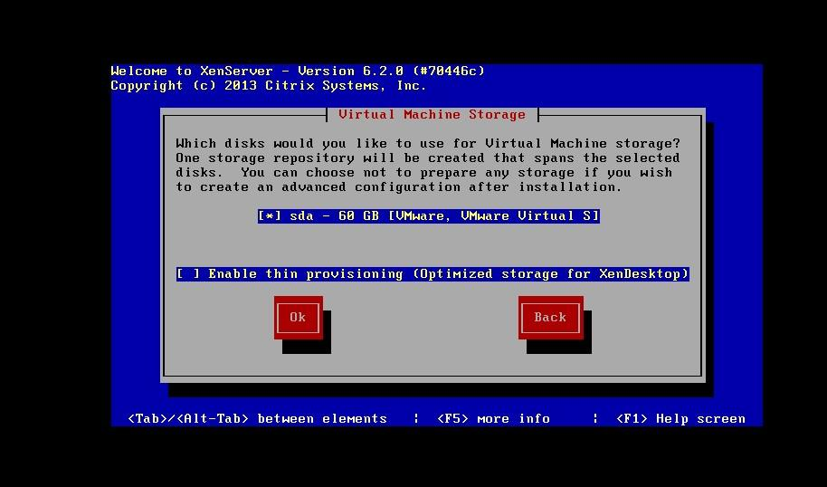

Local media

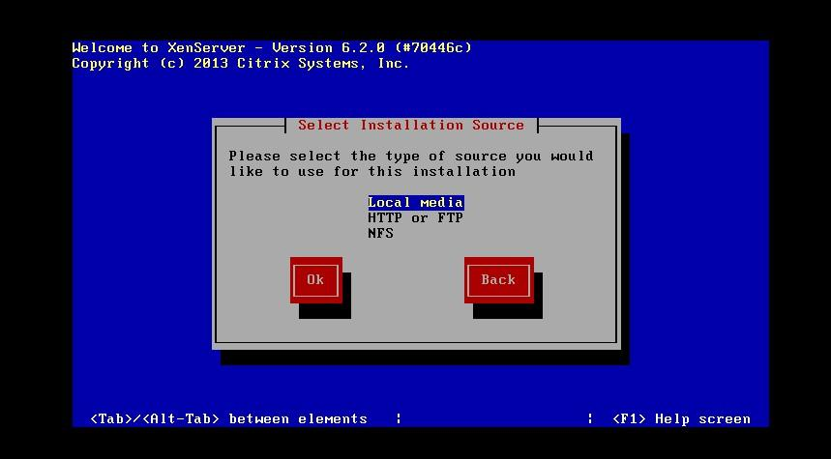

no

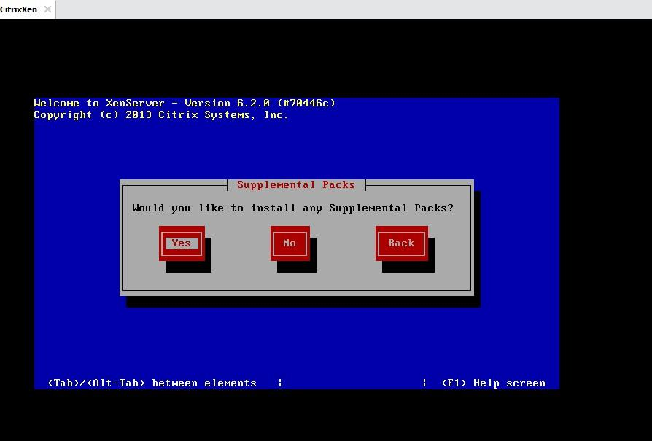

Skip verification

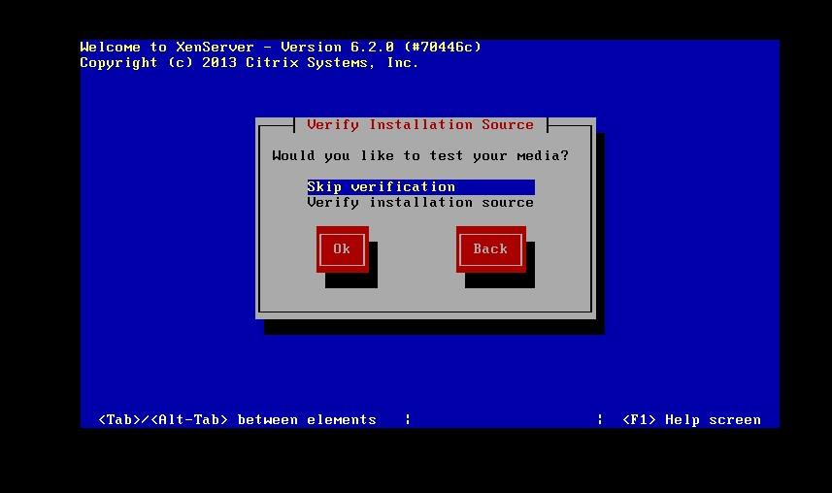

Password-student

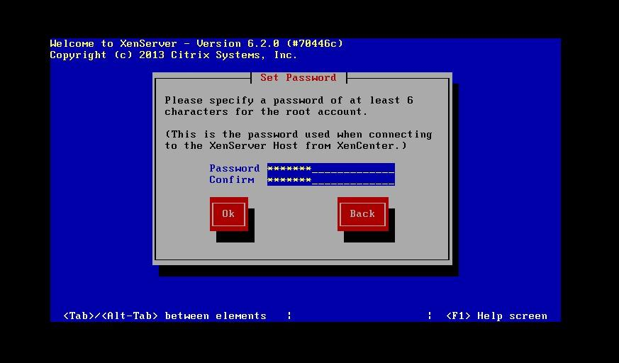

DHCP mode

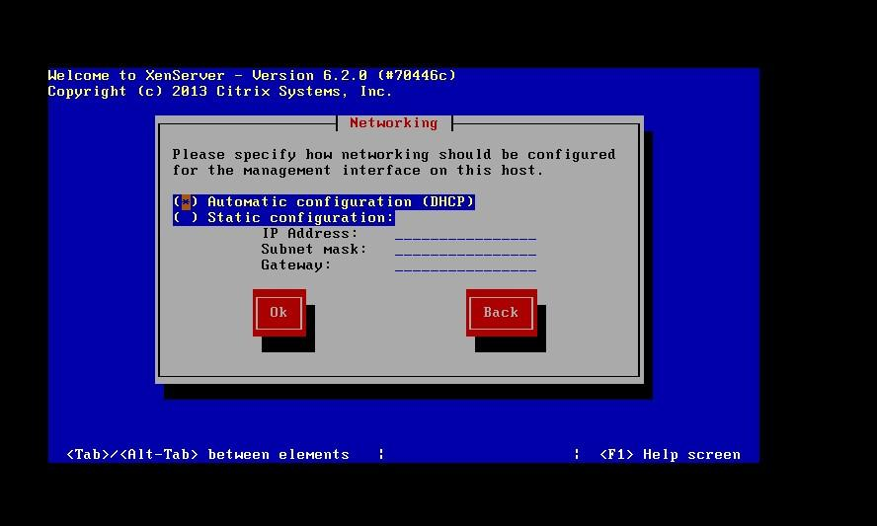

Change name- xenserver

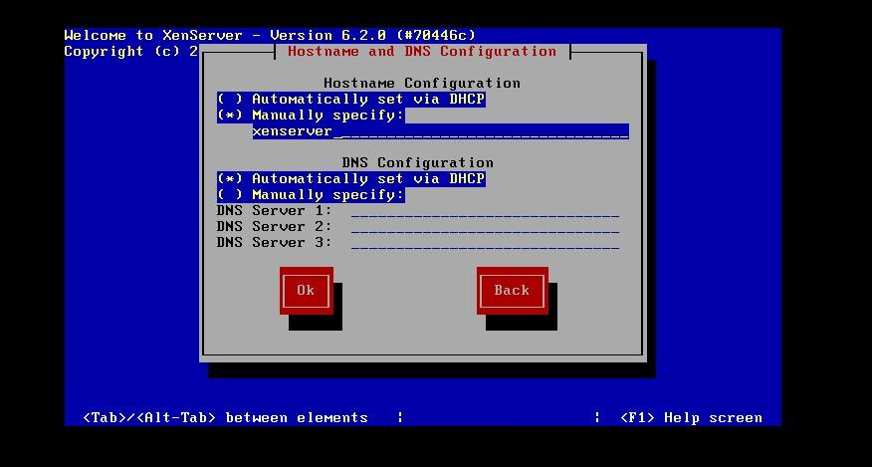

Asia

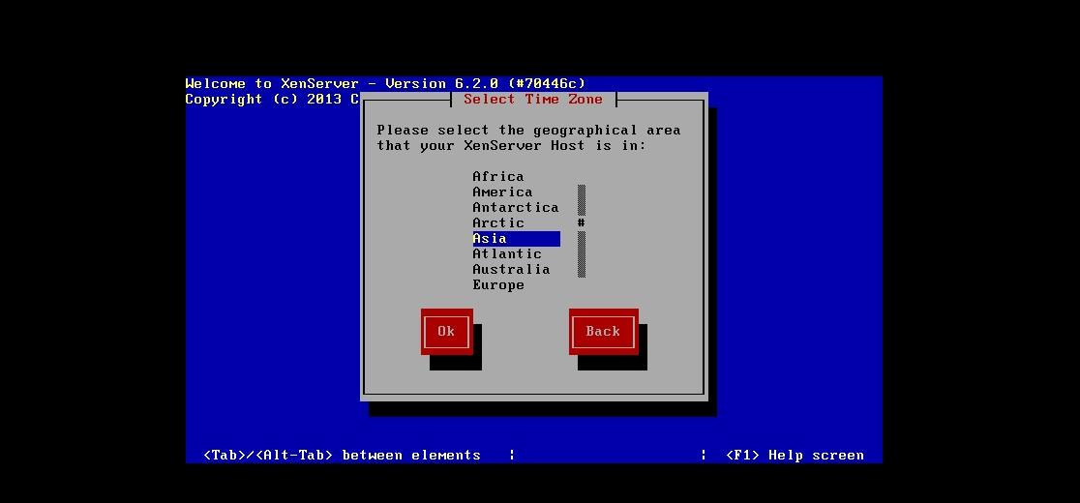

Calcutta

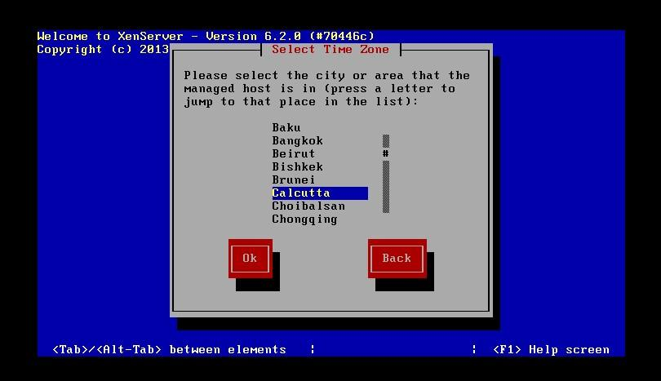

NTP

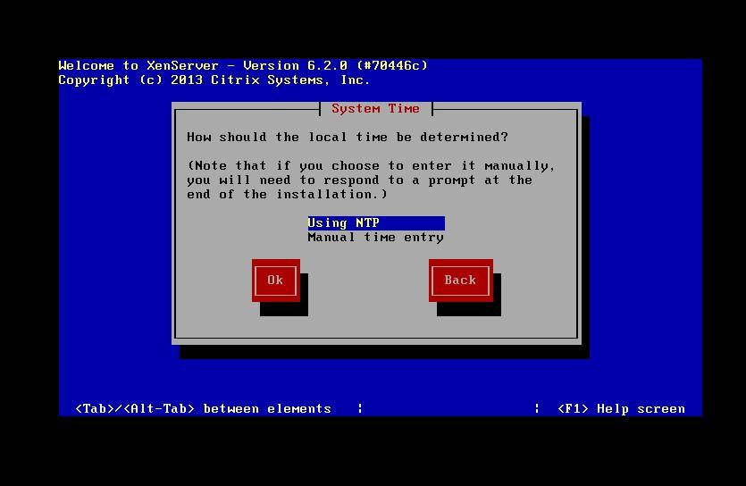

ok

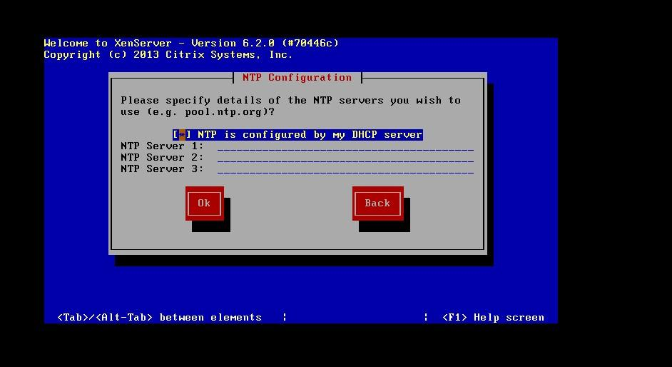

Install

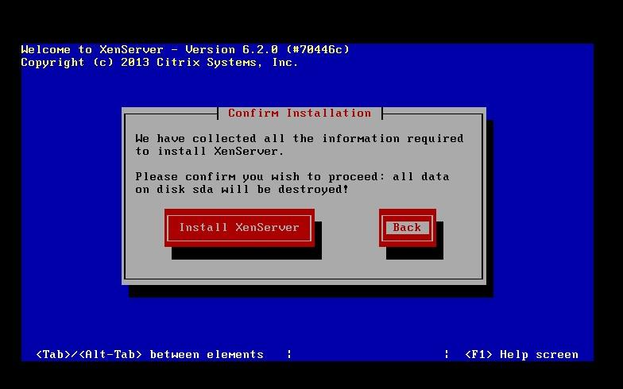

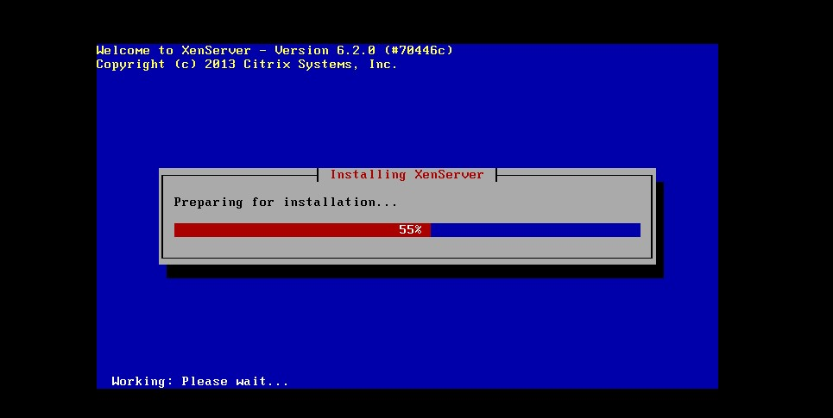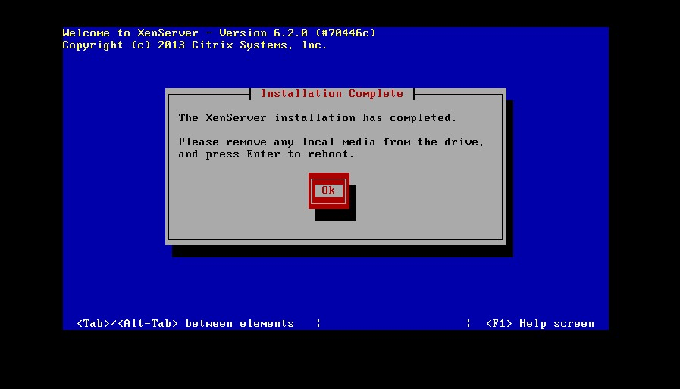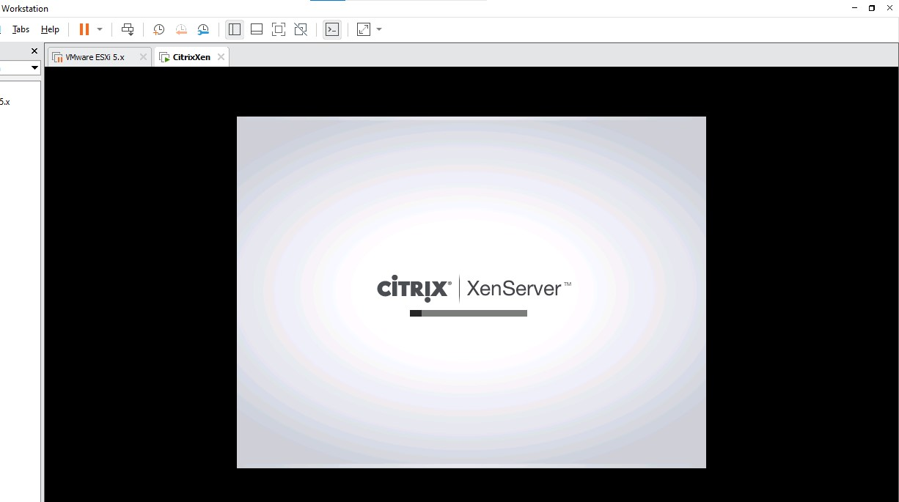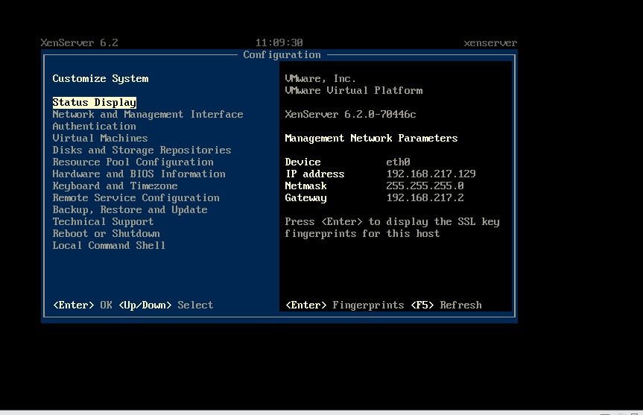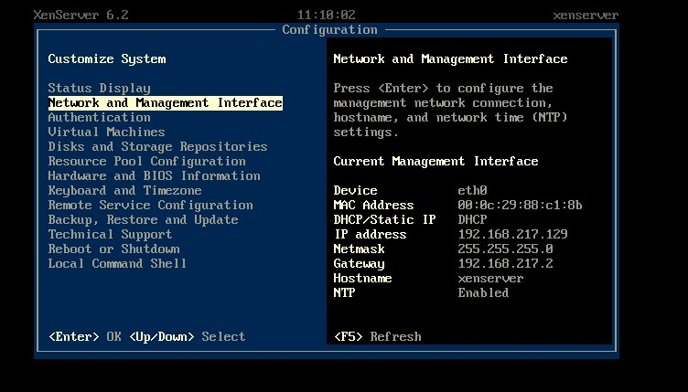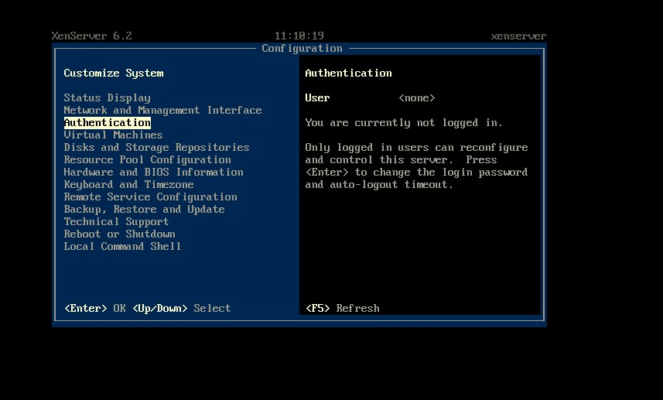

1. Creating & Installing Windows 7 Virtual Machine

Create new VM

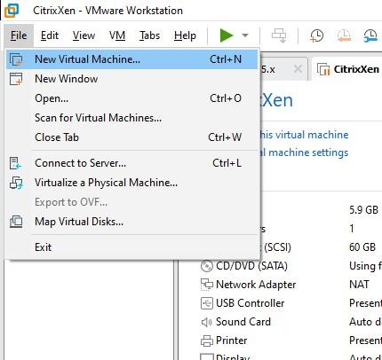

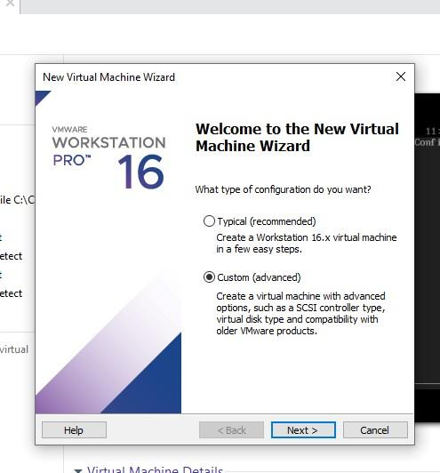

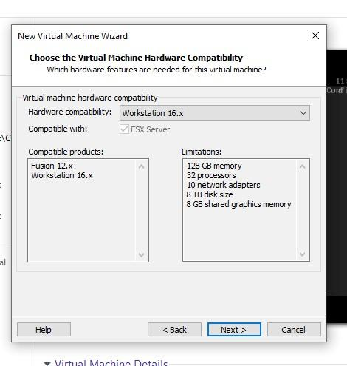

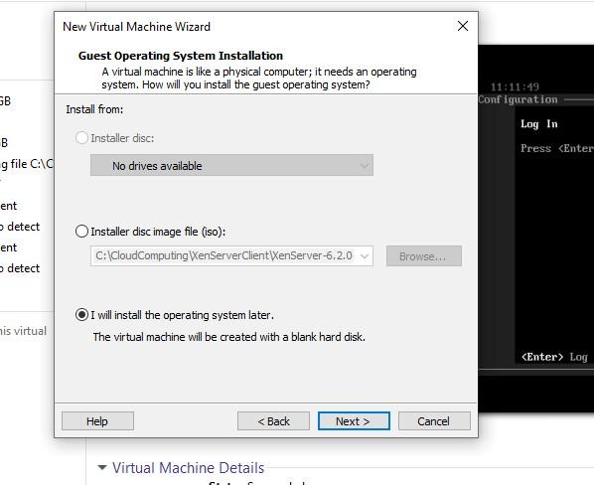

Select microsoft windows

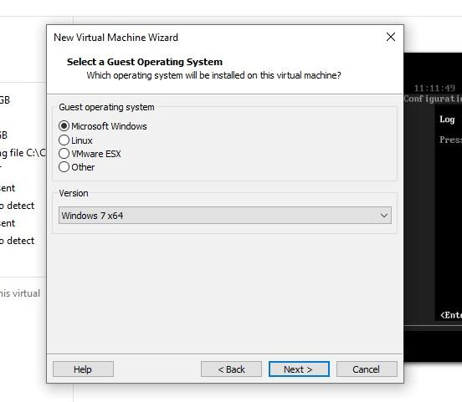

Create new folder - Windows7

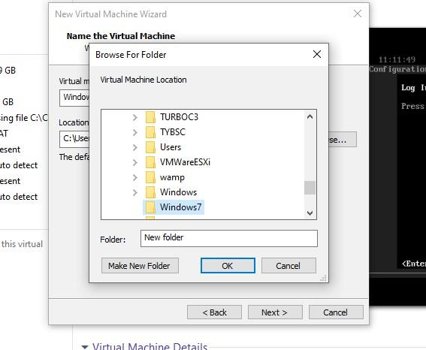

VM name- windows 7 x64 & browse→selct the path of folder created

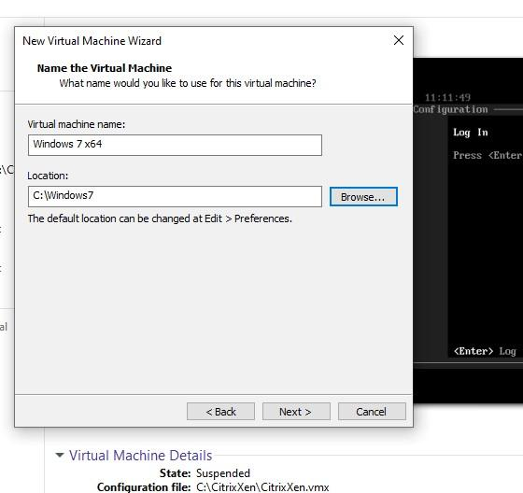

BIOS

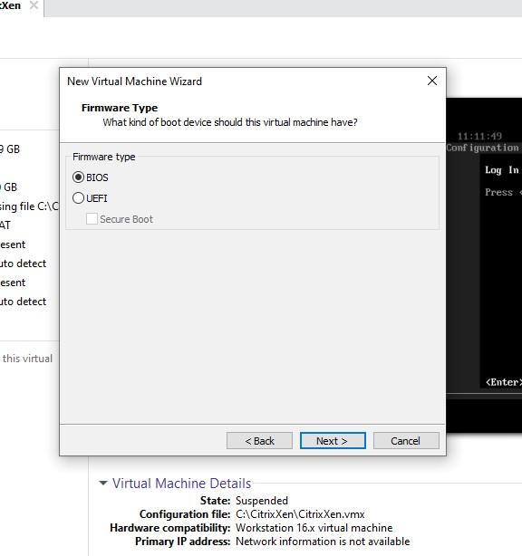

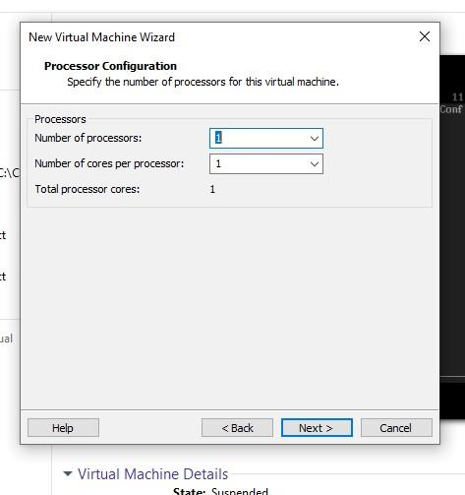

Memory - 2048 mb

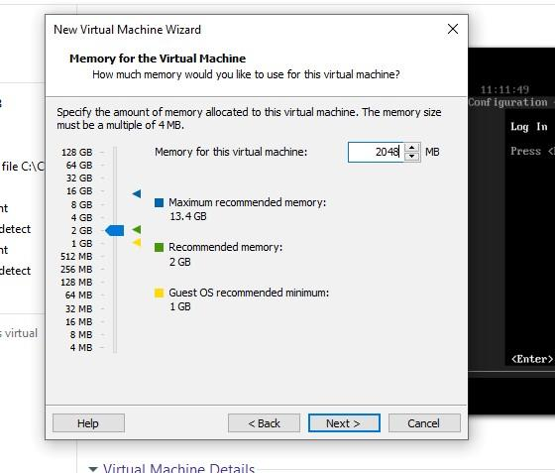

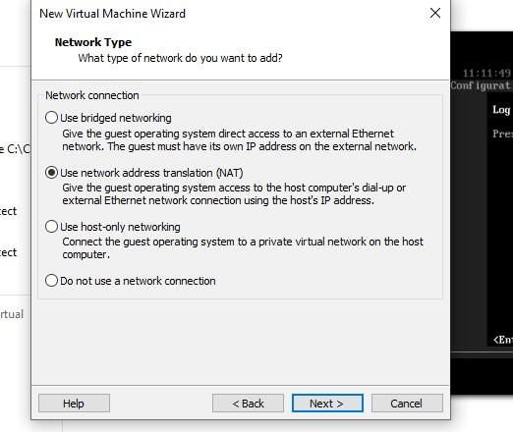

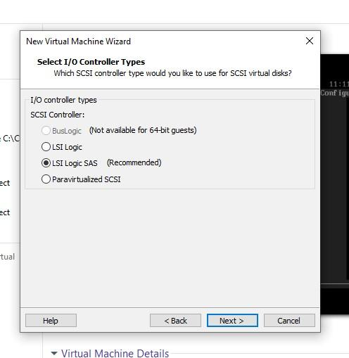

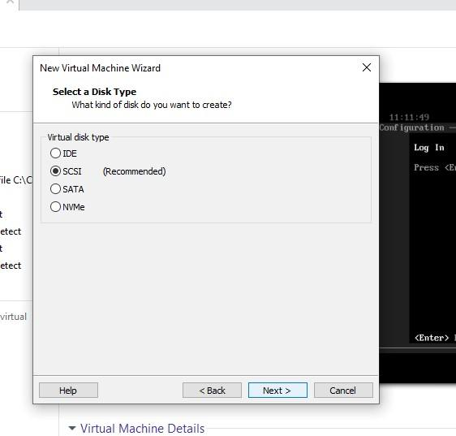

Create new virtual disk

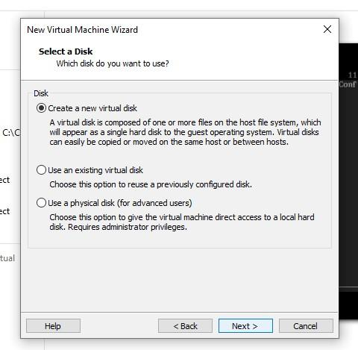

Disk size - 60 gb

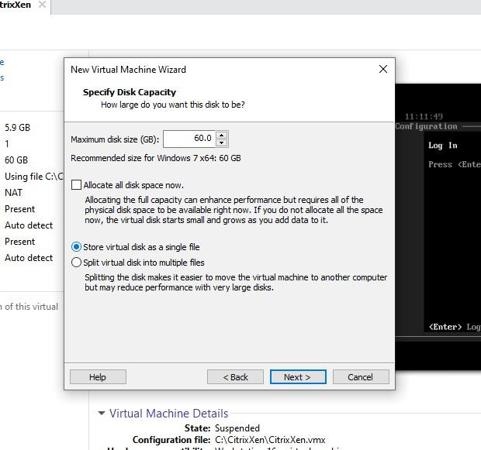

Select path of folder created

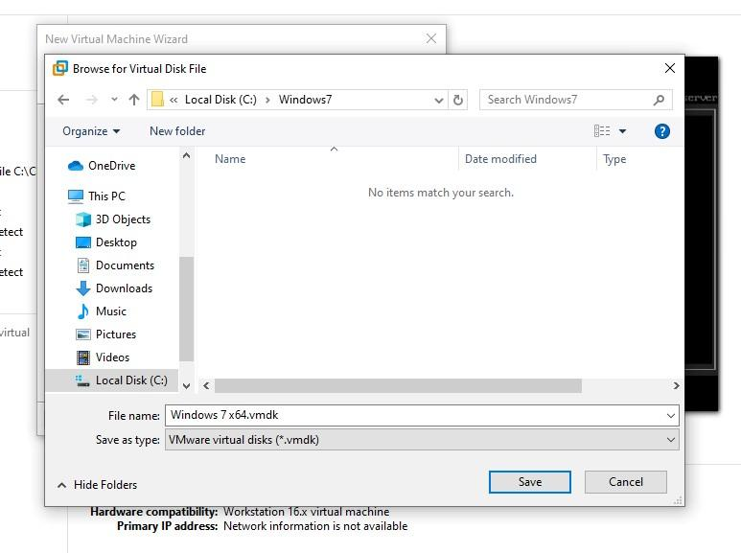

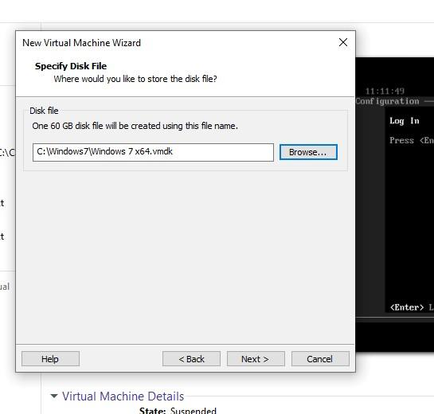

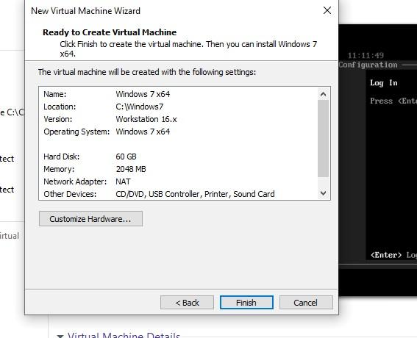

In file manager→cloud computing folder→ISO file

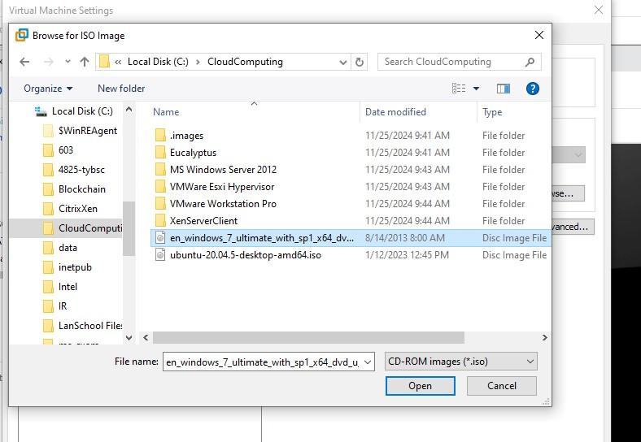

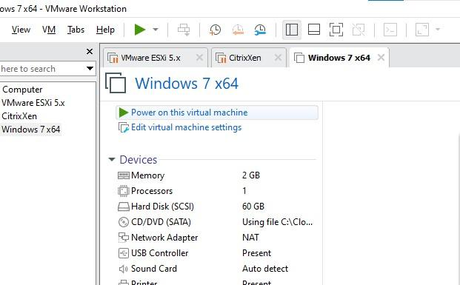In CD/DVD →iso image file→see previous slide

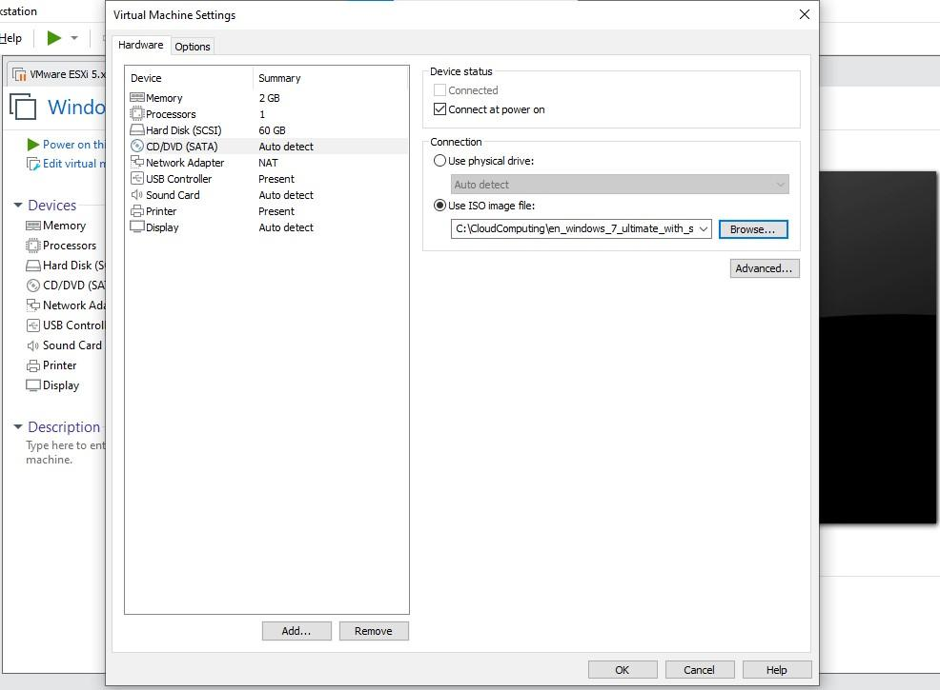

Power on VM

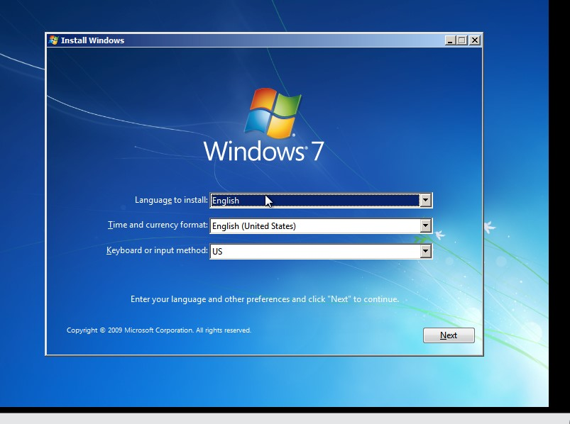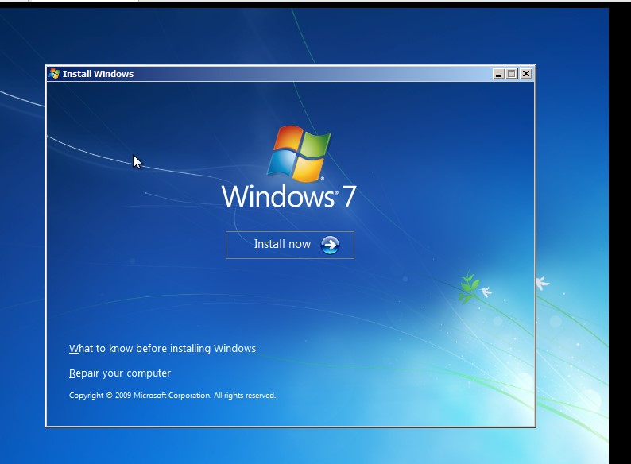

accept

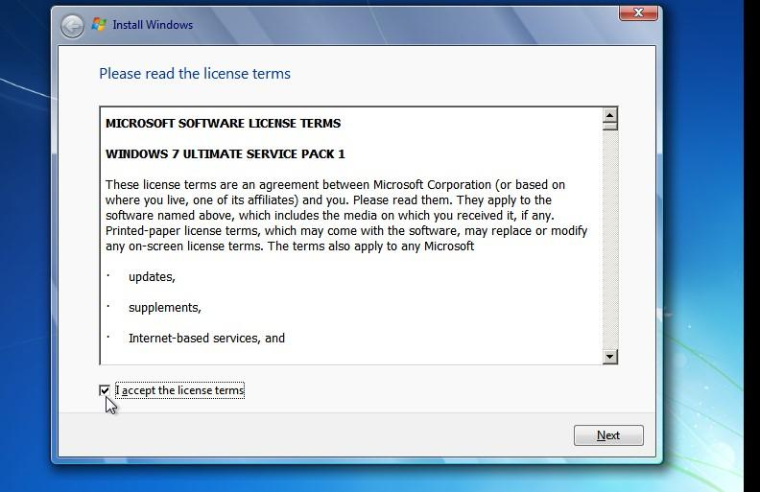

custom

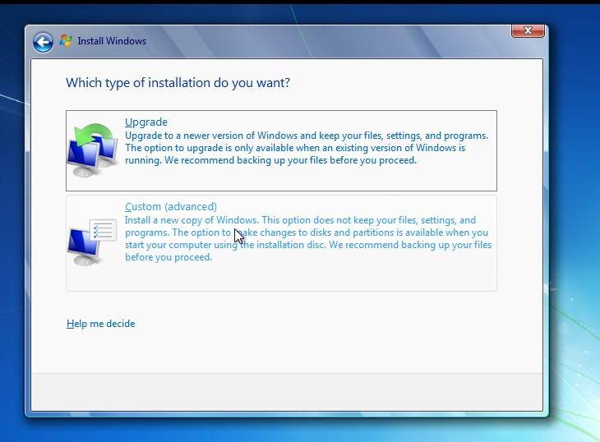

Double click

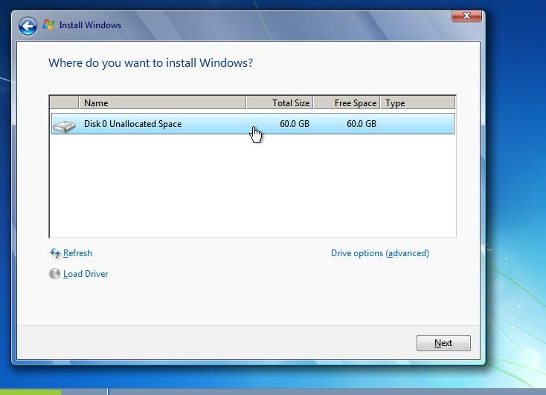

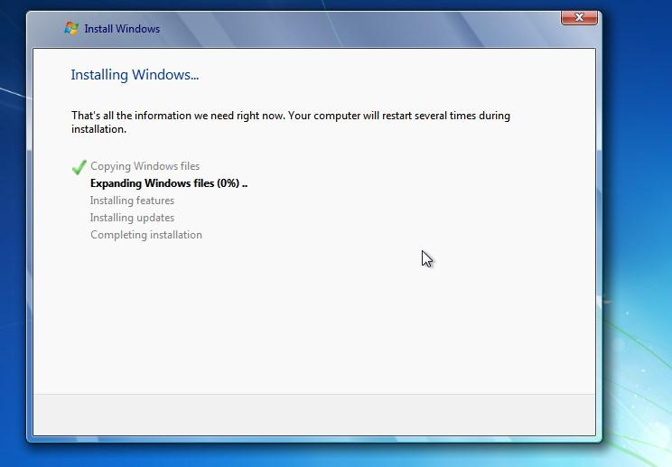

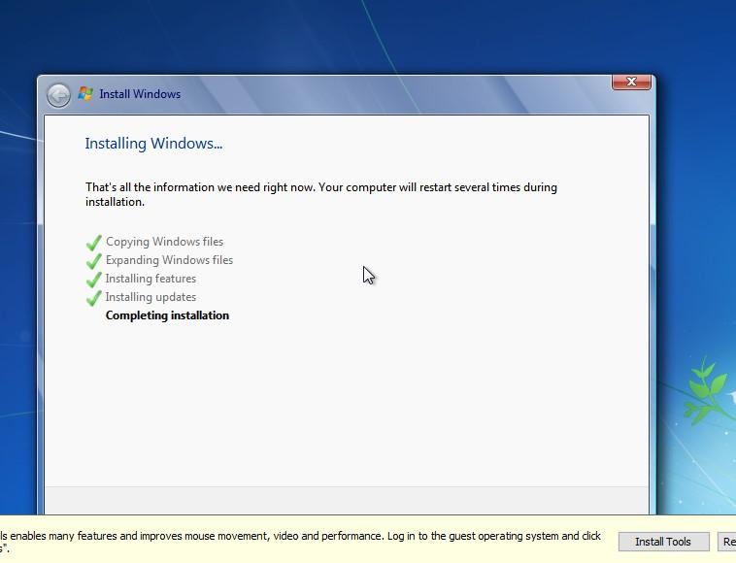

Give Username And computer name

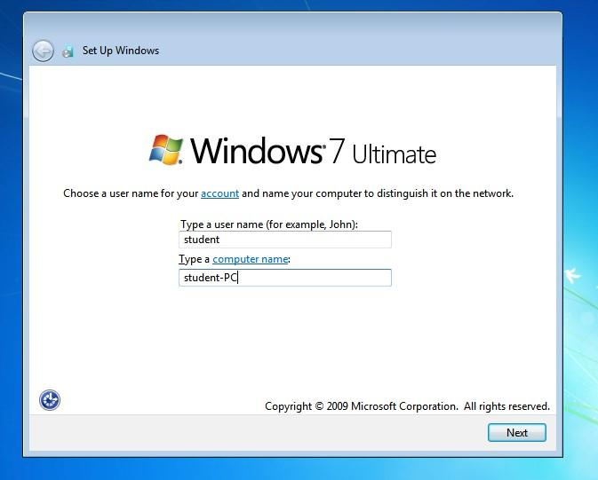

password-student

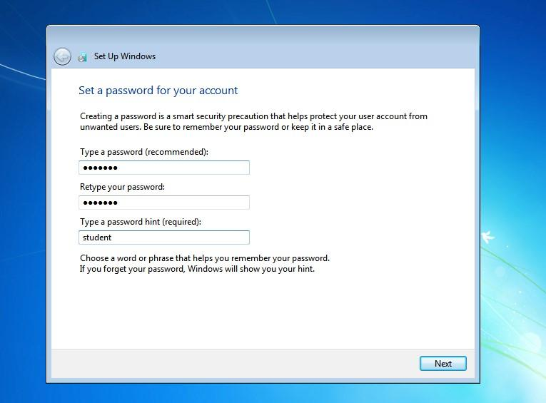

skip

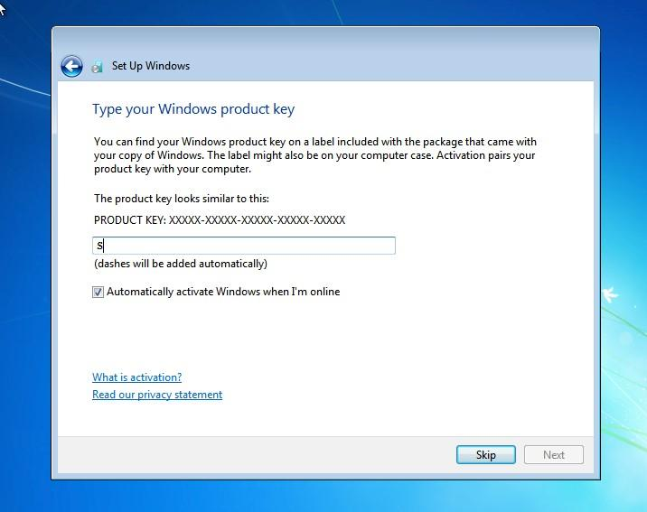

Ask me later

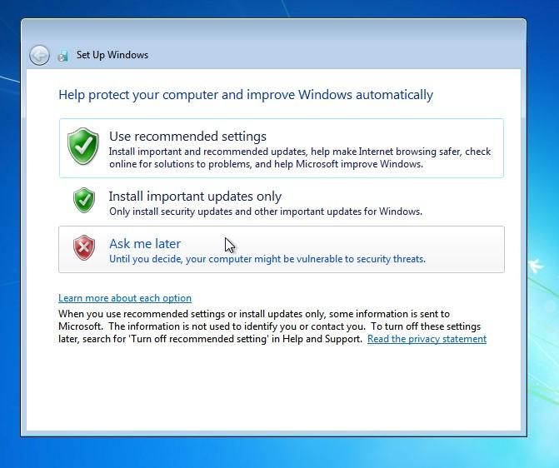

Select this

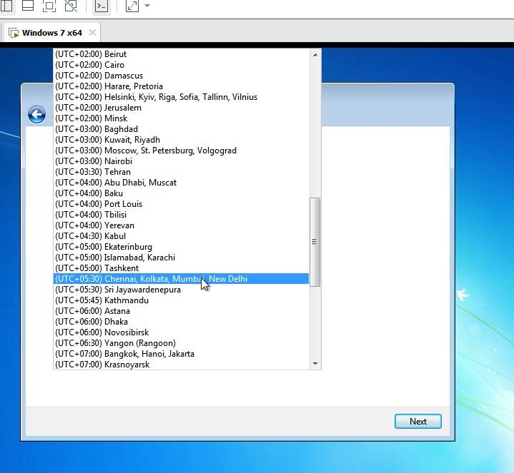

Change date and time

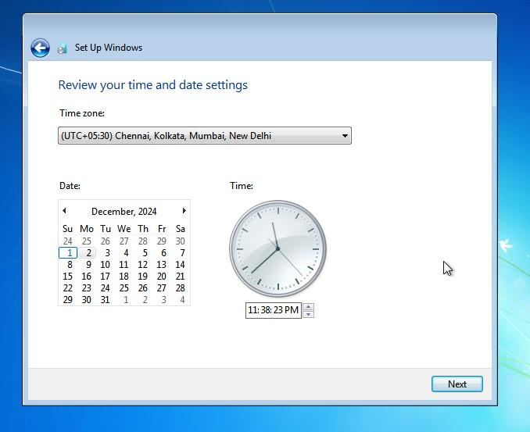

Home network

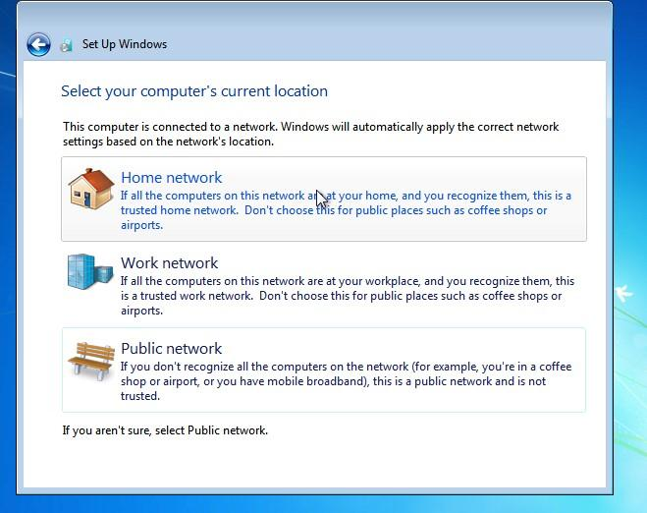

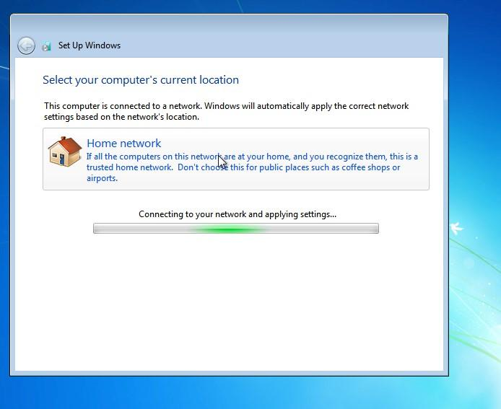

Create new folder

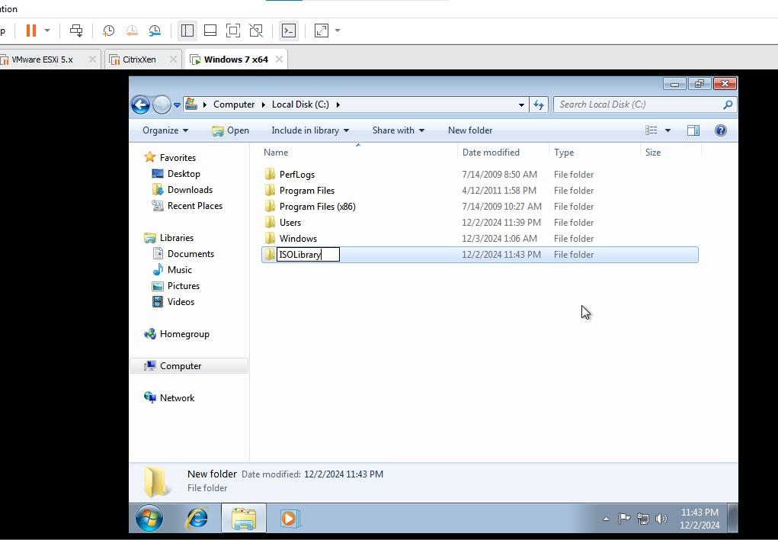

Right click folder→share with specific people

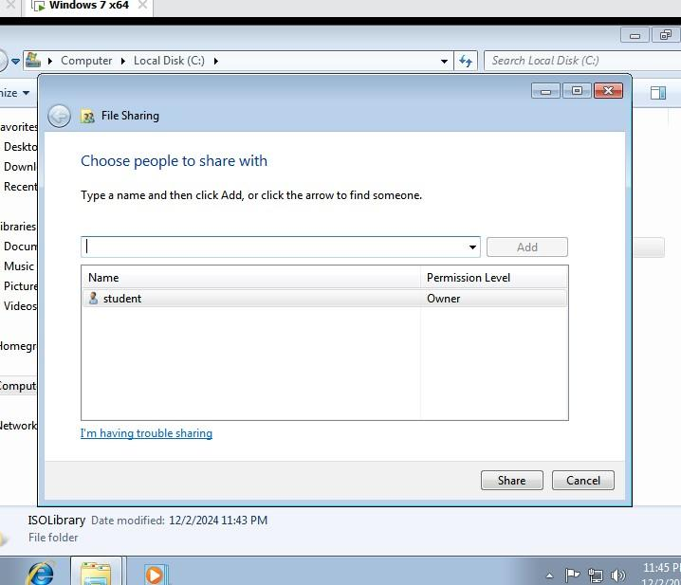

Select everyone and Add

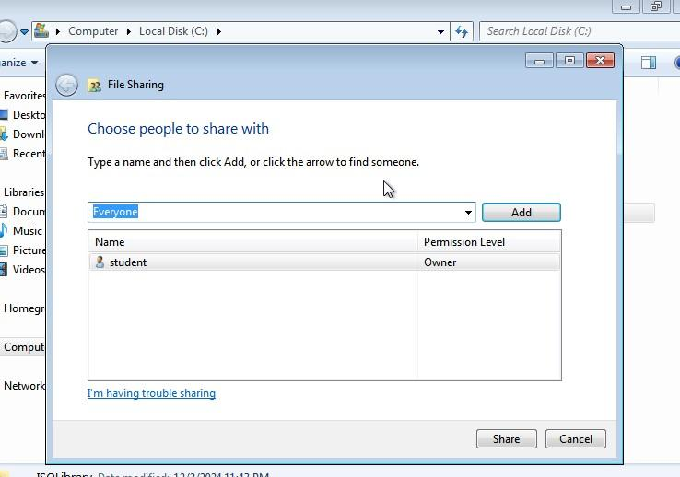

Share

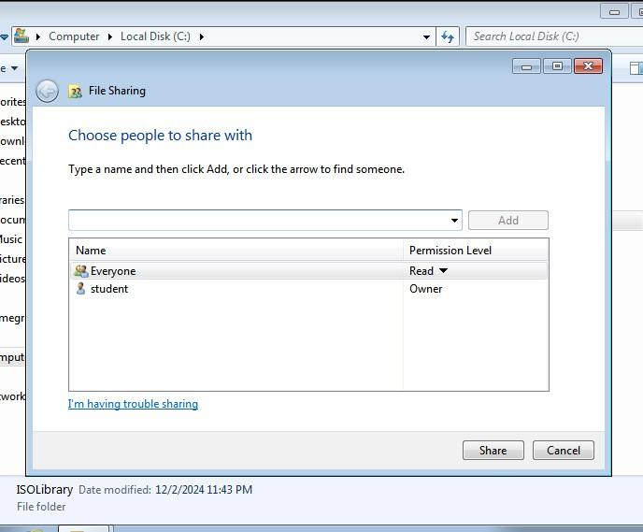

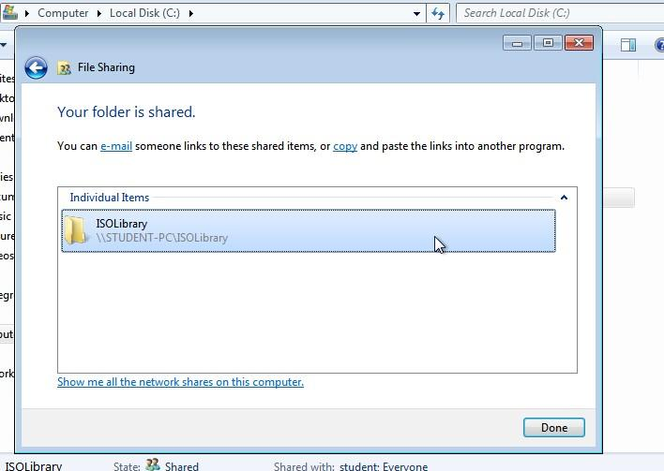

Control panel

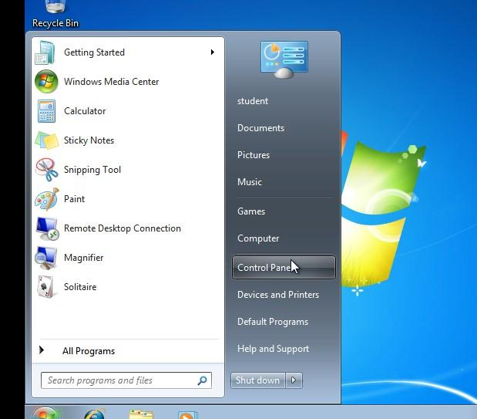

viewBy-select small icons

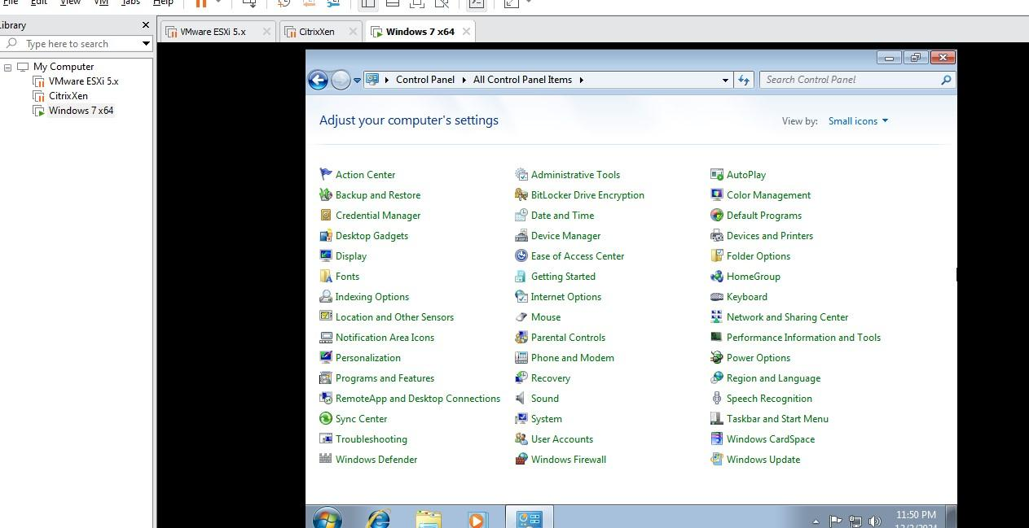

turn off Windows firewall

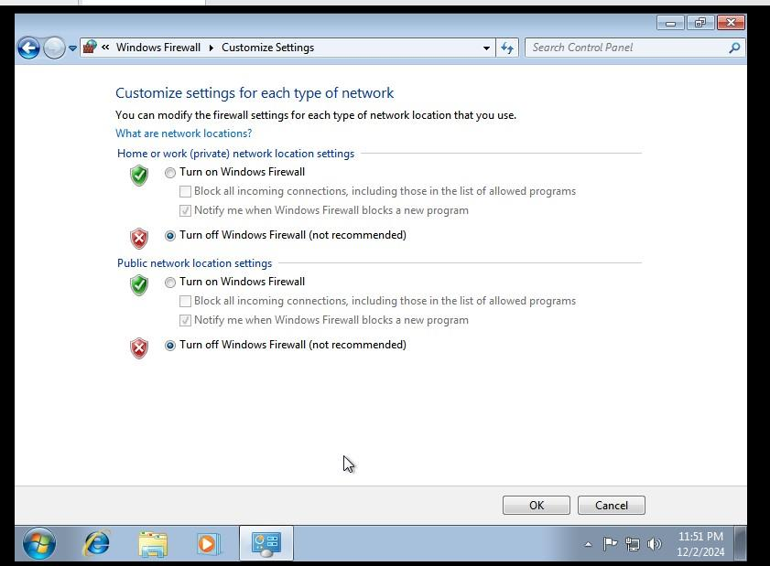

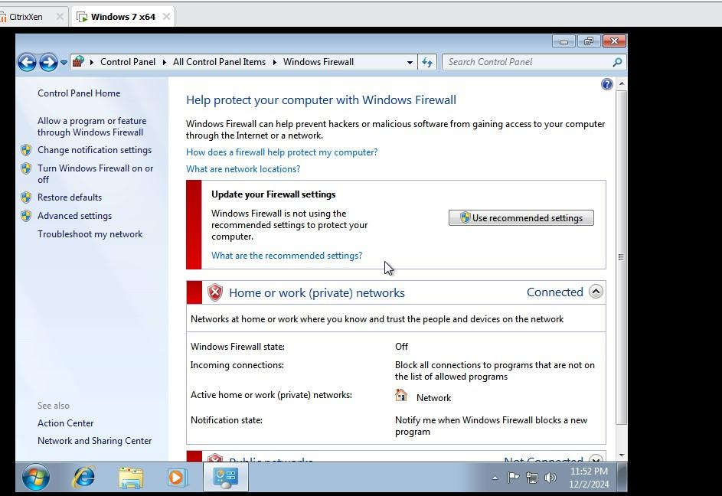

Download iso file

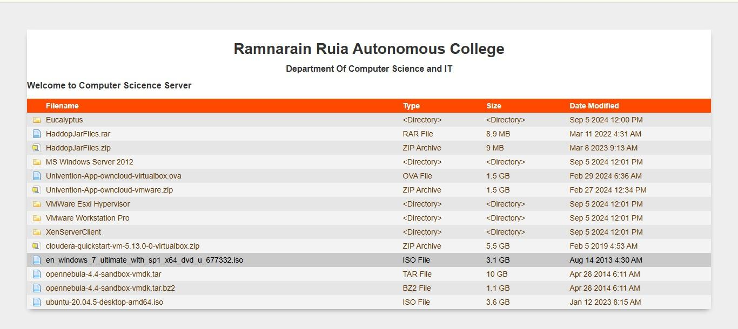

Install VMware tools

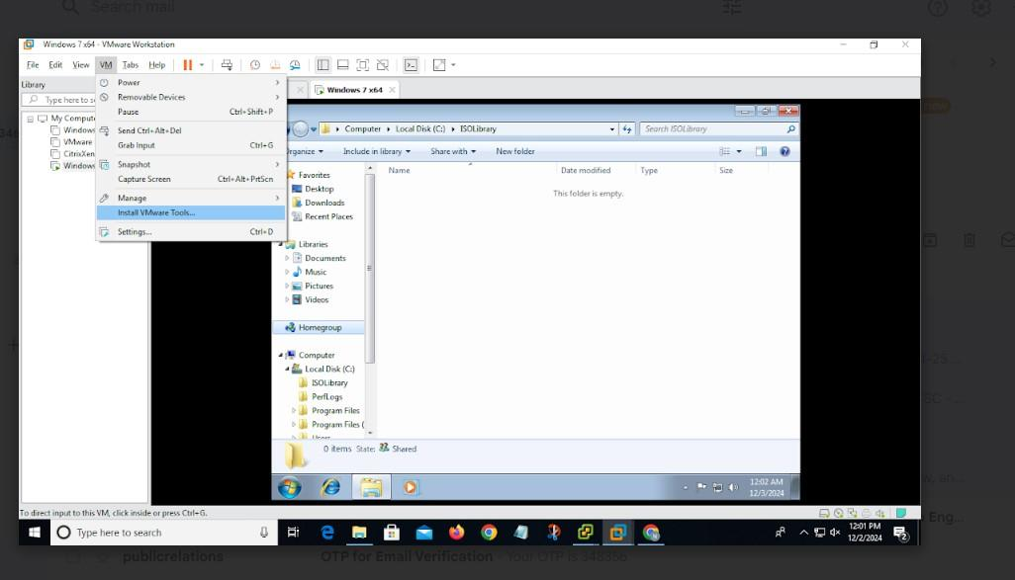

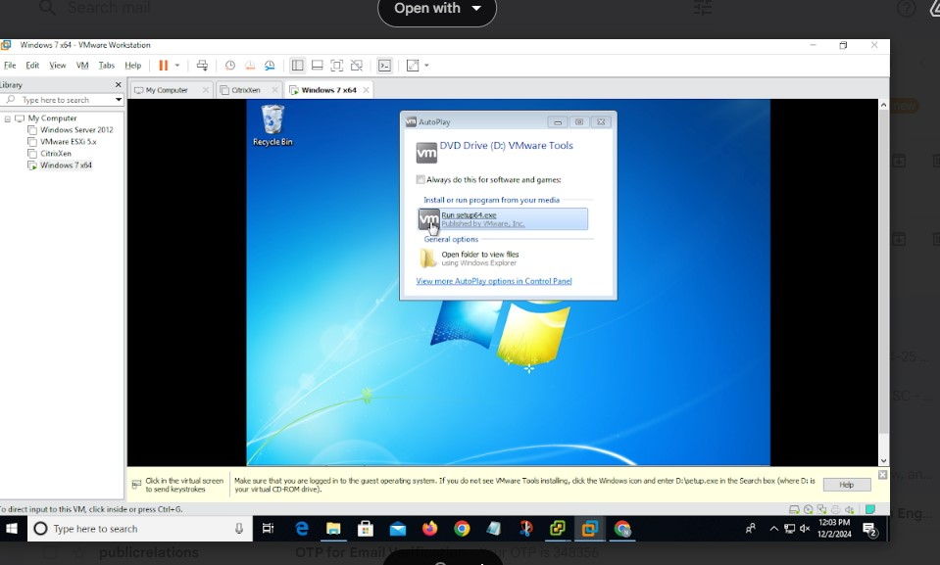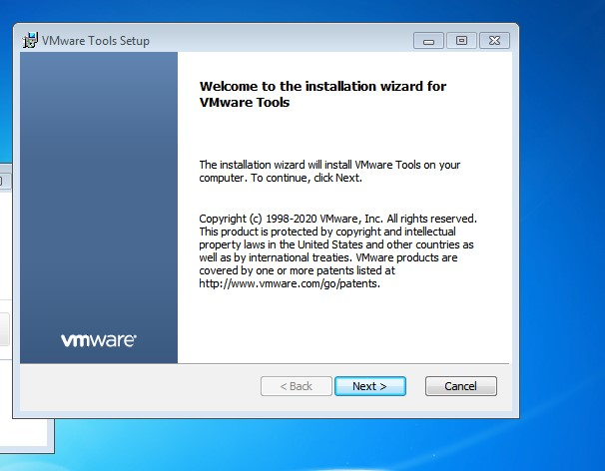

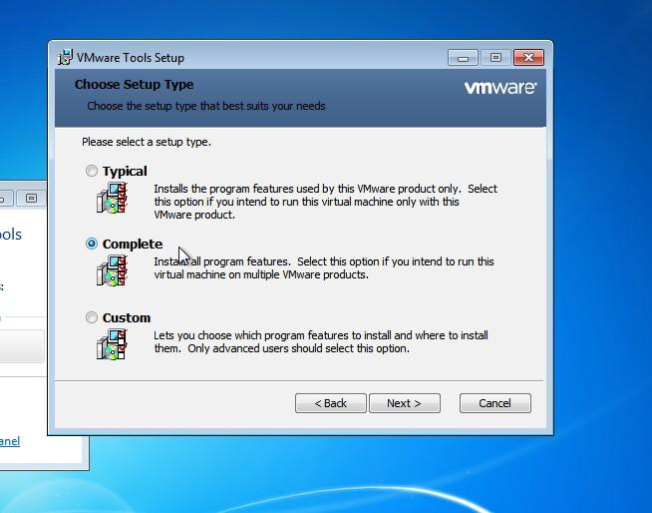

Install

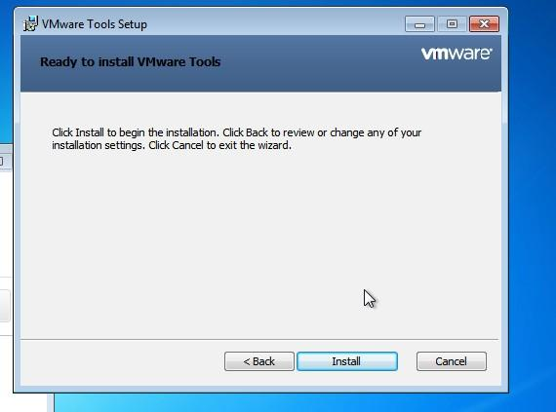

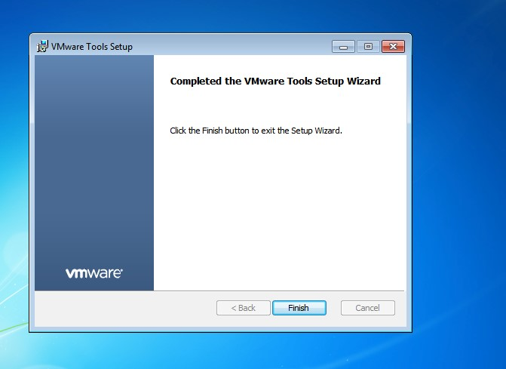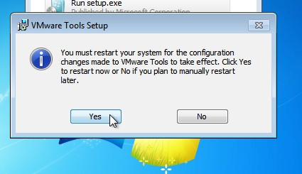

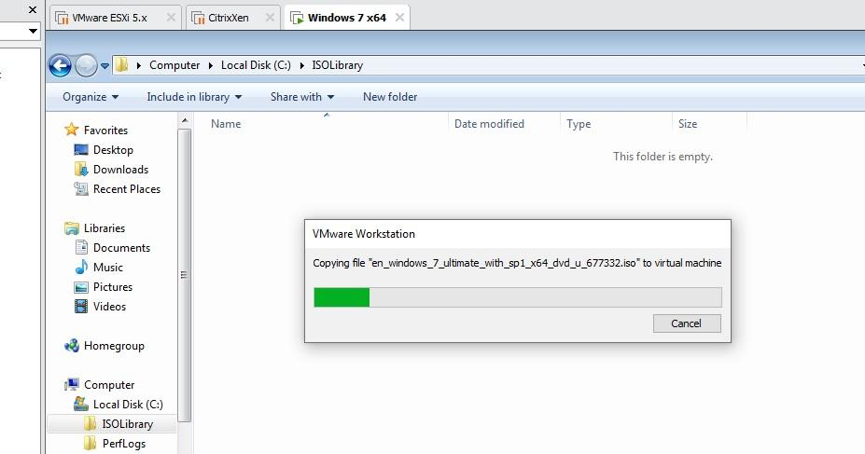password-student

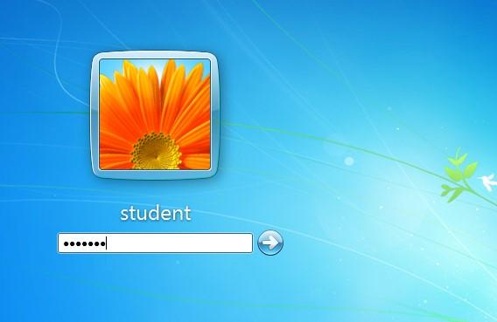

Drag the iso file here

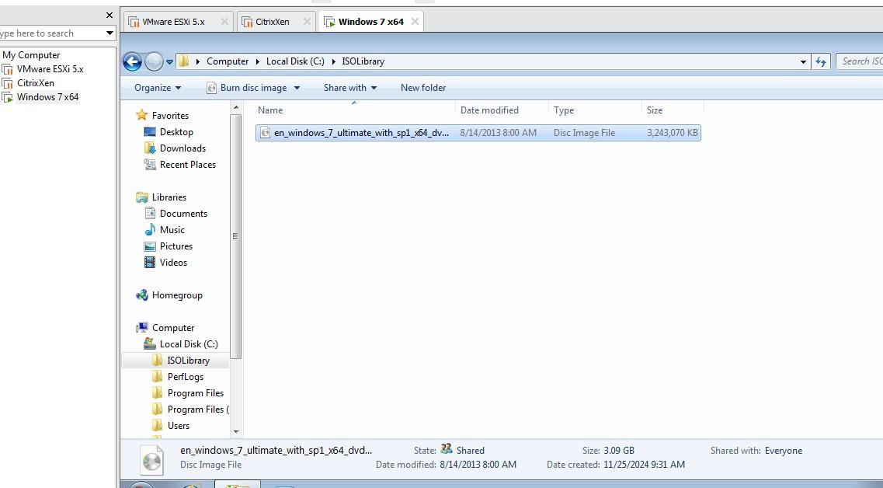Its the another way bowser of windows

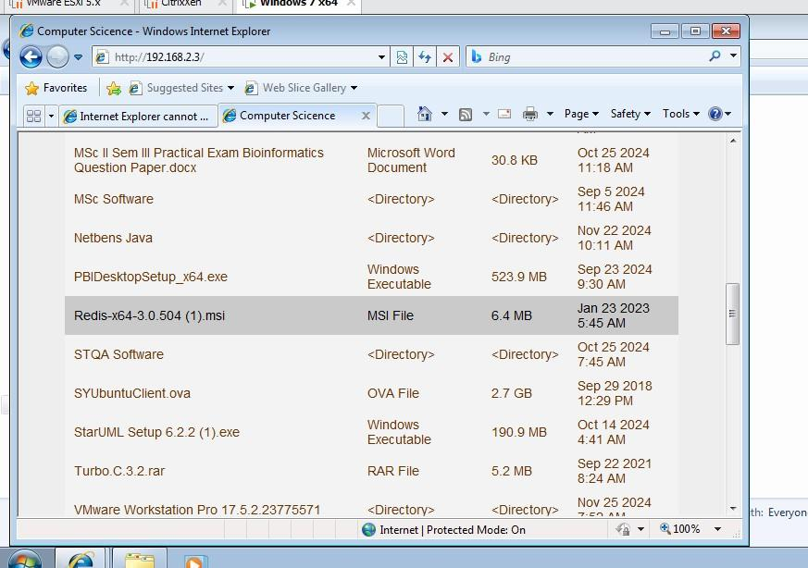

1. Installing Xen Center Client Software

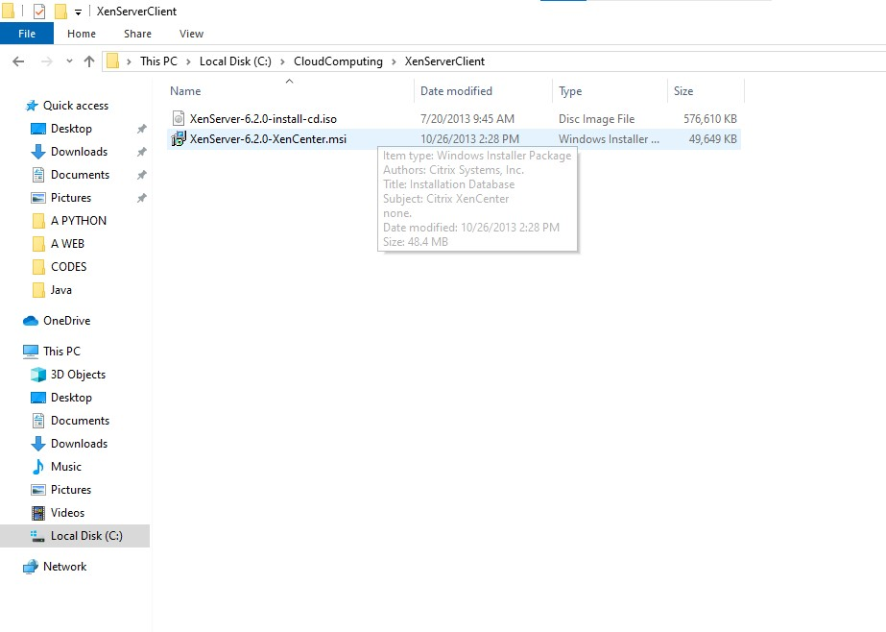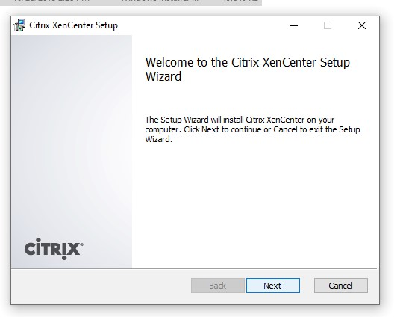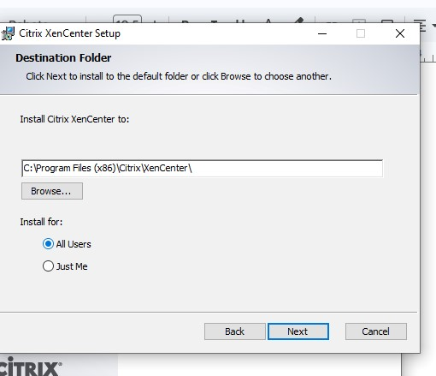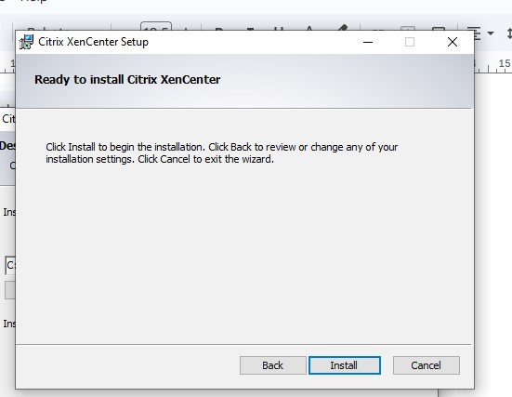

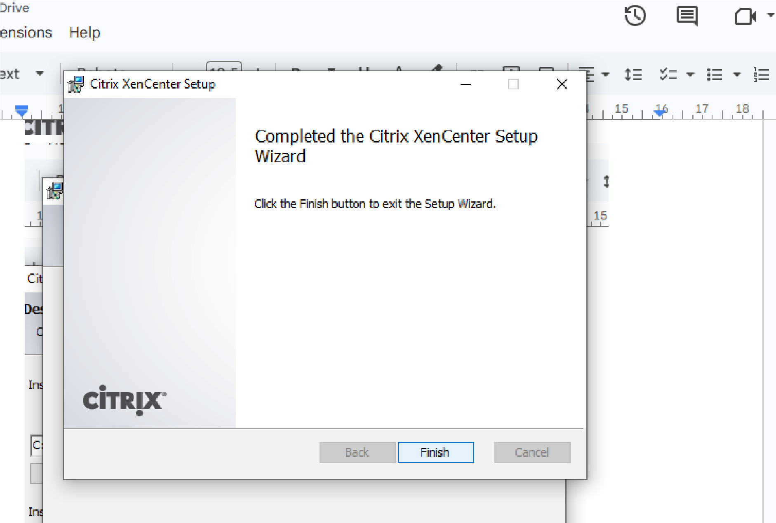

5. Creating Virtual Machine on Citrix Xen Server

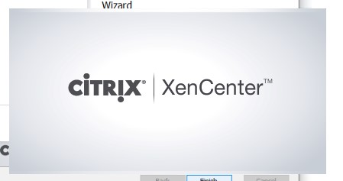

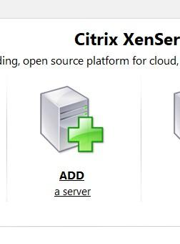

Give ip

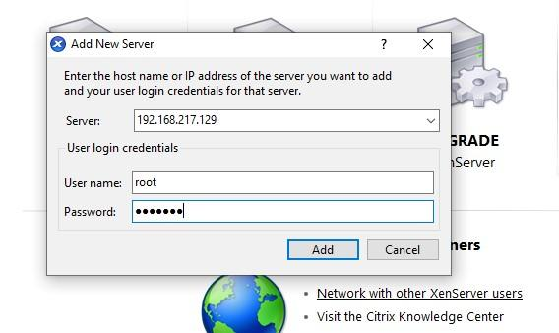

connected

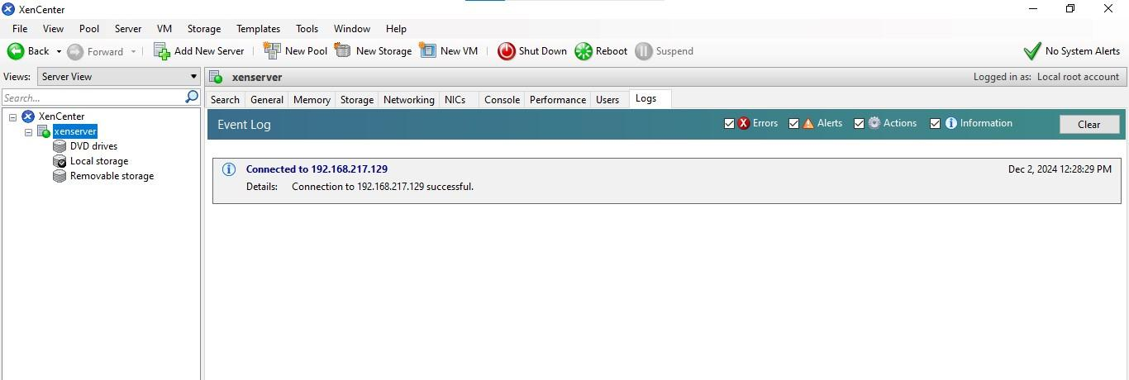

New storage

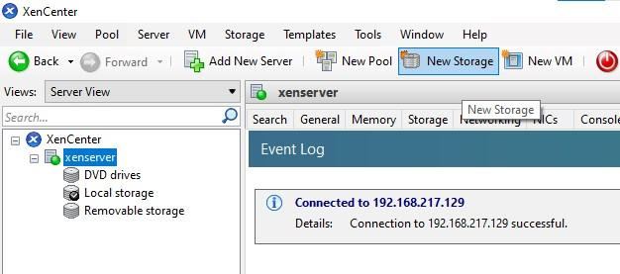

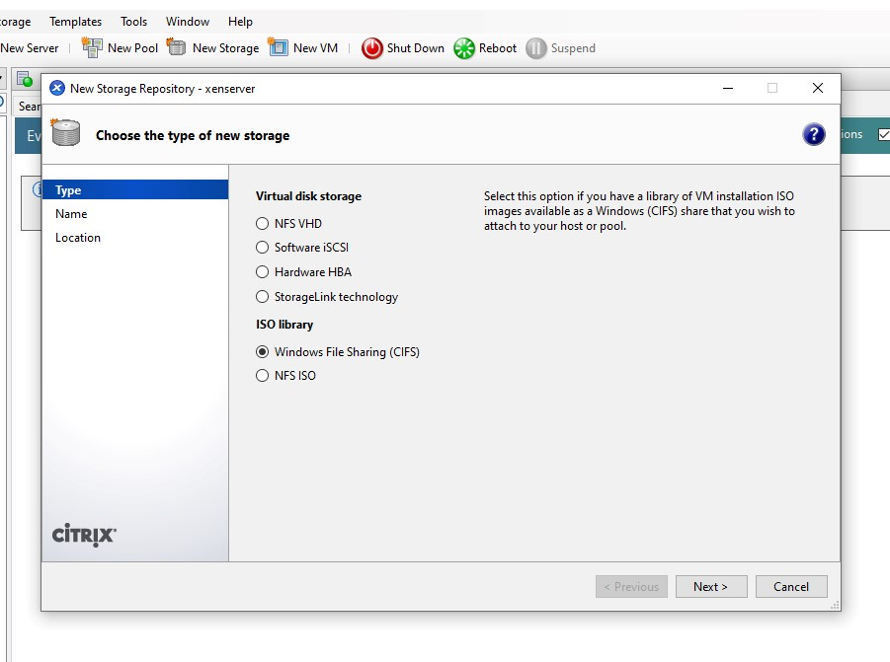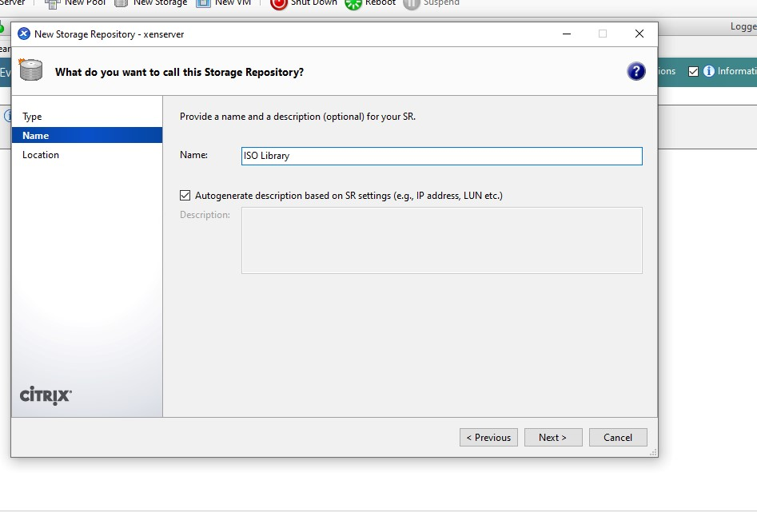

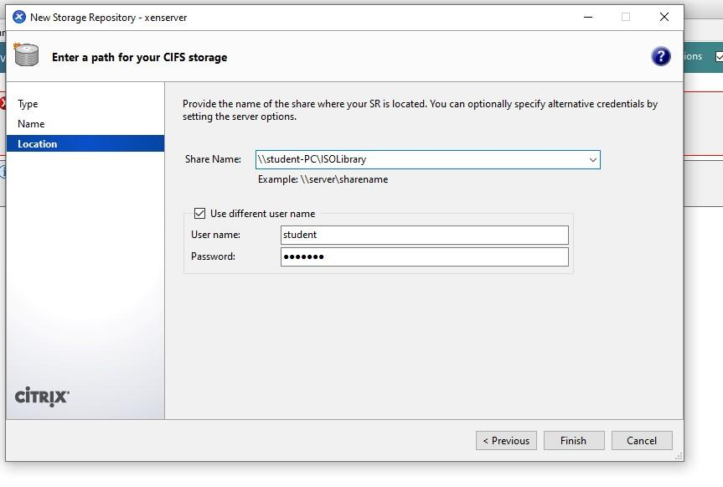

New vm→windows 7 (64-bit)

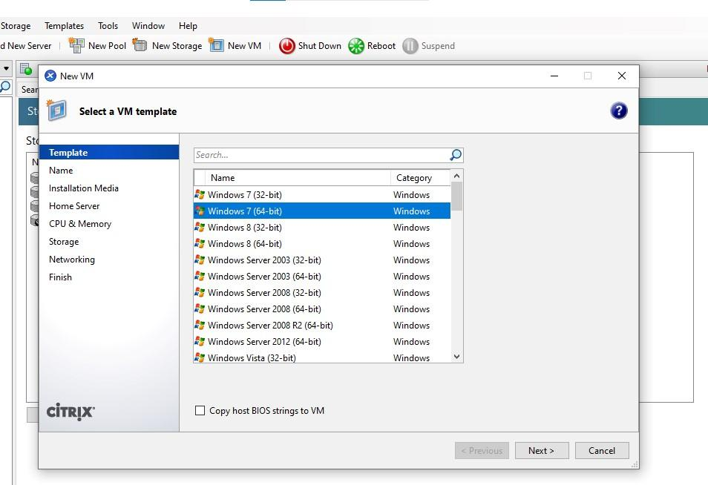

Name the vm

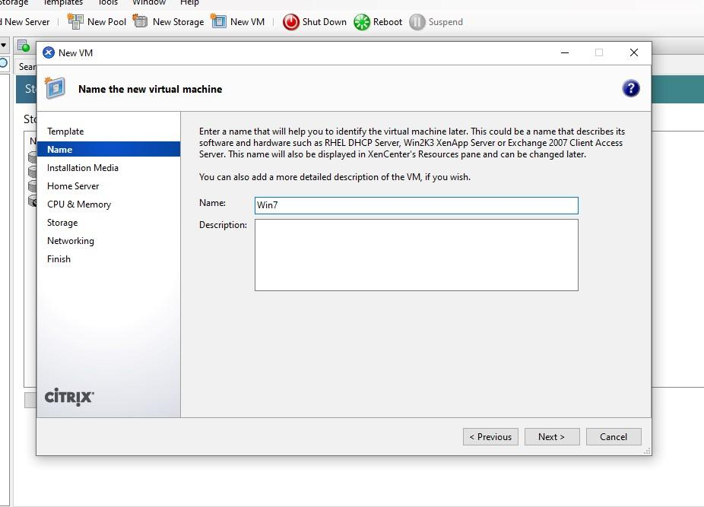

Iso file

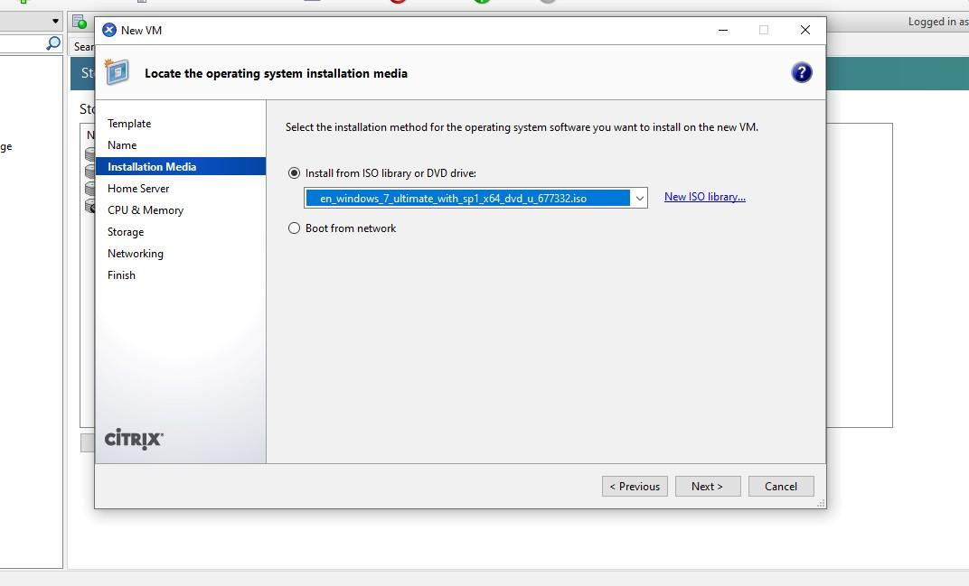

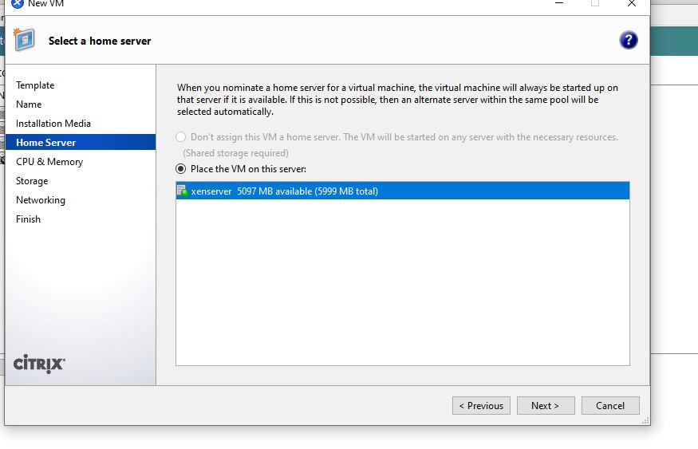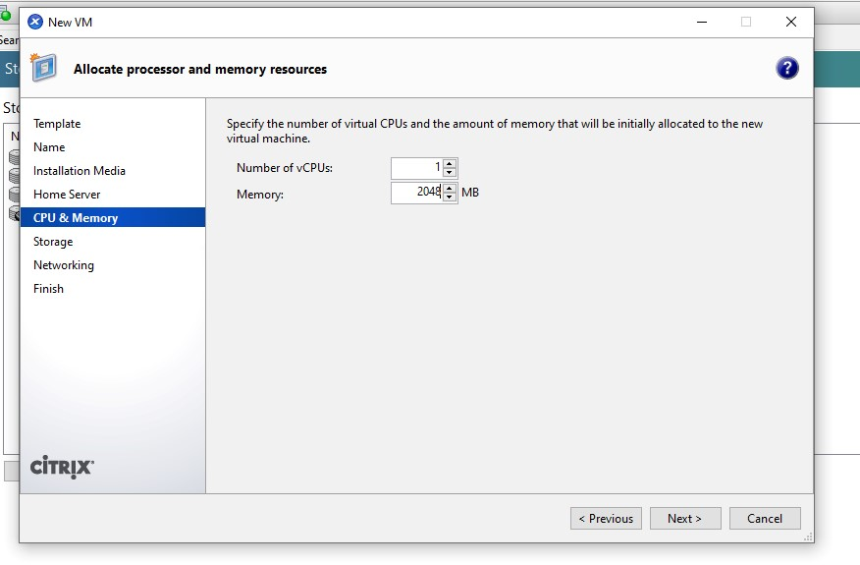

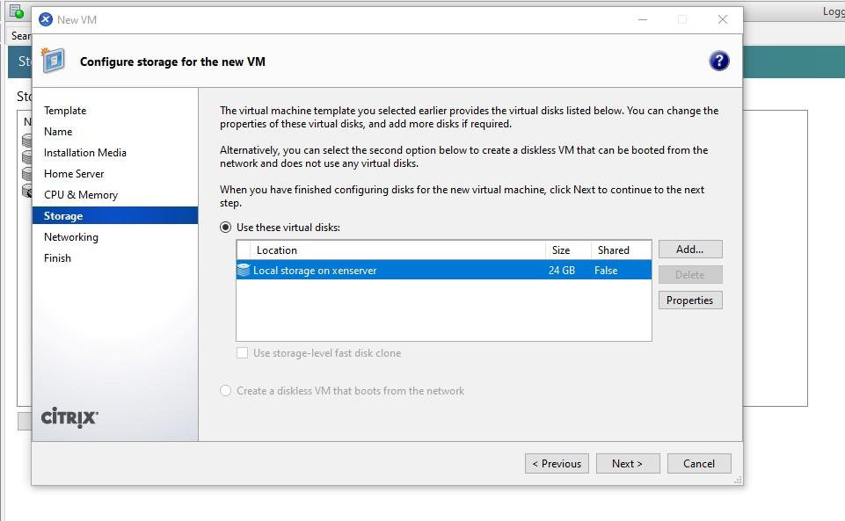

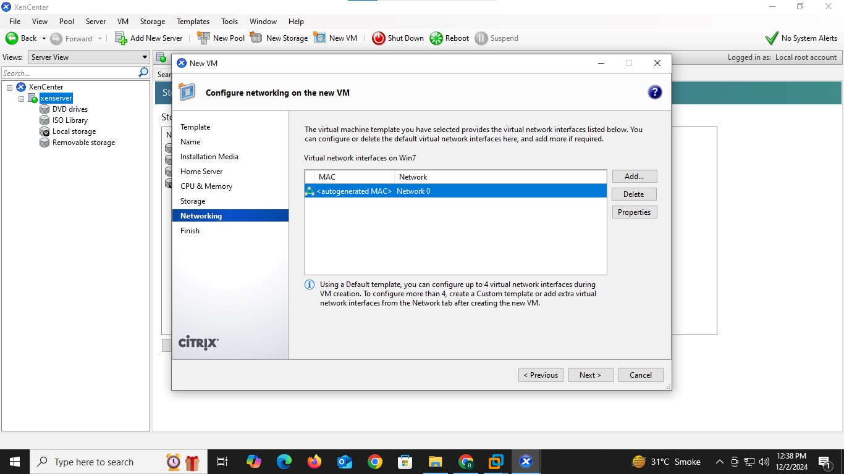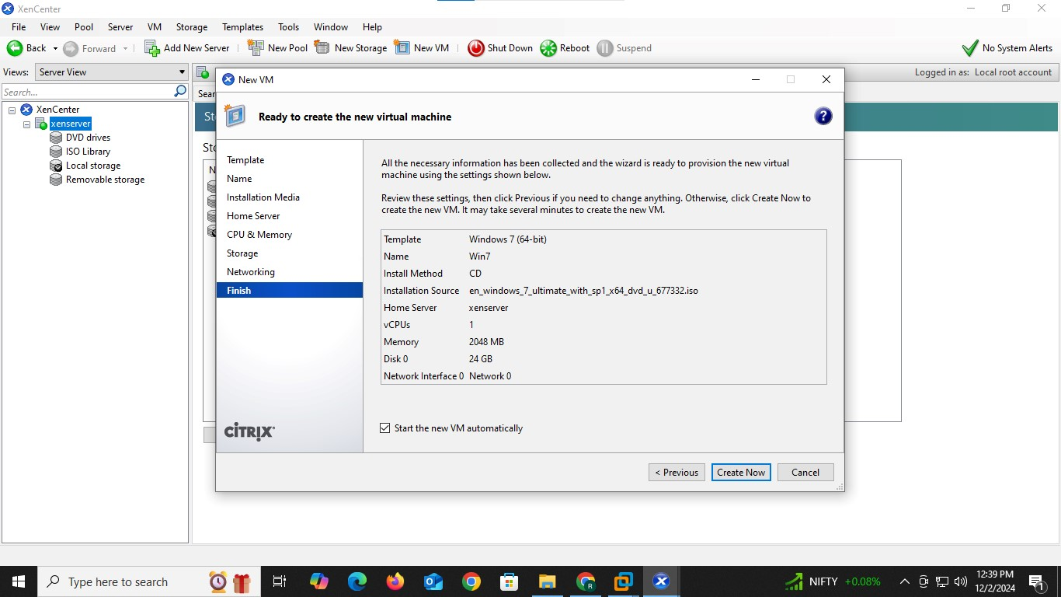

Finish the process here as it cannot go further

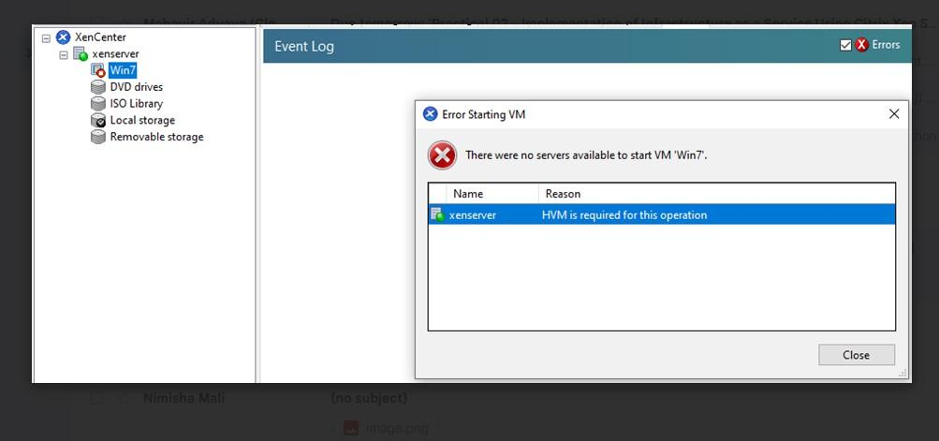

Practical No. 3

Implementation of Infrastructure as a Service using Windows HyperV (Windows Server 2012 R2)

**Q.1]** Implement IaaS using Windows Hyper-V

**Steps:**

**Step 1:** Start VMware Workstation

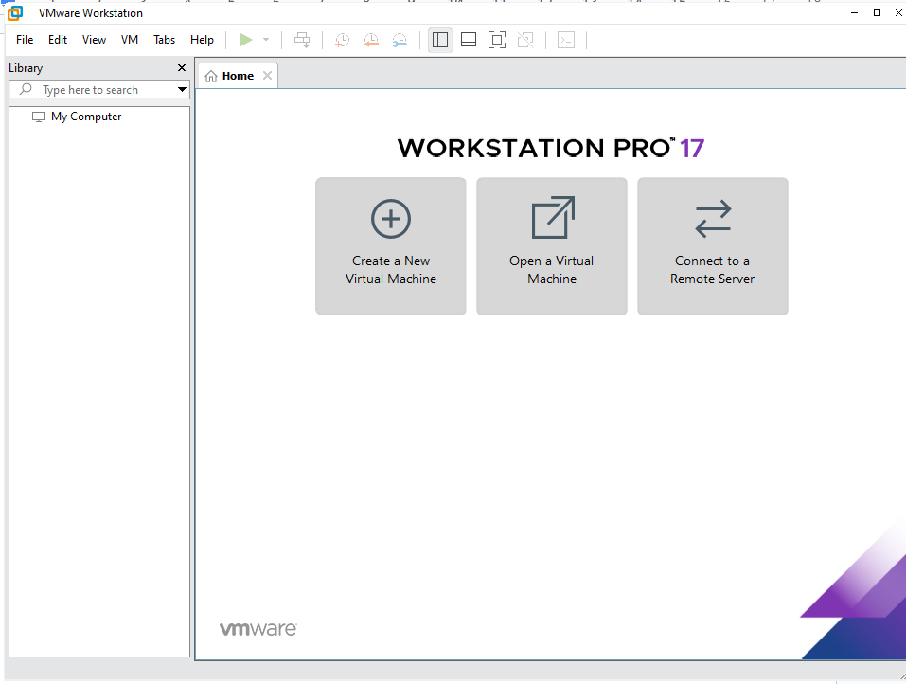

**Step 2:** Select create a new virtual machine

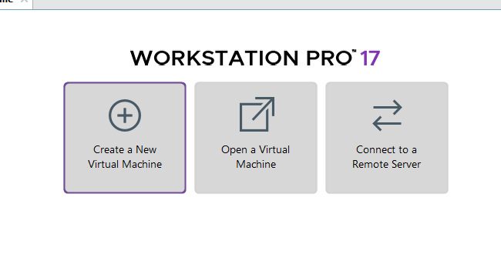

**Step 3:** Select custom option

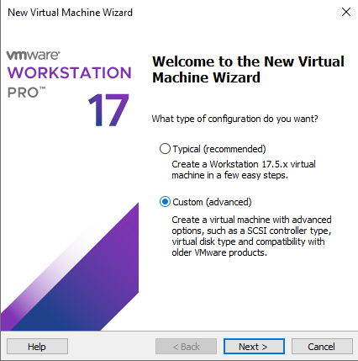

**Step 4:** Click next

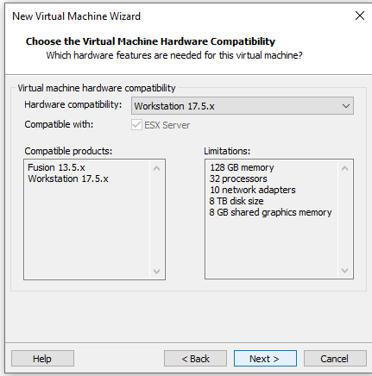

**Step 5:** Select last option

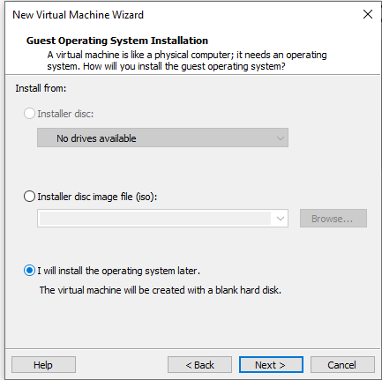

**Step 6:** Select operating system as Microsoft windows and version as windows server 2012

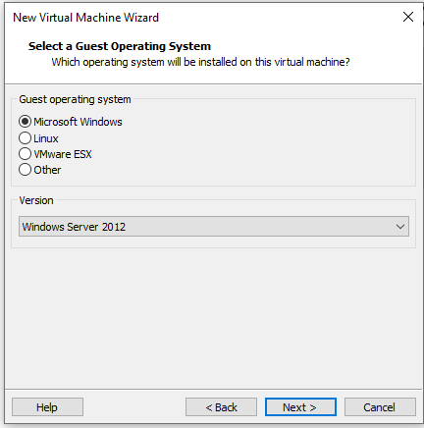

**Step 7:** Select folder to store virtual machine

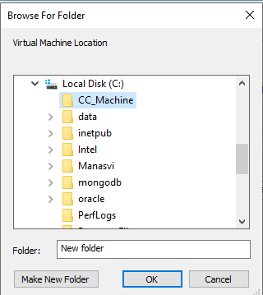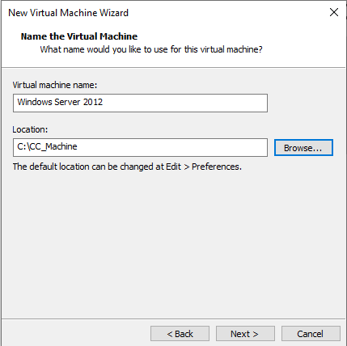

**Step 8:** Select default BIOS as firmware:

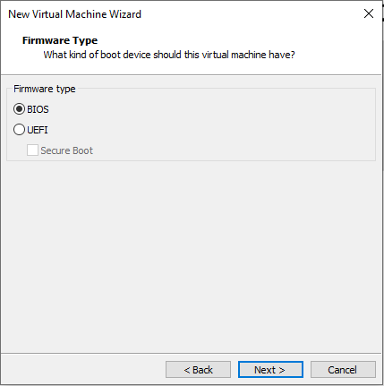

**Step 9:** Select the number of processors in processor configuration

*Here number of processors is given as 2*

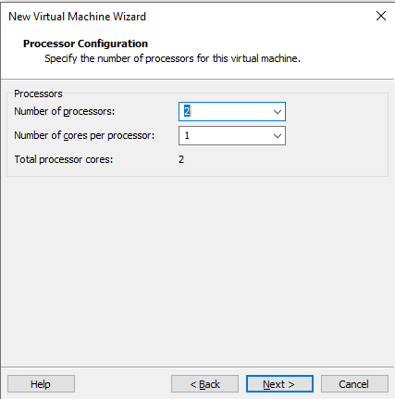

**Step 10:** Set memory size of VM to 4 GB

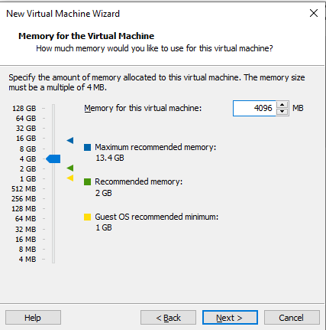

**Step 11:** Select NAT as network type

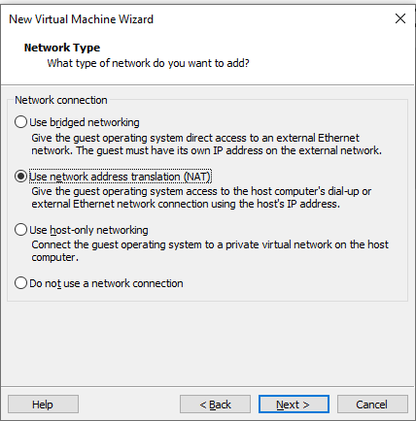

Step 12: in I/O controller types select default

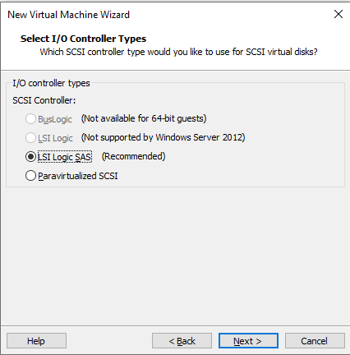

Step 13: select recommended disk type

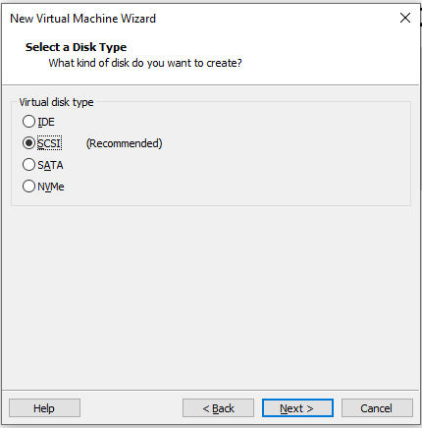

Step 14: in disk select create new virtual disk

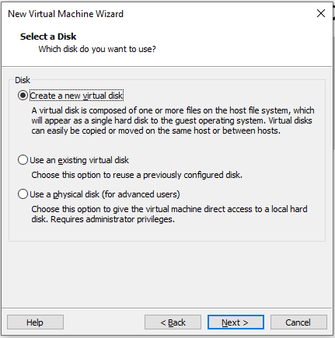

Step 15: in disk capacity give 60GB and store virtual disk as a single disk

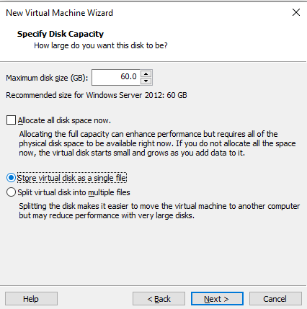

Step 16: store the windows server 2012 file in the same folder created before

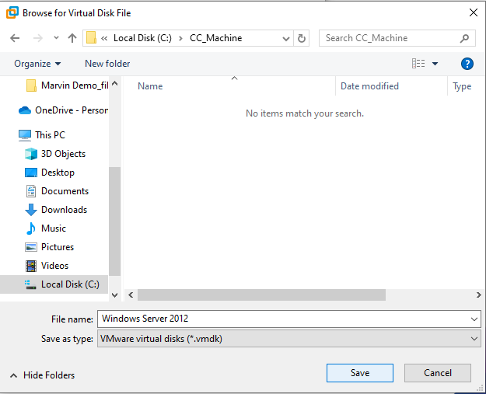

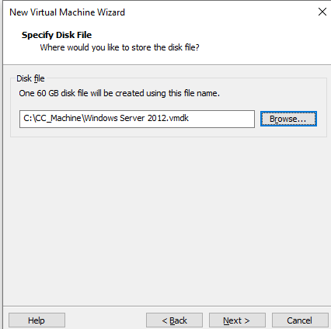

Step 17: view summary and confirm

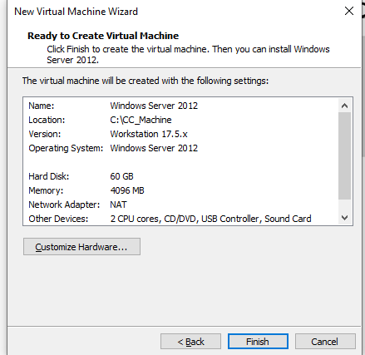

*Creation of successful windows virtual machine*

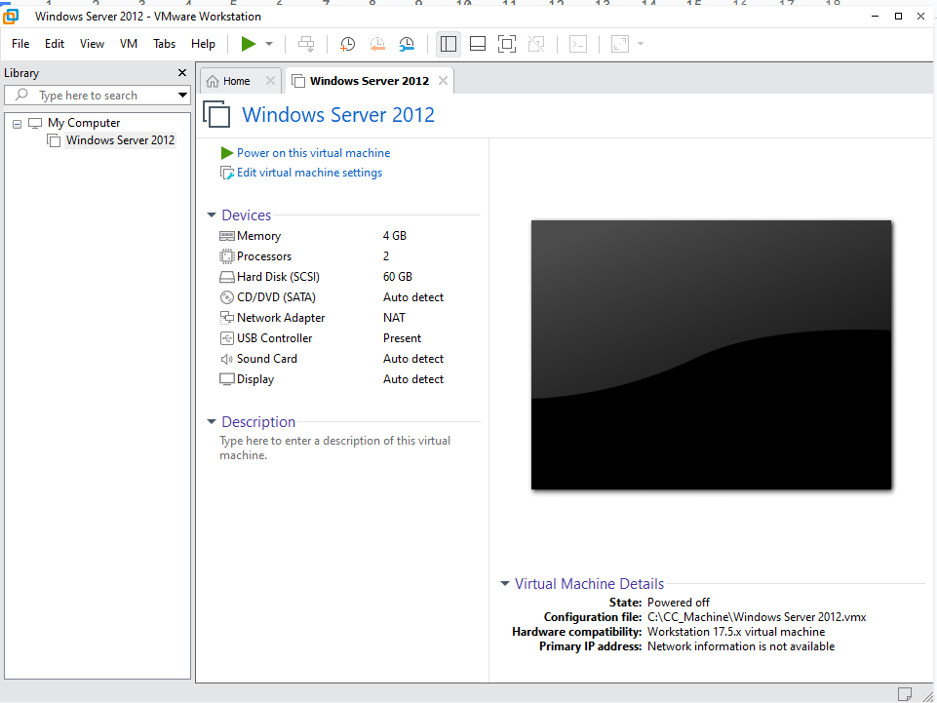

*Now we need to provide image file for the installation*

Step 18: select CD/DVD(SATA) to give image file

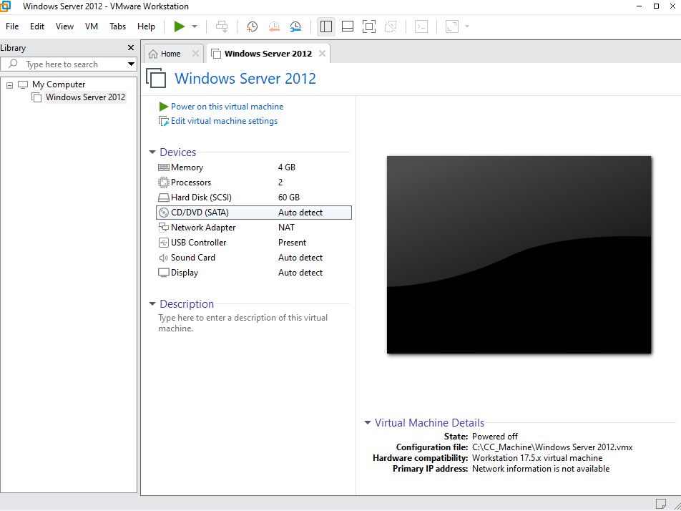

Step 19: give the ISO file path

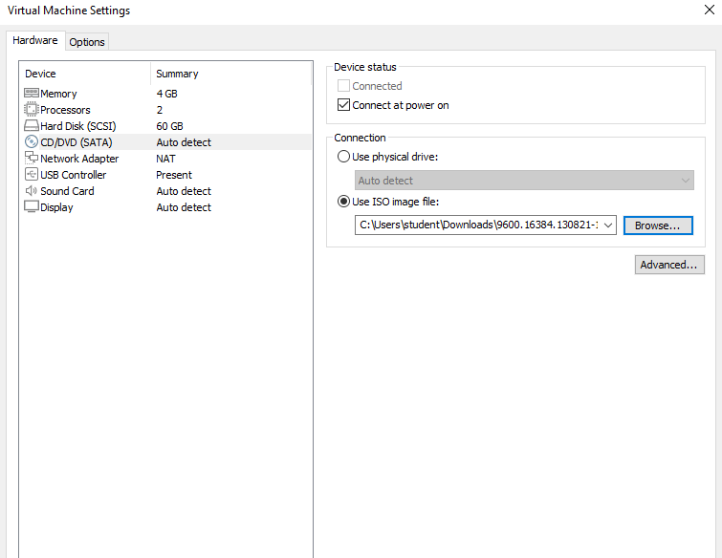

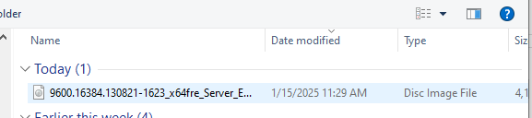

*Now the virtual machine is ready to start*

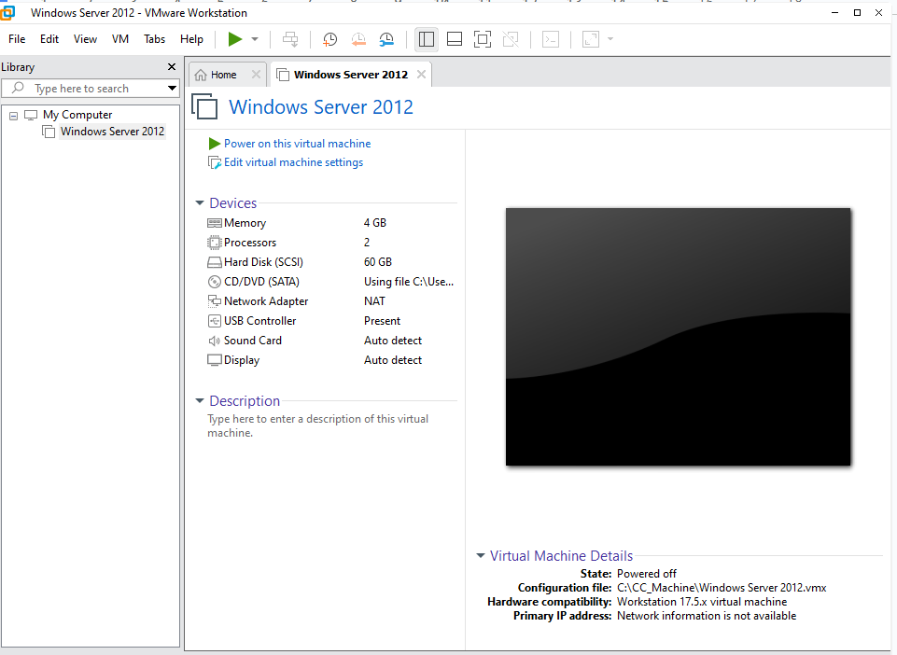

Step 20: click on power on machine

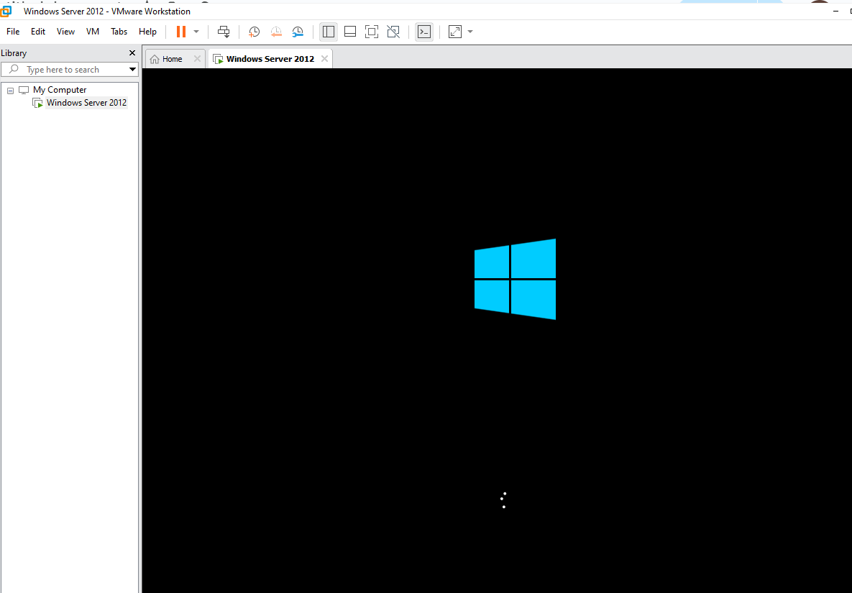

Step 21: click on install now 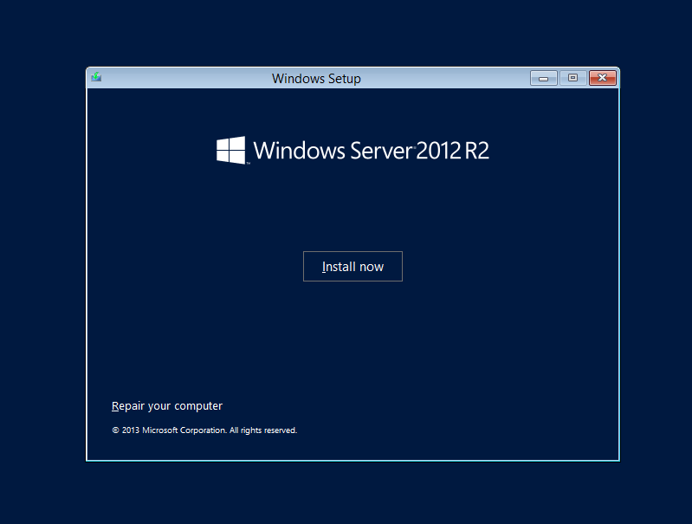

Step 22: give the product key

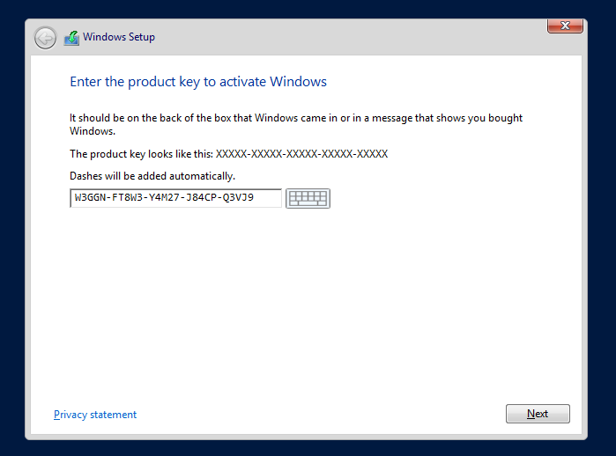

Step 23: select operating system with GUI

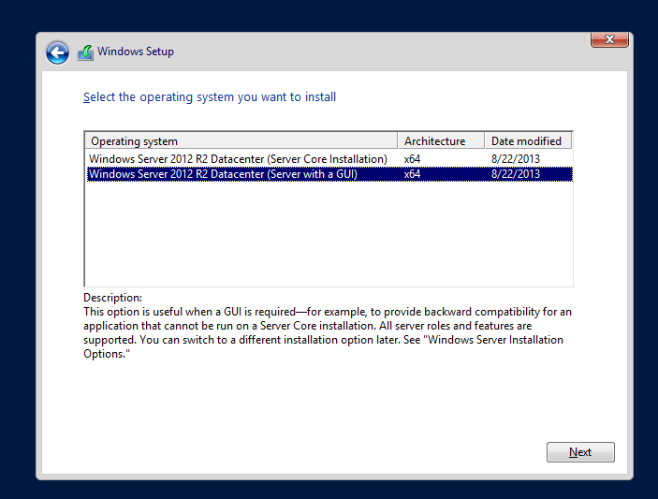

Step 24: accept the terms of licence and select custom: install windows only (advanced)

Step 25: select the disk space *here we have allocated the full space*

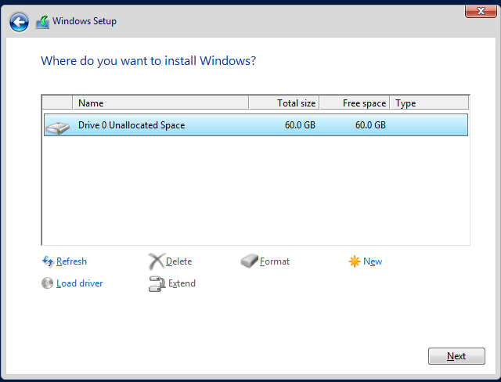

Step 26: now the installation process start

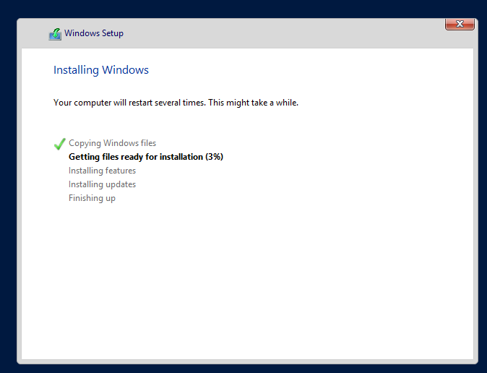

Step 27: now the machine shall restart

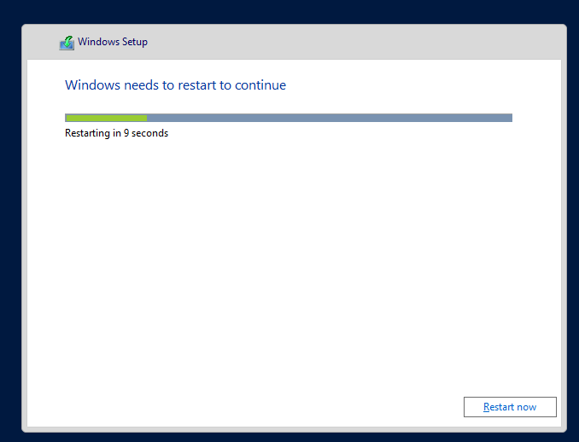

Step 28: set up the password

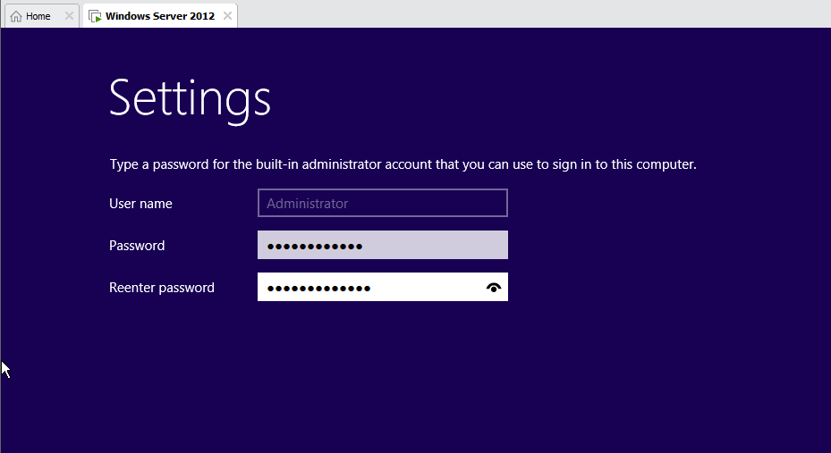

Step 29: now the windows shall start

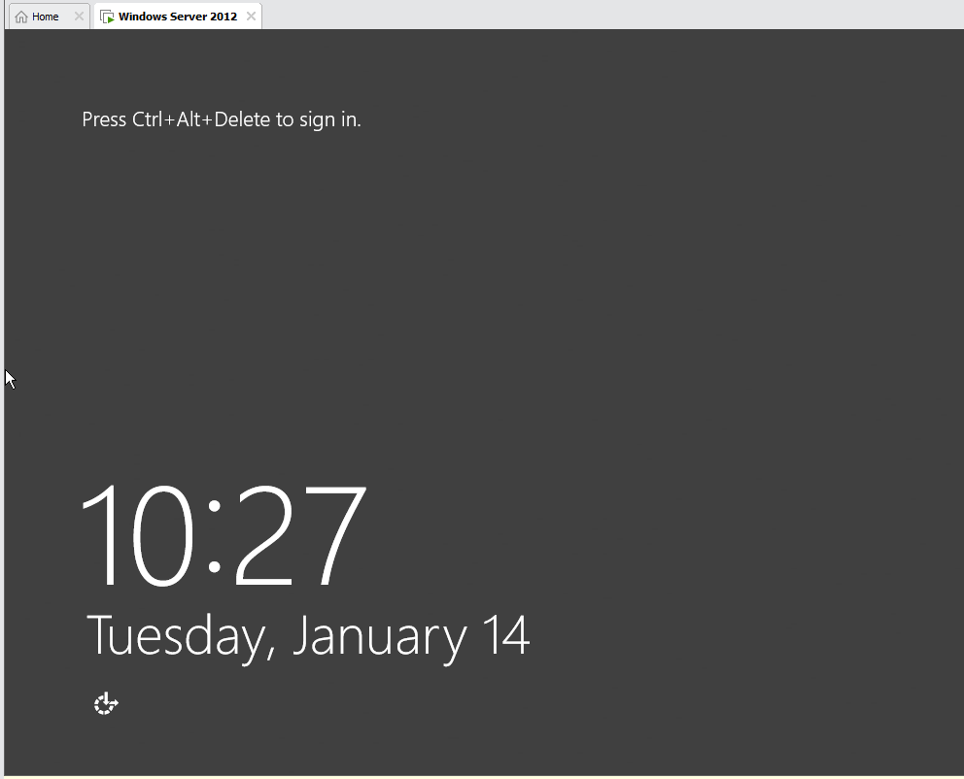

Step 30: now give the password and sign in

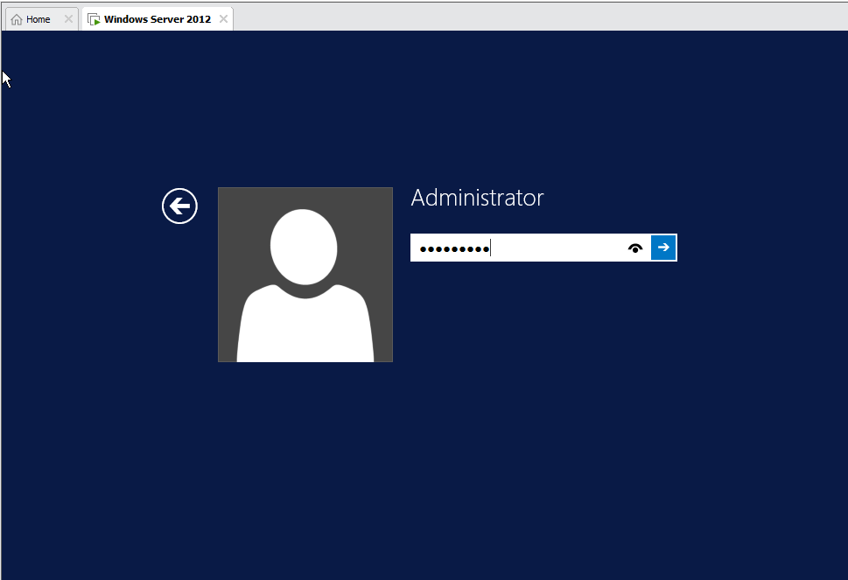

Step 31: server manager dashboard shall appear

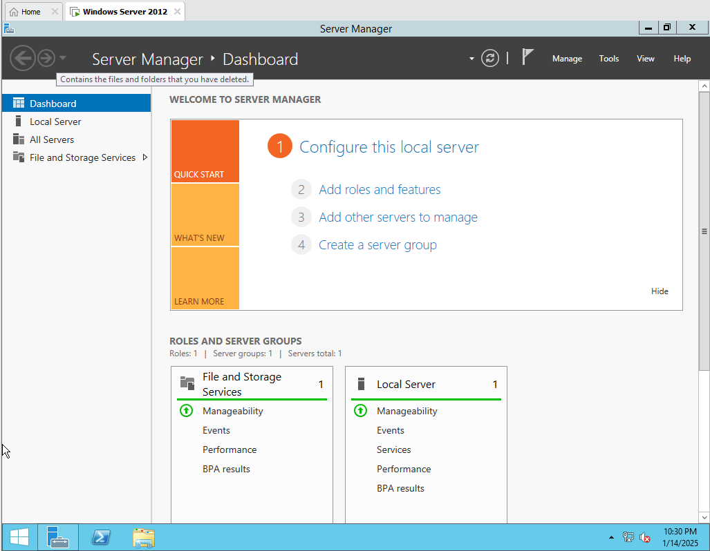

Step 32: change the computer name

*Go to local server→ click on computer name→*

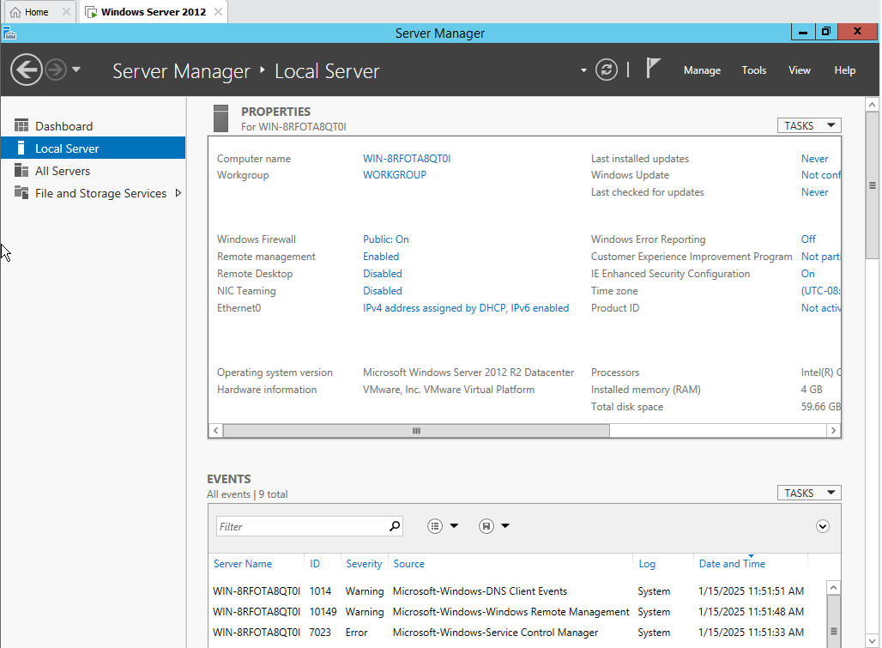

*Click on change:*

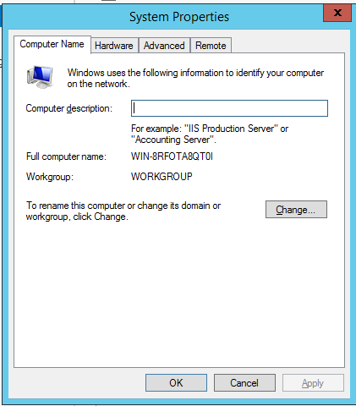

*Give name and click ok*

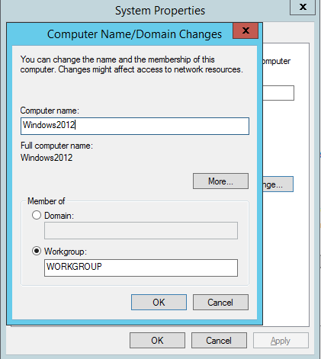

Step 33: to save the changes the restart shall be required

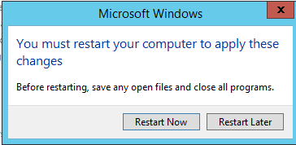

Step 34: give the password again after restart and log in into system

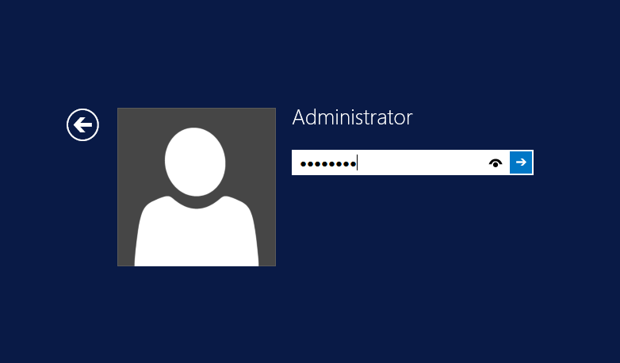

Step 35: now the windows name changed shall be seen

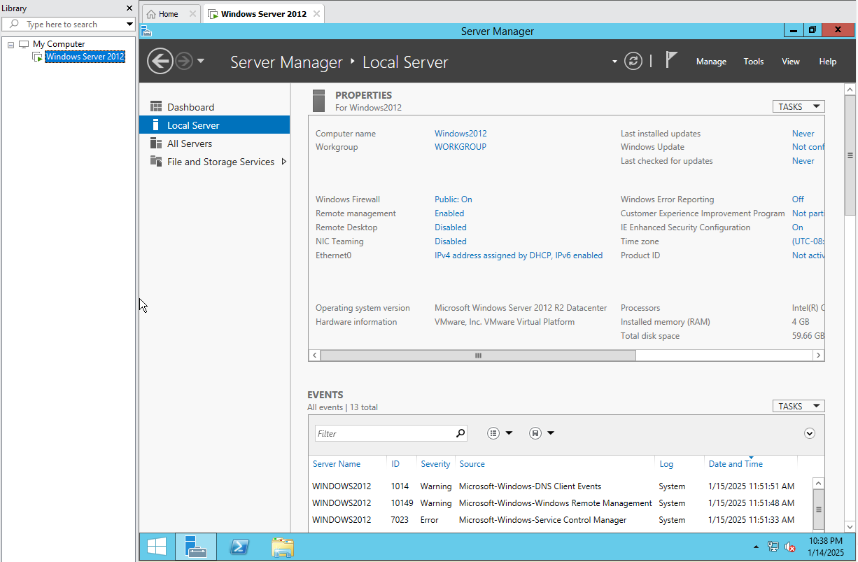

**INSTALLING HYPER V MANAGER**

Step 36: click on manage → add roles and features

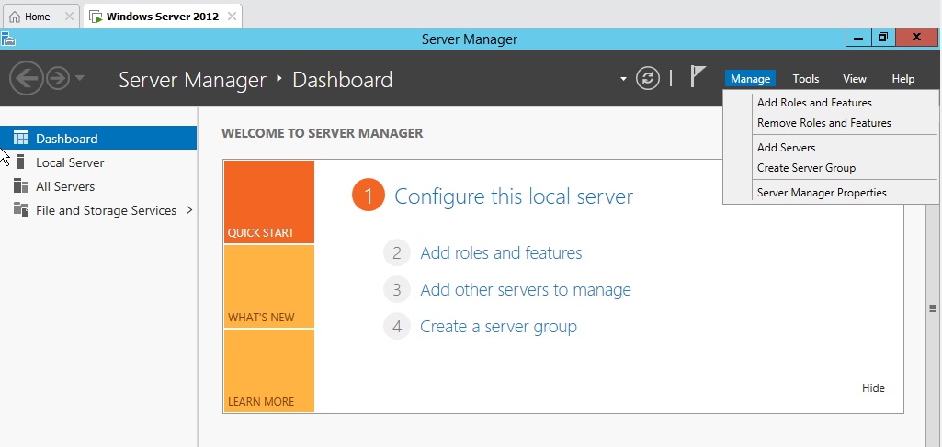

Step 37: the add roles and features wizard shall appear  
*Click next*

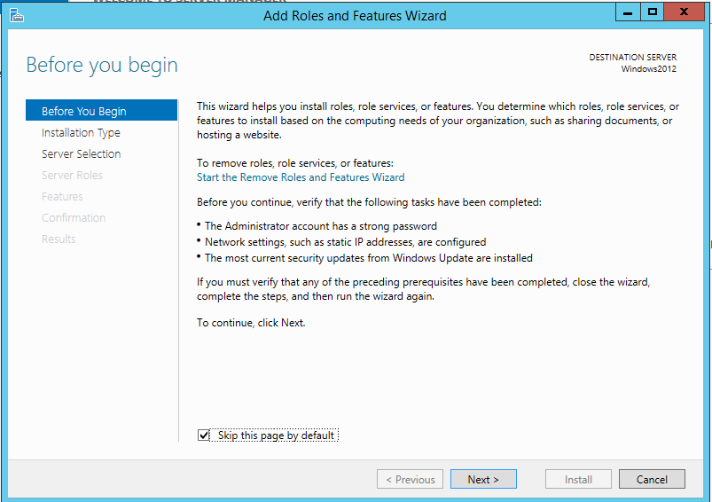

Step 38: for installation type select role-based or feature based installation and click next

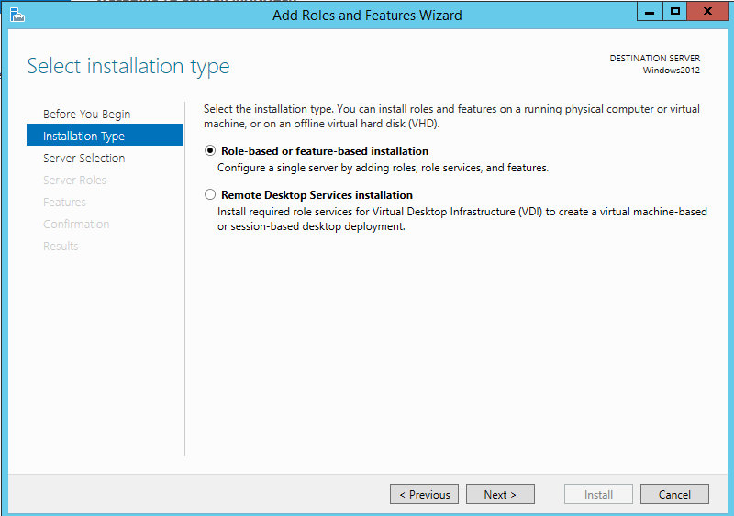

Step 39: select the server and click next

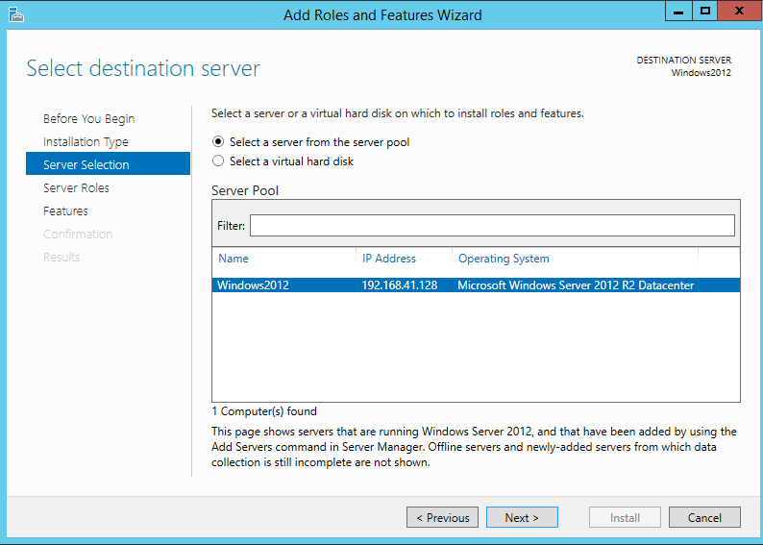

Step 40: in server roles select Hyper V

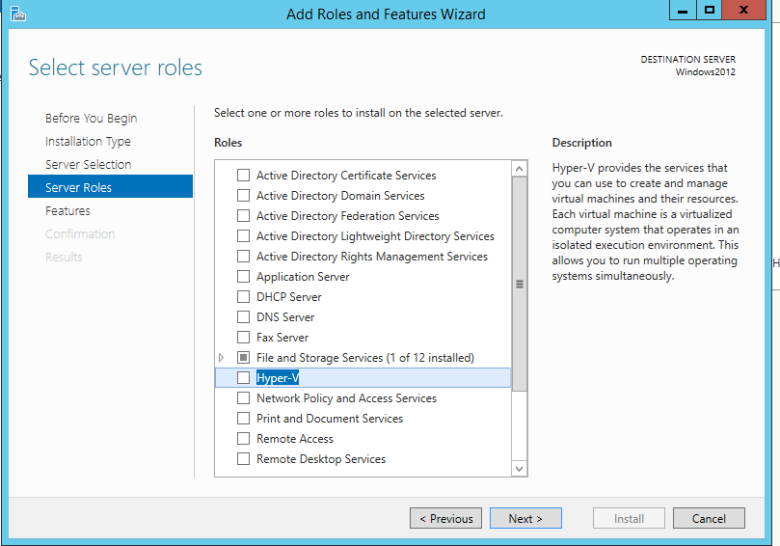

Step 41: add features

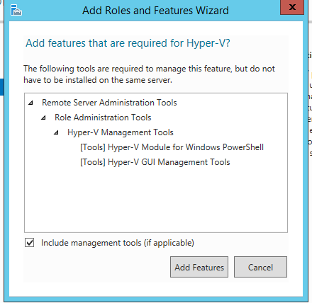

*Error of hyper visor already running, to handle this error follow the next steps*

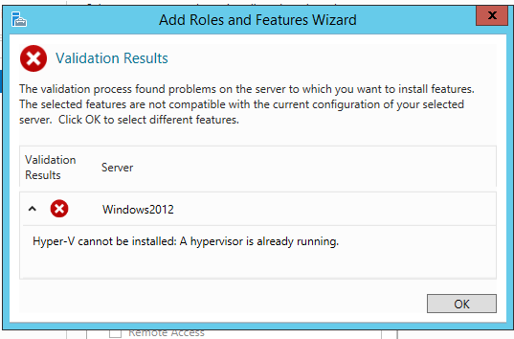

*Click ok and shut down the guest machine*

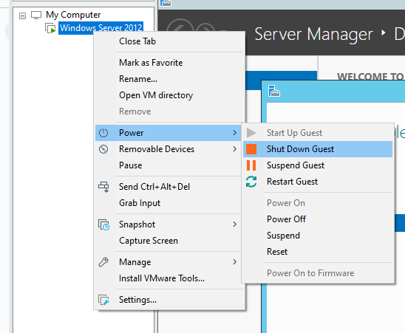

*Go to edit virtual machine settings*

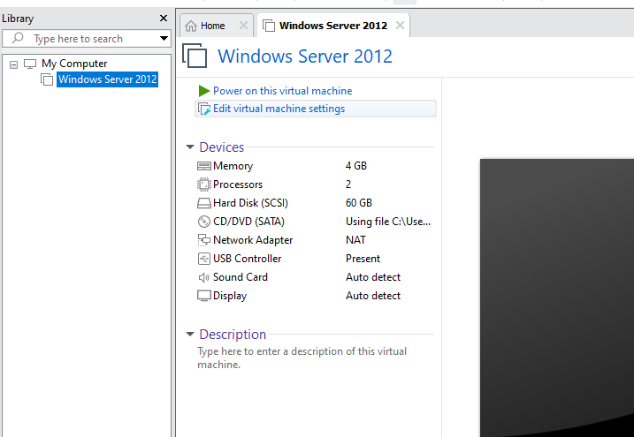

*In virtual machine settings go to the option’s tab*

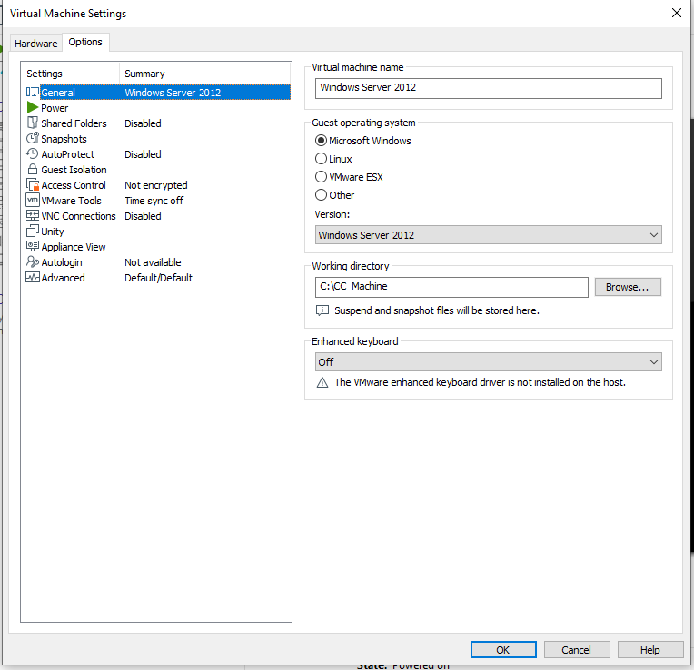

*In version select Hyper V (unsupported) and click OK*

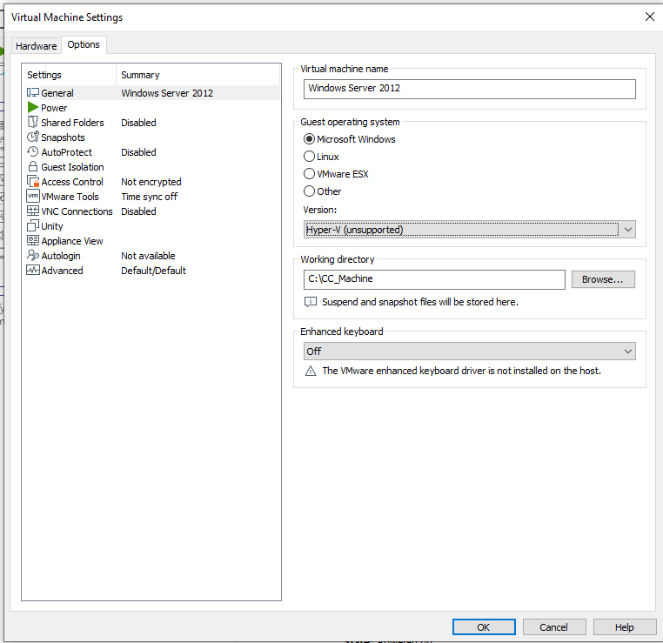

*Now we have successfully bypassed the hypervisor of VM ware workstation*

*Now power on the virtual machine and log in to server*

*Step 42: again select the add roles and features from the manage tab*

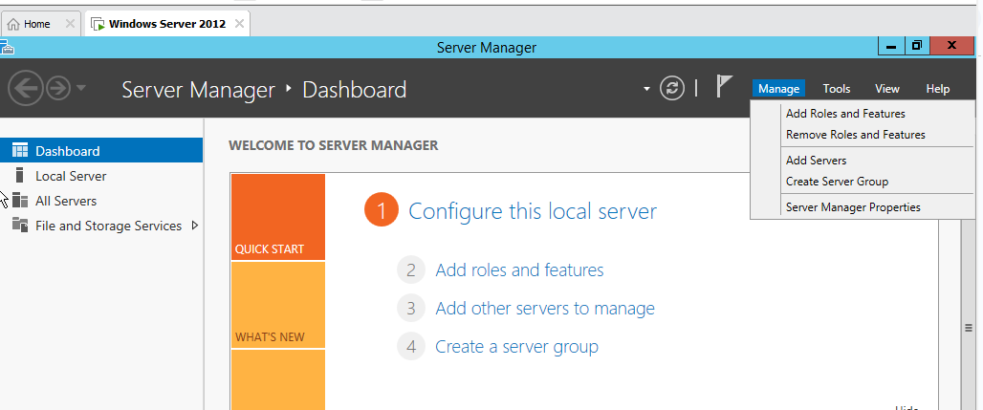

Step 43: repeat steps 38 to steps 41

*Hypervisor successfully added*

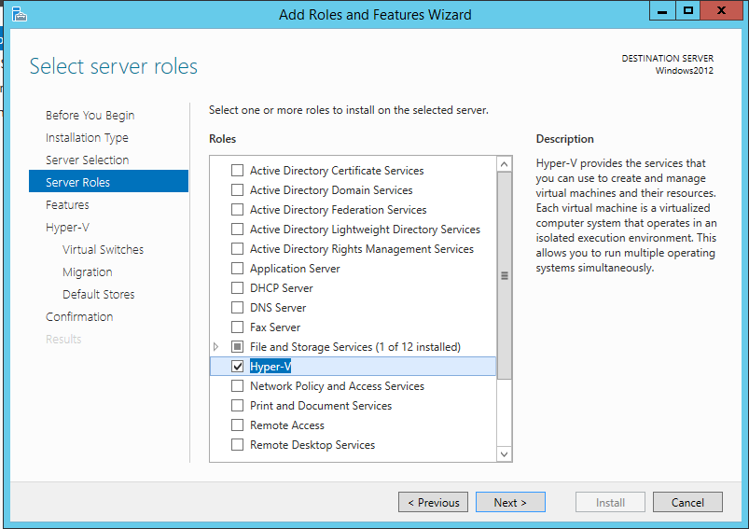

Step 44: in features select .Net Framework 3.5 Features

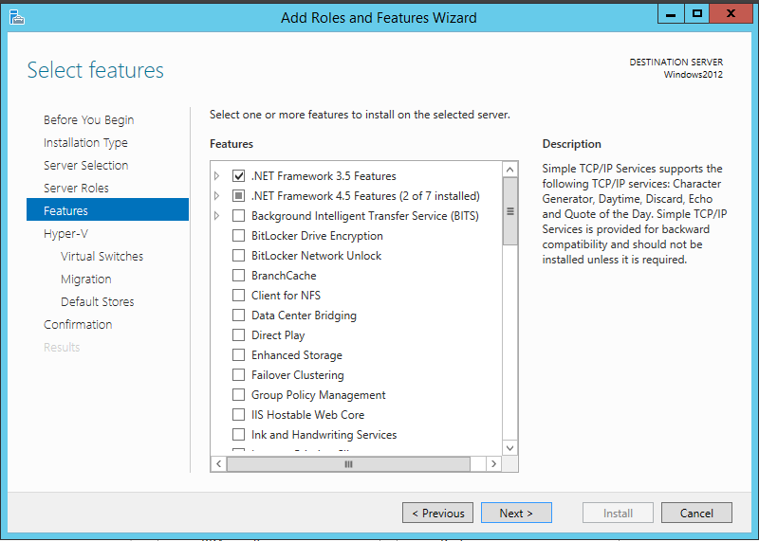

Step 45: click next

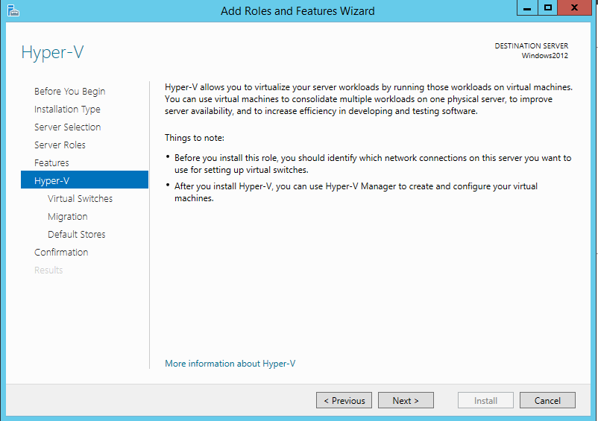

Step 46: select virtual switches → ethernet → next

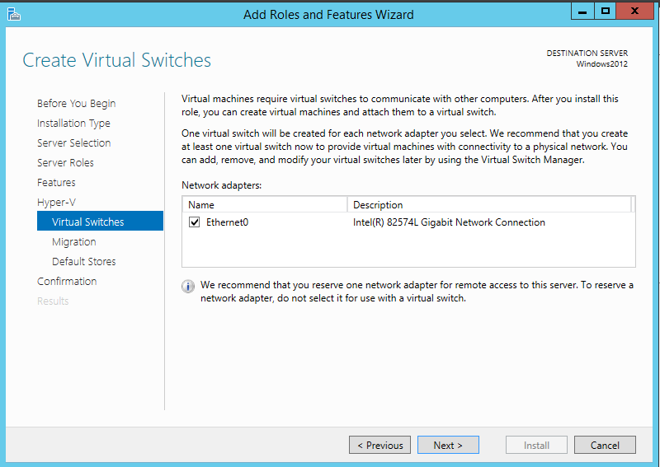

Step 47: in migration select *allow this server to send and receive live migrations of virtual machines* and click next

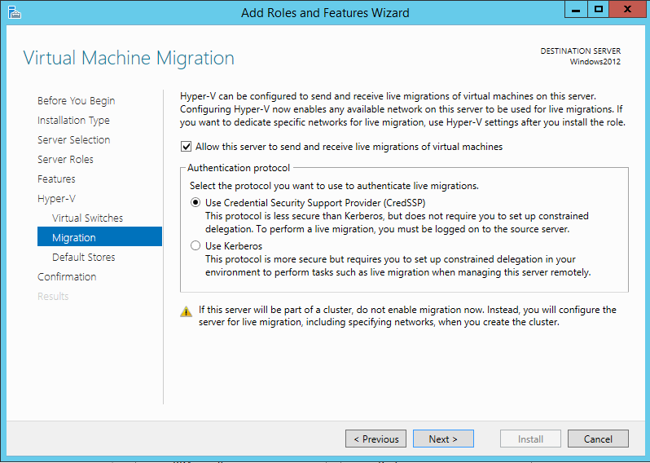

Step 48: the paths for virtual disk and virtual machine shall be displayed → click next

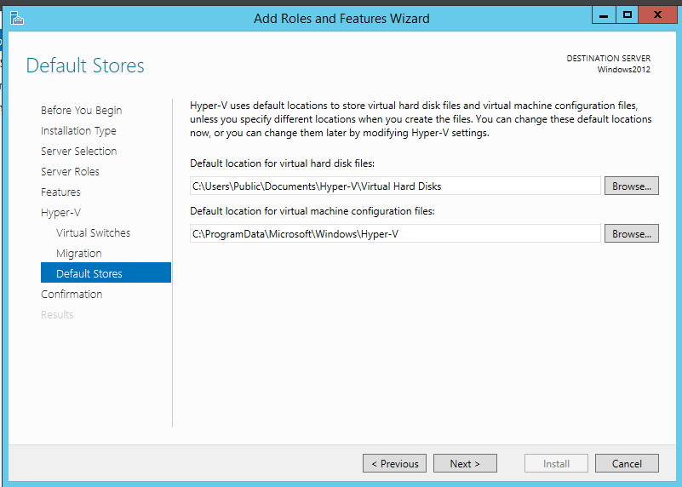

Step 49: click on install

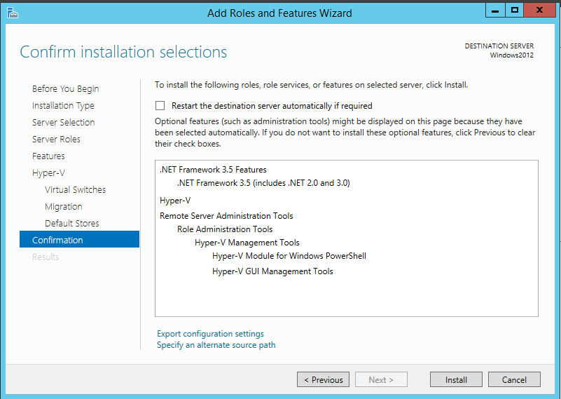

Step 50: on successful installation, a restart shall be required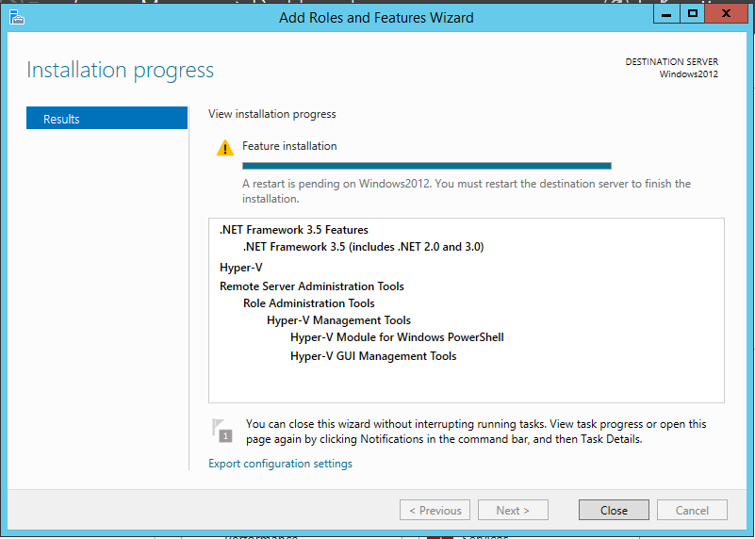

Step 51:restart the system and select planned as reason

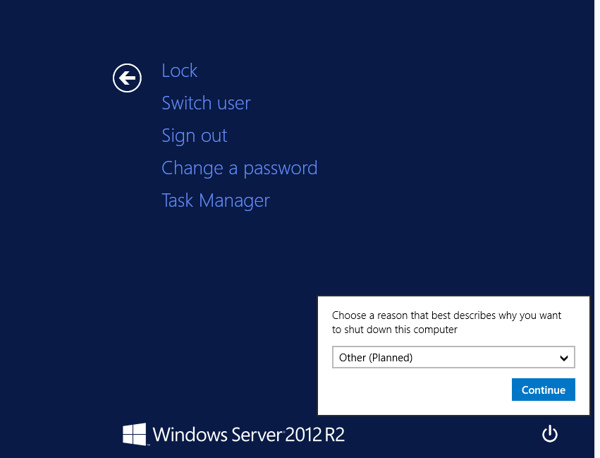

Step 52: login into system again and go to the tools tabs now hyper-V manager shall be visible and click on hyper-V manager

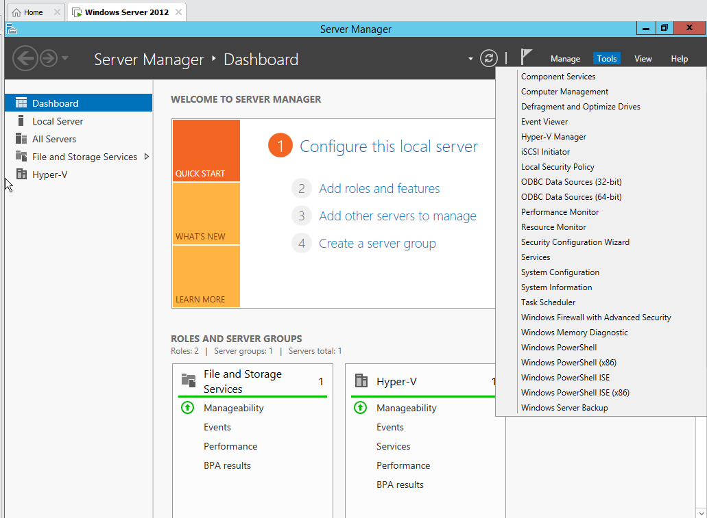

Step 53: virtual machine servers shall be visible  
*Currency their are no servers added*

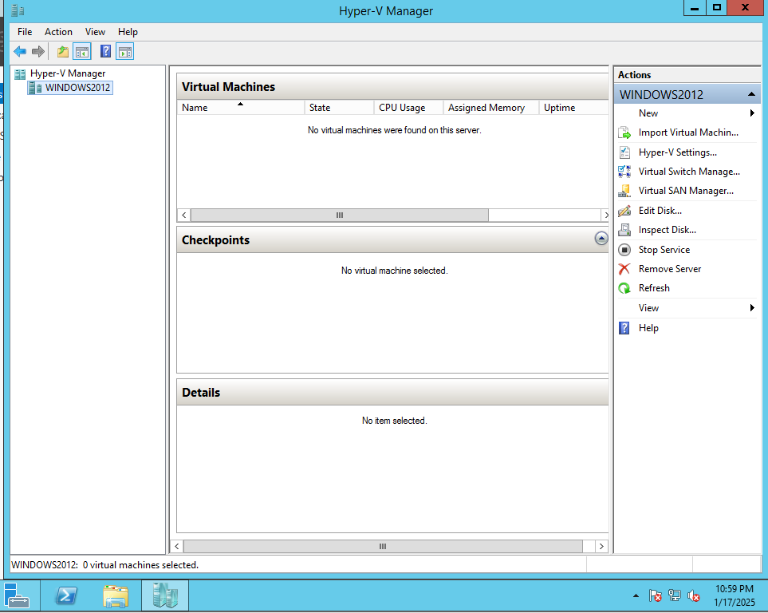

Step 54: now right click on server → new → select virtual machine

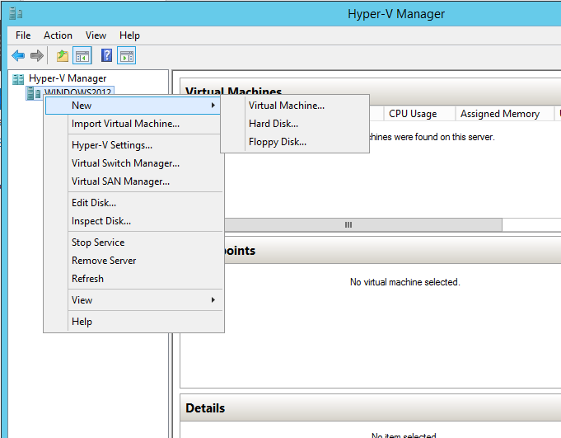

Step 55: click next

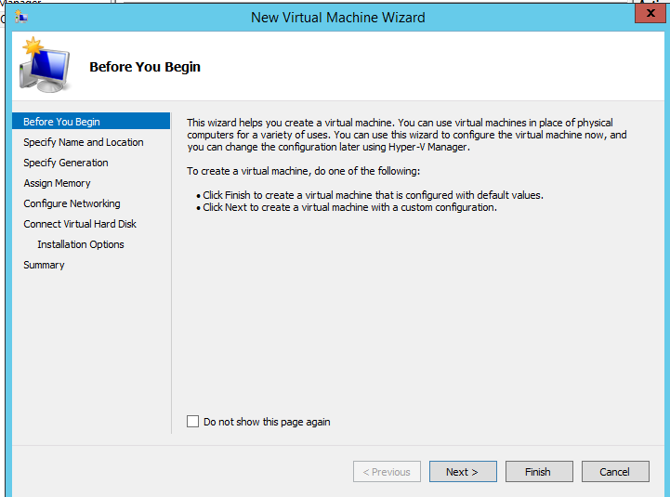

Step 56: give name to the machine

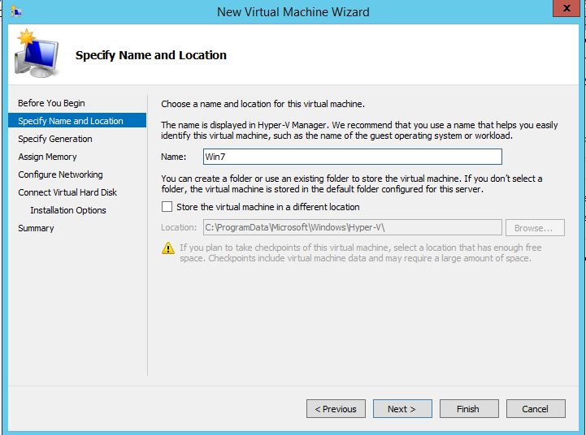

Step 57: select the generation of virtual machine

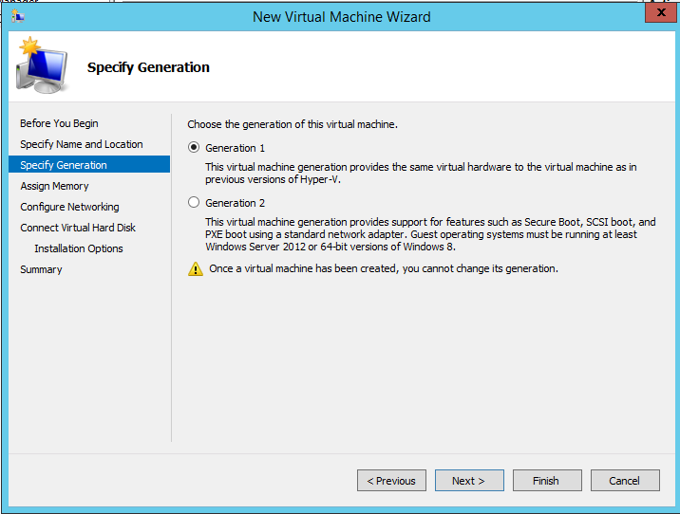

Step 58: assign memory

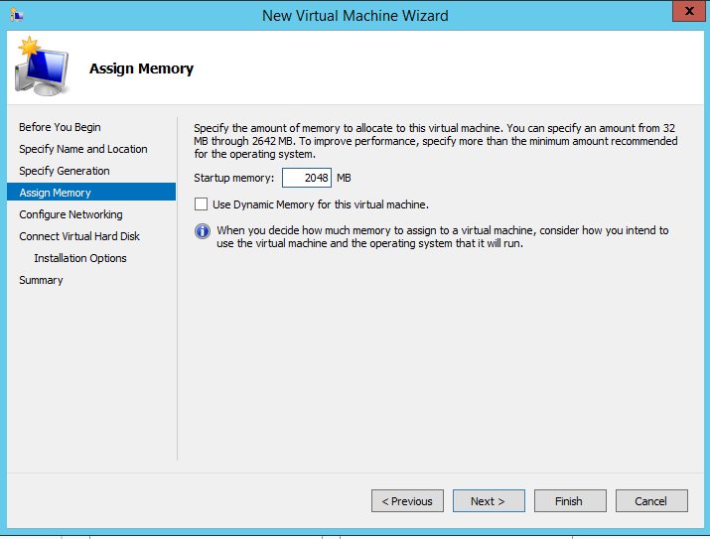

Step 59: Select the networking feature and click next

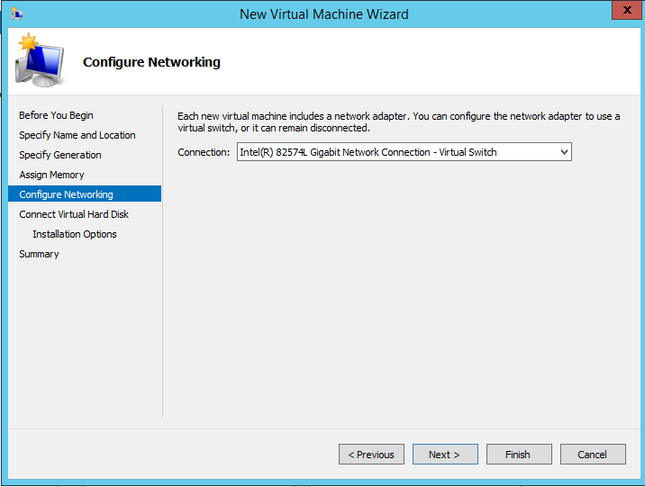

Step 60: enter the virtual disk association details  
*Give size less than 64 TB and also consider the size of base machine*

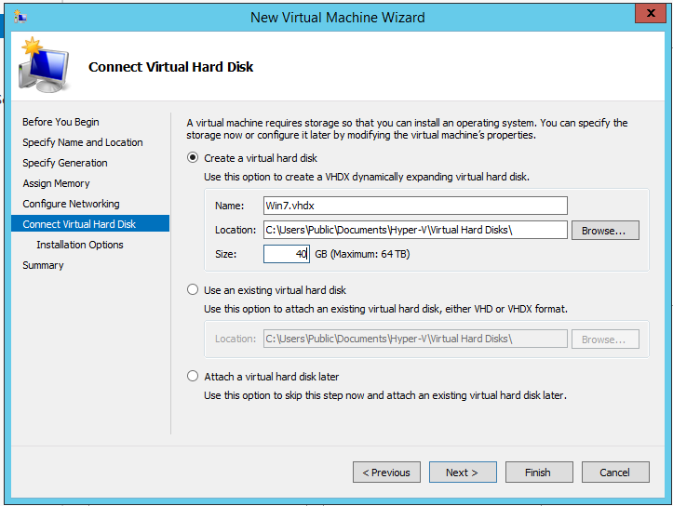

Step 61: select installation of operating system as install an operating system later and click next

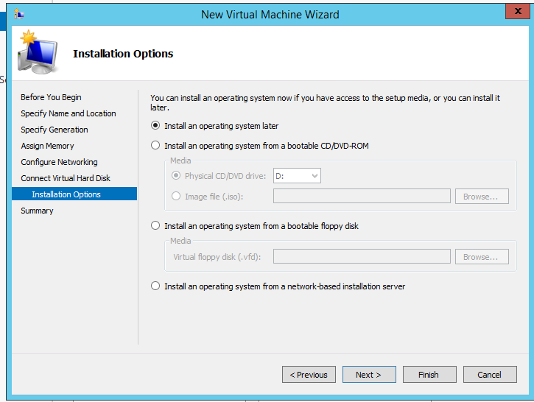

Step 62: on viewing summary click on finish to complete the process

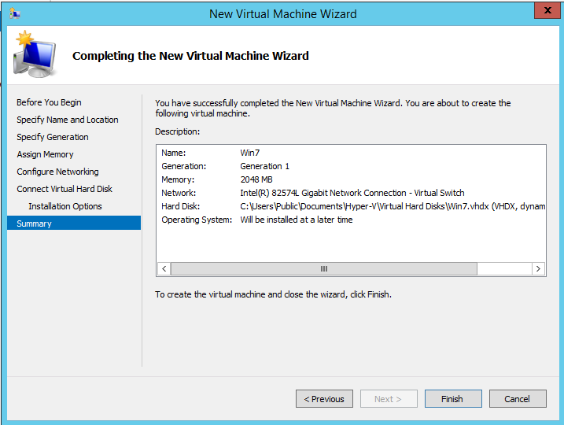

Step 63: now the created virtual machine shall appear on the Virtual machines panel. Now to assign the ISO file click on settings

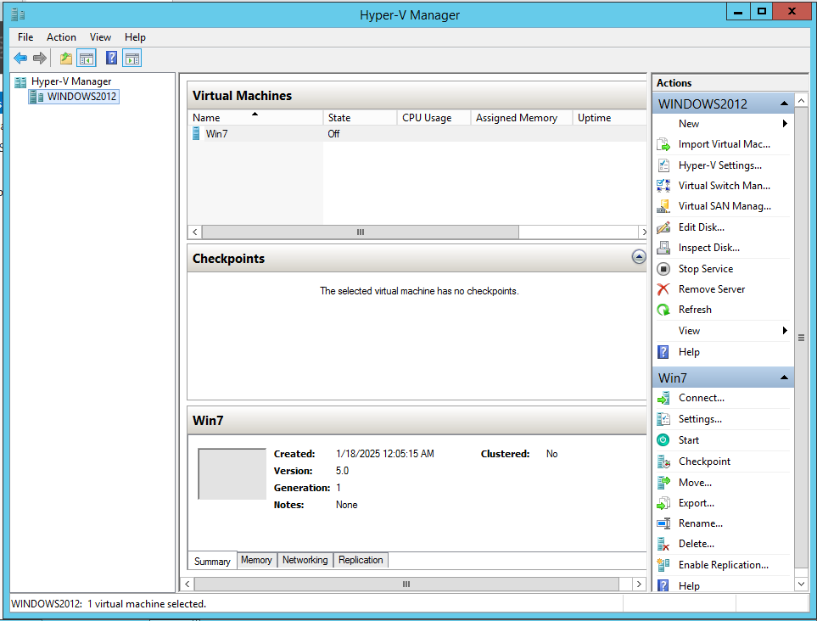

Step 64: click on IDE controller →DVD drive → give the path of the ISO file → click apply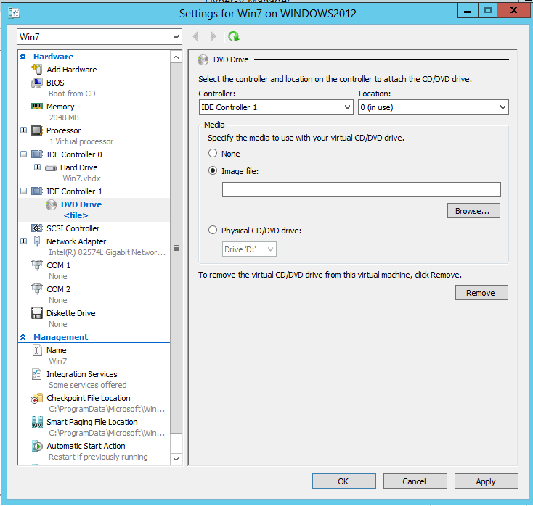

Step 65: from the virtual machine panel on the machine *i.e click on Win7 → click on connect*

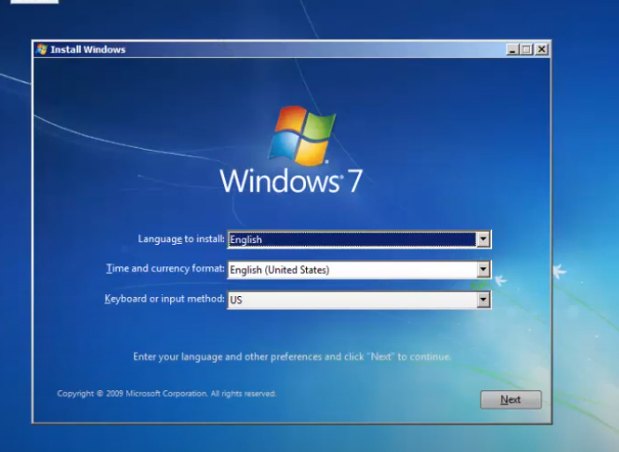

*The virtual machine shall start, complete the installation of win7. Thus the aim of installing a windows operating system on a hypervisor manager is achieved.*

Practical No. 4

Implementation of Remote Procedure Calls

**Q.1]** Implementation of Remote Procedure Calls

* RPC for simple calculator (Addition, Subtraction, Division, Multiplication)
* RPC for Math Functions (Square, Square Root, Cube, CubeRoot)
* RPC to find the factorial
* RPC to find the Fibonacci Series

**Code:**

import java.util.*;

import java.net.*;

class calculator_server {

DatagramSocket objDS;

DatagramPacket objDP;

String strInput, strMethodName, strResult;

int intVal1, intVal2;

double dVal1, dVal2;

calculator_server() {

try {

objDS = new DatagramSocket(1200);

byte b[] = new byte[4096];

while (true) {

objDP = new DatagramPacket(b, b.length);

objDS.receive(objDP);

String para1 = "0";

String para2 = "0";

strInput = new String(objDP.getData(), 0, objDP.getLength());

if (strInput.equalsIgnoreCase("q")) {

System.exit(1);

} else {

StringTokenizer st = new StringTokenizer(strInput, " ");

int i = 0;

while (st.hasMoreTokens()) {

String token = st.nextToken();

strMethodName = token;

para1 = st.nextToken();

if (st.hasMoreTokens()) {

para2 = st.nextToken();

}

intVal1 = Integer.parseInt(para1);

intVal2 = Integer.parseInt(para2);

dVal1 = Double.parseDouble(para1);

dVal2 = Double.parseDouble(para2);

}

}

System.out.println(strInput);

InetAddress ia = InetAddress.getLocalHost();

if (strMethodName.equalsIgnoreCase("add")) {

strResult = "" + add(intVal1, intVal2);

} else if (strMethodName.equalsIgnoreCase("sub")) {

strResult = "" + sub(intVal1, intVal2);

} else if (strMethodName.equalsIgnoreCase("mul")) {

strResult = "" + mul(intVal1, intVal2);

} else if (strMethodName.equalsIgnoreCase("div")) {

strResult = "" + div(intVal1, intVal2);

} else if (strMethodName.equalsIgnoreCase("square")) {

strResult = "" + square(dVal1);

} else if (strMethodName.equalsIgnoreCase("sqRoot")) {

strResult = "" + squareRoot(dVal1);

} else if (strMethodName.equalsIgnoreCase("cube")) {

strResult = "" + cube(dVal1);

} else if (strMethodName.equalsIgnoreCase("cubeRoot")) {

strResult = "" + cubeRoot(dVal1);

} else if (strMethodName.equalsIgnoreCase("facto")) {

strResult = "" + factorial(intVal1);

} else if (strMethodName.equalsIgnoreCase("fibonacci")) {

strResult = "" + fibonacciSeries(intVal1);

}

byte b1[] = strResult.getBytes();

try (DatagramSocket objDS1 = new DatagramSocket()) {

DatagramPacket objDP1 = new DatagramPacket(b1, b1.length, InetAddress.getLocalHost(), 1300);

System.out.println("Result : " + strResult + "\n");

objDS1.send(objDP1);

}

}

} catch (Exception e) {

e.printStackTrace();

}

}

public int add(int val1, int val2) {

return val1 + val2;

}

public int sub(int val3, int val4) {

return val3 - val4;

}

public int mul(int val3, int val4) {

return val3 * val4;

}

public int div(int val3, int val4) {

return val3 / val4;

}

public double square(double num) {

return num * num;

}

public double squareRoot(double num) {

return Math.sqrt(num);

}

public double cube(double num) {

return num * num * num;

}

public double cubeRoot(double num) {

return Math.cbrt(num);

}

public long factorial(int num) {

long result = 1;

for (int i = 1; i <= num; i++) {

result *= i;

}

return result;

}

public String fibonacciSeries(int n) {

if (n <= 0) {

return "Input must be a positive integer";

}

StringBuilder fibSeries = new StringBuilder();

long a = 0, b = 1;

for (int i = 0; i < n; i++) {

fibSeries.append(a).append(" ");

long next = a + b;

a = b;

b = next;

}

return fibSeries.toString().trim();

}

public static void main(String[] args) {

new calculator_server();

}

}

**Output:**

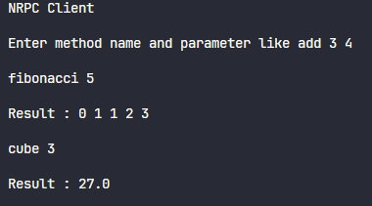

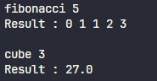

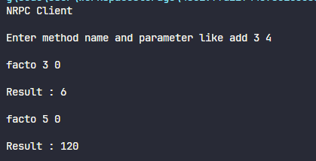

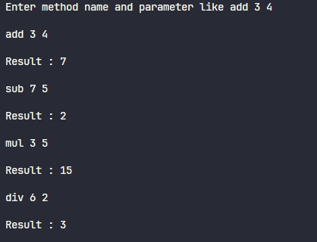

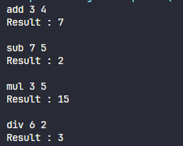

Practical No. 5

Implementation of Remote Method Invocation

**Q.1]** Implementation of Remote Method Invocation for:

* Displaying Date & Time from the server
* Convert the given digits to words - accept 123 and display One Two Three
* Fibonacci Series
* Factorial

**Code:**

**[DateTimeClient.java]:**

import java.net.*;

import java.rmi.*;

import java.io.*;

import java.util.*;

public class DateTimeClient {

public static void main(String args[]) {

DateTimeInterface DTI;

System.out.println("Hello!");

try {

DTI = (DateTimeInterface) Naming.lookup("//127.0.0.1:1099/DateTime");

String Ans = DTI.getTime();

System.out.println("Current Date & Time is - " + Ans);

String in = "";

Scanner myObj = new Scanner(System.in);

while (true) {

System.out.print("Enter function to perform (facto,convert,fibo): ");

in = myObj.nextLine();

String result = "";

if (in.equals("facto")) {

System.out.print("Enter input: ");

String para = myObj.nextLine();

result = Long.toString(DTI.factorial(Integer.parseInt(para)));

System.out.println("Result: " + result);

} else if (in.equals("convert")) {

System.out.print("Enter input: ");

String para = myObj.nextLine();

result = DTI.convertDigitsToWords(para);

System.out.println("Result: " + result);

} else if (in.equals("fibo")) {

System.out.print("Enter input: ");

String para = myObj.nextLine();

result = DTI.fibonacciSeries(Integer.parseInt(para));

System.out.println("Result: " + result);

} else if (in.equals("q")) {

break;

}

System.out.println("\n");

}

System.out.println();

} catch (Exception e) {

e.printStackTrace();

}

}

}

**[DateTimeImple]:**

import java.net.*;

import java.rmi.*;

import java.rmi.server.*;

import java.util.*;

public class DateTimeImpl extends UnicastRemoteObject implements DateTimeInterface {

public DateTimeImpl() throws RemoteException {

}

public String getTime() {

String Reply = "";

try {

Date CurrentDT = new Date();

Reply = CurrentDT.toString();

} catch (Exception e) {

System.out.println("Error is :" + e.toString());

}

return Reply;

}

public String convertDigitsToWords(String input) {

String[] digitWords = {

"zero", "one", "two", "three", "four",

"five", "six", "seven", "eight", "nine"

};

StringBuilder result = new StringBuilder();

for (char ch : input.toCharArray()) {

if (Character.isDigit(ch)) {

int digit = Character.getNumericValue(ch);

result.append(digitWords[digit]).append(" ");

} else {

result.append(ch);

}

}

return result.toString().trim();

}

public long factorial(int num) {

long result = 1;

for (int i = 1; i <= num; i++) {

result *= i;

}

return result;

}

public String fibonacciSeries(int n) {

if (n <= 0) {

return "Input must be a positive integer";

}

StringBuilder fibSeries = new StringBuilder();

long a = 0, b = 1;

for (int i = 0; i < n; i++) {

fibSeries.append(a).append(" ");

long next = a + b;

a = b;

b = next;

}

return fibSeries.toString().trim();

}

}

**[DateTimeInterface]:**

import java.net.*;

import java.rmi.*;

interface DateTimeInterface extends Remote {

public String getTime() throws RemoteException;

public String convertDigitsToWords(String input) throws RemoteException;

public long factorial(int num) throws RemoteException;

public String fibonacciSeries(int n) throws RemoteException;

}

**[DateTimerServer]:**

import java.net.*;

import java.rmi.*;

import java.rmi.server.*;

import java.rmi.registry.Registry;

public class DateTimeServer {

public static void main(String args[]) {

try {

Registry r = java.rmi.registry.LocateRegistry.createRegistry(1099);

DateTimeImpl objDateTime = new DateTimeImpl();

Naming.rebind("DateTime", objDateTime);

System.out.println("Object is loaded in repository");

} catch (Exception e) {

e.printStackTrace();

}

}

}

**Output:**

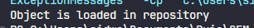

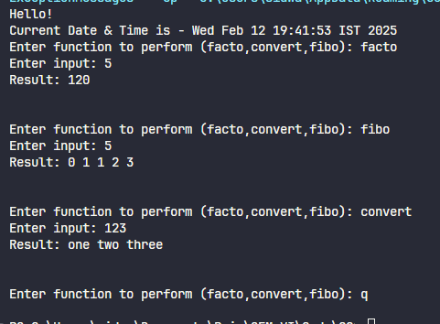

Practical No. 6

Hadoop

**Q.1]** Implementing Hadoop & Map Reduce Using Cloudera.

**Steps:**

1. Download and extract cloudera VM files



1. Open Oracle VirtualBox
2. Select File > Import Appliance

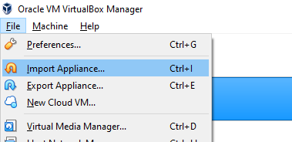

1. Select the downloaded cloudera VM

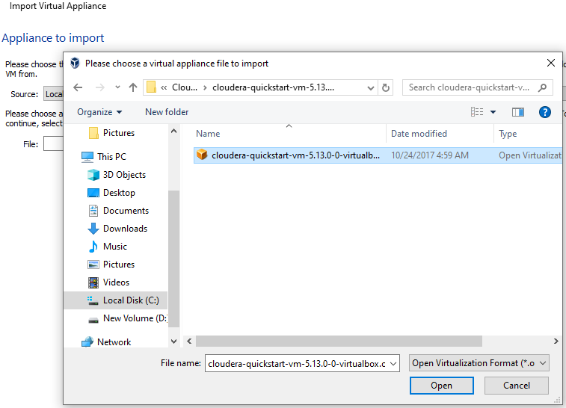

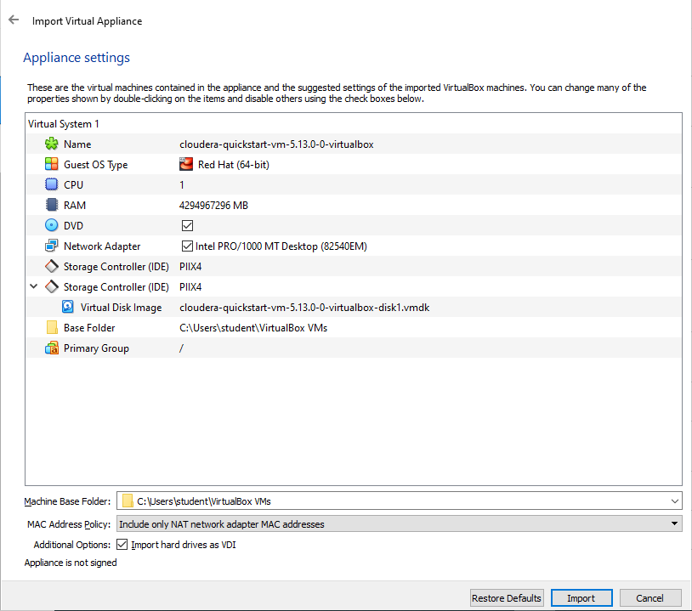

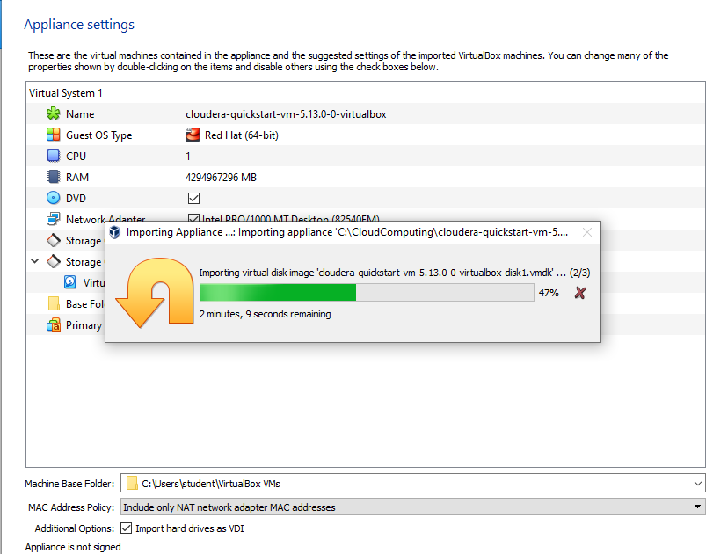

1. Set RAM as 8GB

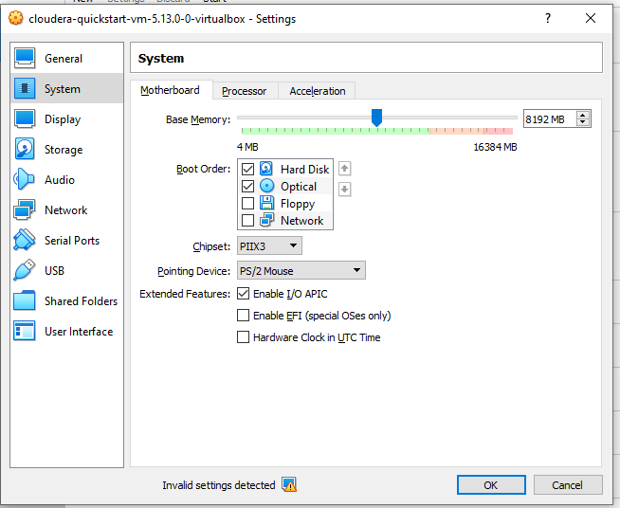

1. Set CPU count to 2

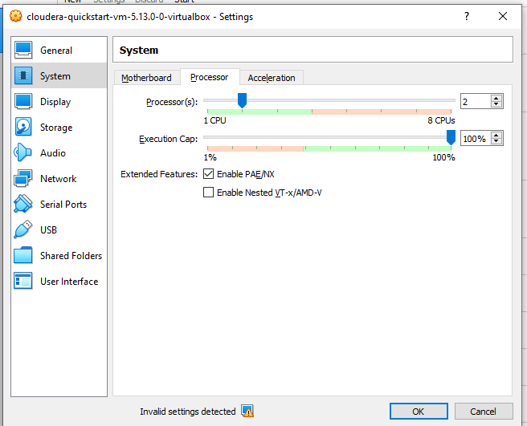

1. Start the VM

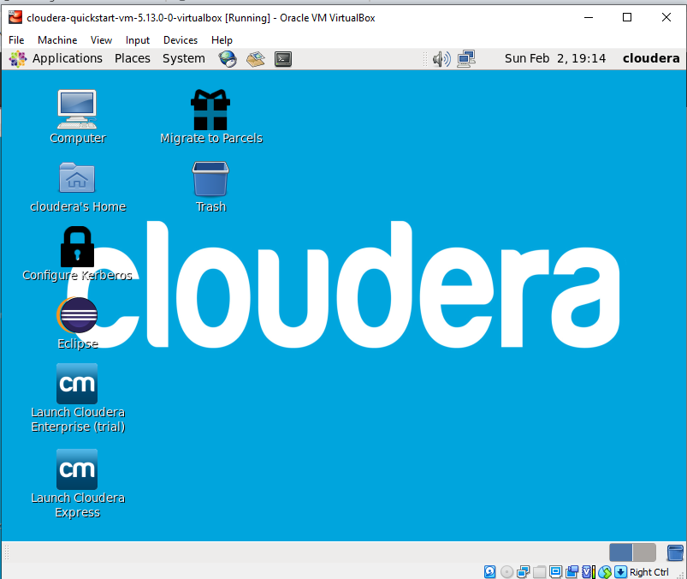

1. Start Eclipse

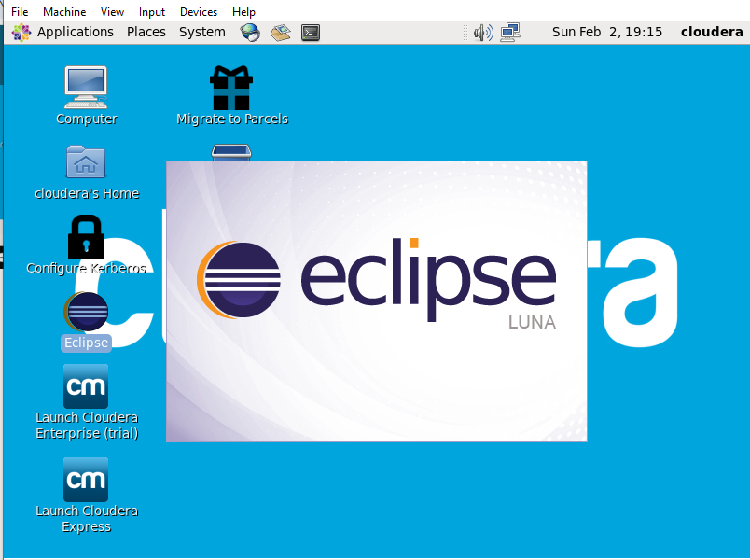

1. Click File > New > Java Project

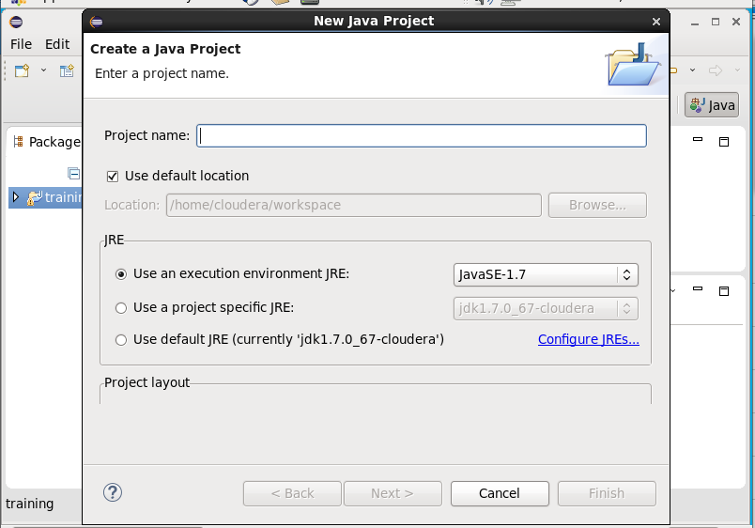

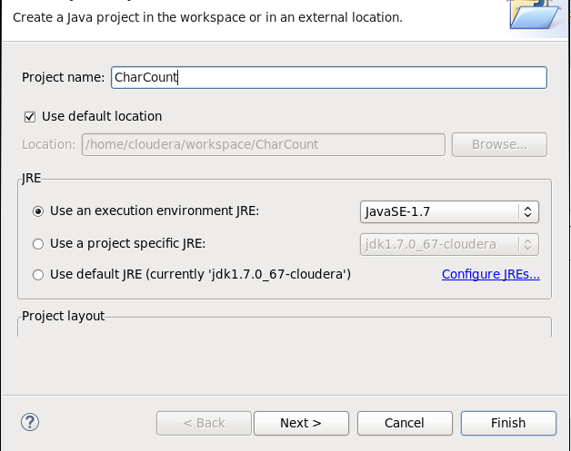

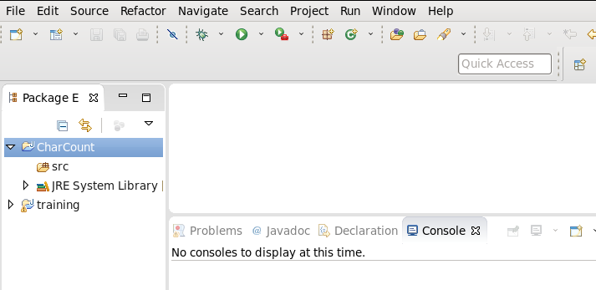

1. Right click project > Build Path > Configure Build Path

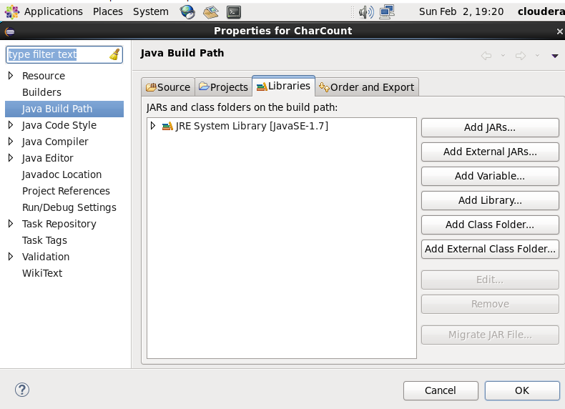

1. Click Add External JARS, go the following file location: File System > usr > lib and select the following JARs files

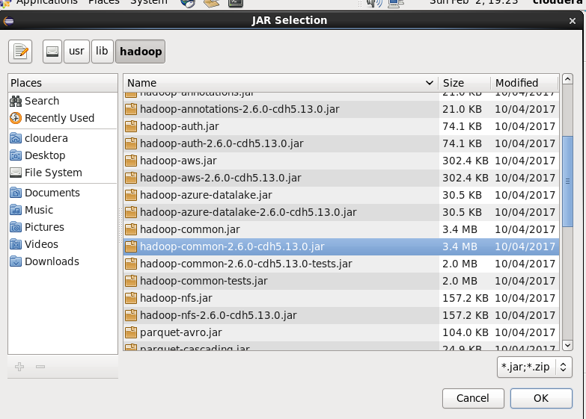

**IMPORTANT:** location is different here

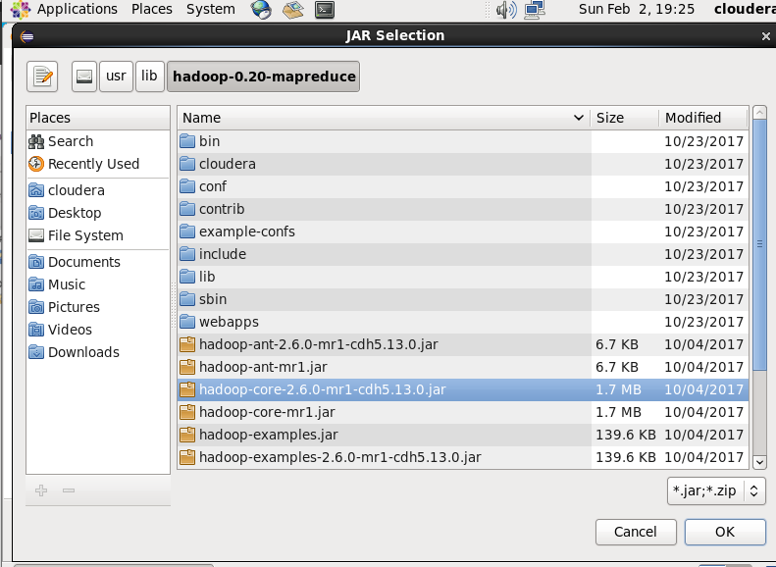

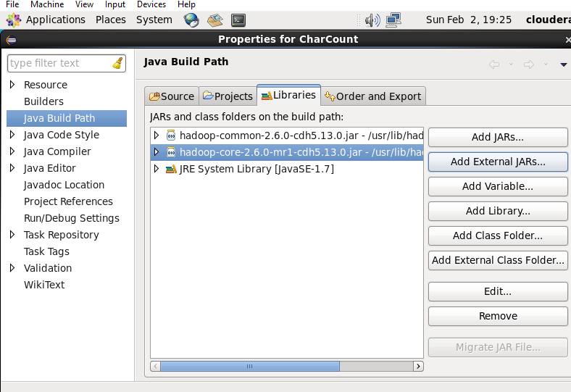

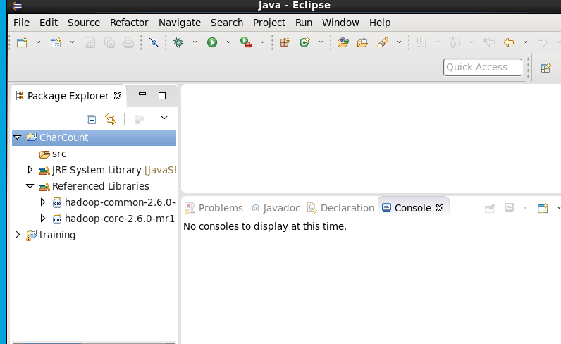

1. Right click src > New > Package

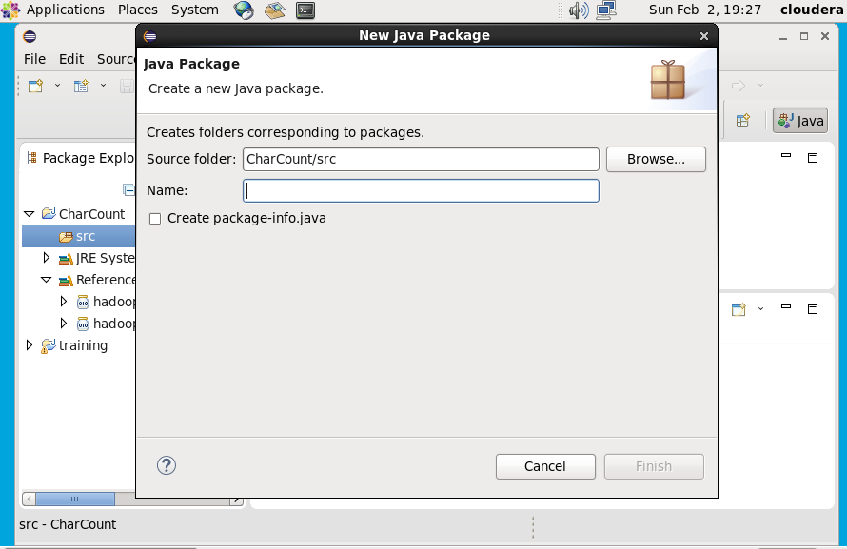

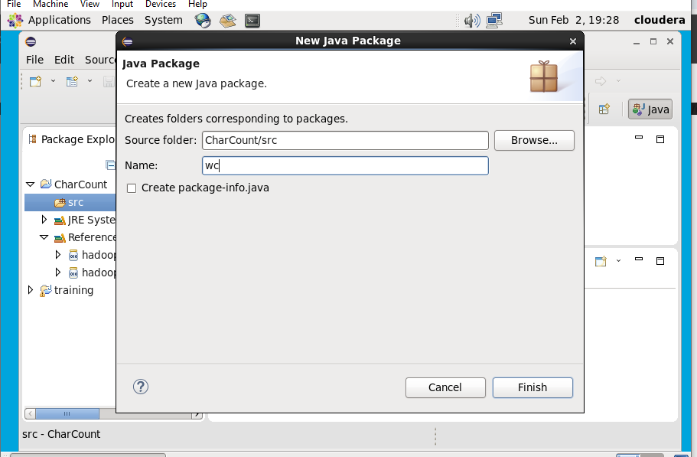

1. Right click package > New > Class

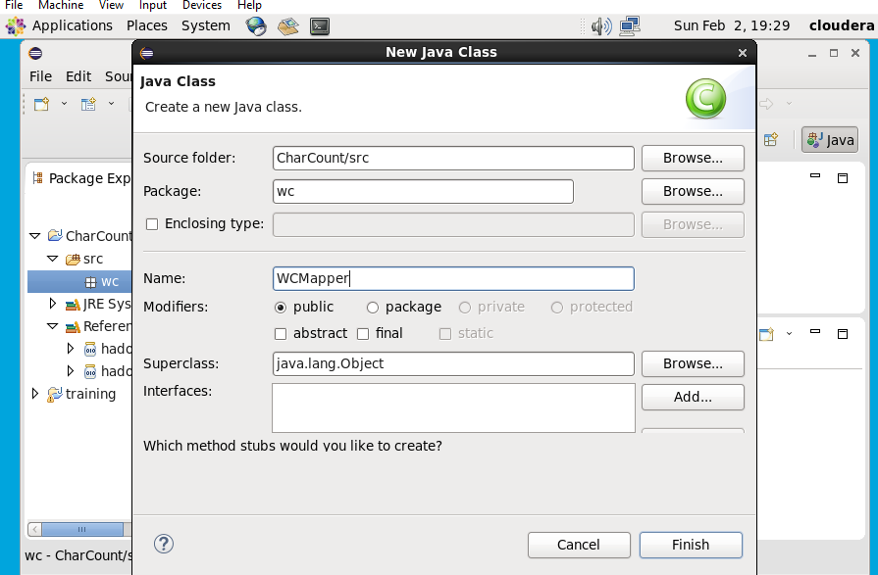

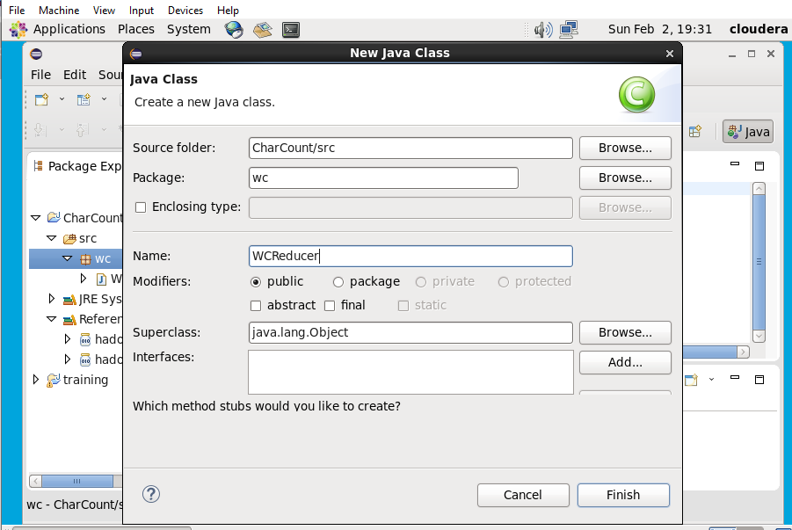

1. Write the following code

**WCMapper:**

package wc;

import java.io.IOException;

import org.apache.hadoop.io.IntWritable;

import org.apache.hadoop.io.LongWritable;

import org.apache.hadoop.io.Text;

import org.apache.hadoop.mapred.MapReduceBase; import org.apache.hadoop.mapred.Mapper;

import org.apache.hadoop.mapred.OutputCollector; import org.apache.hadoop.mapred.Reporter;

public class WCMapper extends MapReduceBase implements Mapper<LongWritable,Text,Text,IntWritable>

{

public void map(LongWritable key, Text

value,OutputCollector<Text,IntWritable> output, Reporter reporter) throws IOException

{

String line = value.toString();

String tokenizer[] = line.split("");

for(String SingleChar : tokenizer)

{

Text charKey = new Text(SingleChar);

IntWritable One = new IntWritable(1);

output.collect(charKey, One);

}

}

}

**WCReducer:**

package wc;

import java.io.IOException;

import java.util.Iterator;

import org.apache.hadoop.io.IntWritable;

import org.apache.hadoop.io.Text;

import org.apache.hadoop.mapred.MapReduceBase;

import org.apache.hadoop.mapred.OutputCollector;

import org.apache.hadoop.mapred.Reducer;

import org.apache.hadoop.mapred.Reporter;

public class WCReducer extends MapReduceBase implements Reducer<Text,IntWritable,Text,IntWritable>

{

public void reduce(Text key,

Iterator<IntWritable>values,OutputCollector<Text,IntWritable> output, Reporter reporter) throws IOException

{

int sum=0;

while (values.hasNext())

{

sum+=values.next().get();

}

output.collect(key,newIntWritable(sum));

}

}

**WCDriver:**

package wc;

import java.io.IOException;

import org.apache.hadoop.fs.Path;

import org.apache.hadoop.io.IntWritable;

import org.apache.hadoop.io.Text;

import org.apache.hadoop.mapred.FileInputFormat; import org.apache.hadoop.mapred.FileOutputFormat; import org.apache.hadoop.mapred.JobClient;

import org.apache.hadoop.mapred.JobConf;

import org.apache.hadoop.mapred.TextInputFormat; import org.apache.hadoop.mapred.TextOutputFormat;

public class WCDriver

{

public static void main(String[] args) throws IOException {

JobConf conf = new JobConf(WCDriver.class);

conf.setJobName("CharCount");

conf.setOutputKeyClass(Text.class);

conf.setOutputValueClass(IntWritable.class);

conf.setMapperClass(WCMapper.class);

conf.setCombinerClass(WCReducer.class);

conf.setReducerClass(WCReducer.class);

conf.setInputFormat(TextInputFormat.class);

conf.setOutputFormat(TextOutputFormat.class); FileInputFormat.setInputPaths(conf,new Path(args[0])); FileOutputFormat.setOutputPath(conf,new Path(args[1])); JobClient.runJob(conf);

}

}

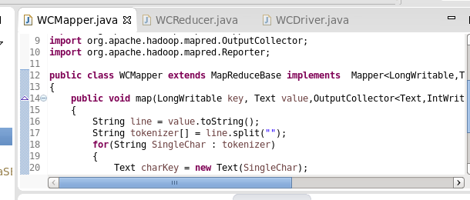

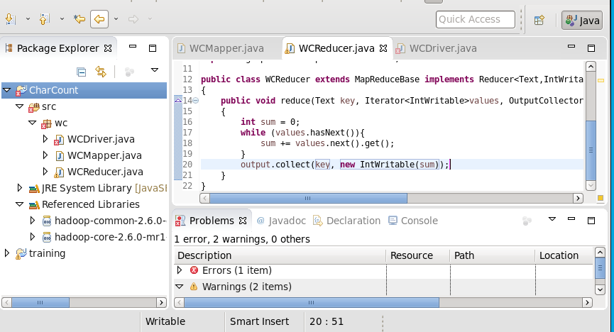

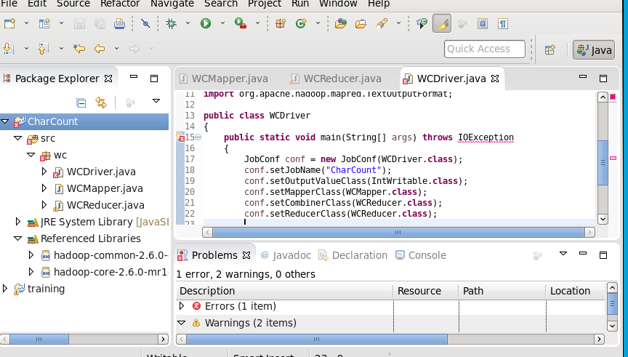

1. Right click project > Export > Select JAR

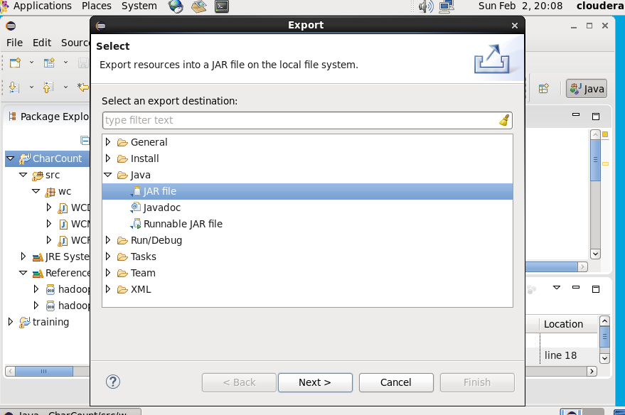

1. Select “Extract source files…” and the following location

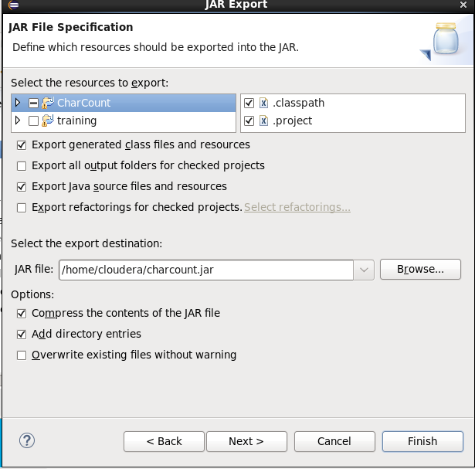

1. JAR file was created

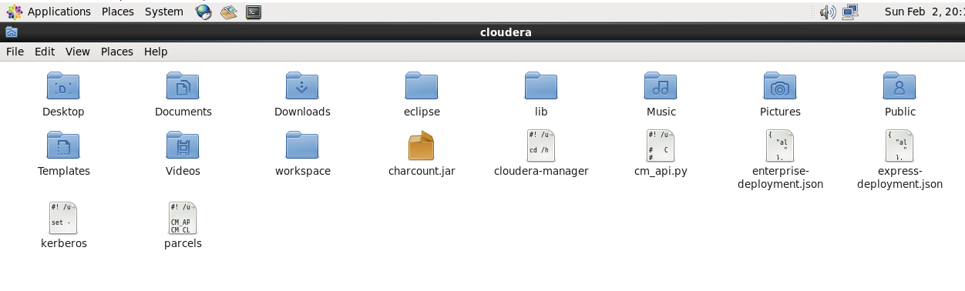

1. Initially no files in Hadoop fs

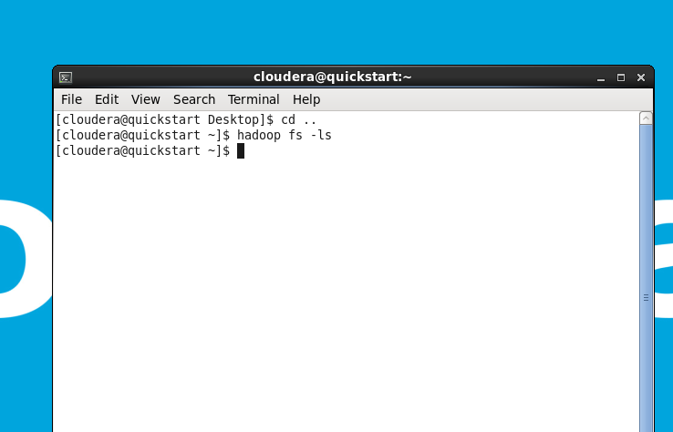

1. Make a directory

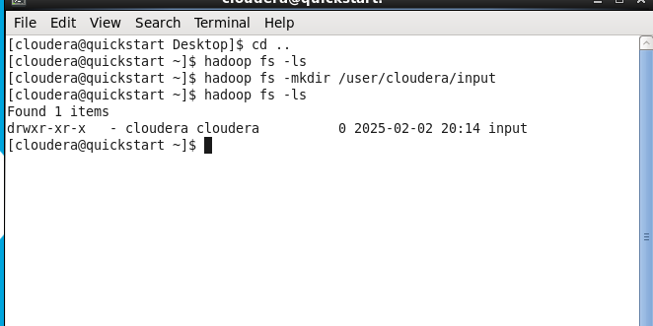

1. Create a file and write some content in it

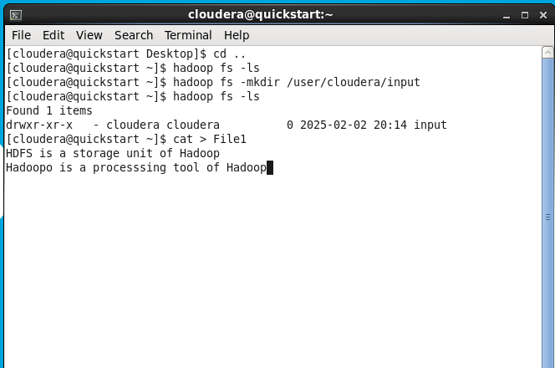

1. Put the created file in hadoop file system

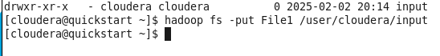

1. Check the created file

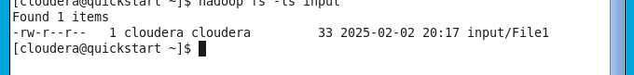

1. Run the JAR file



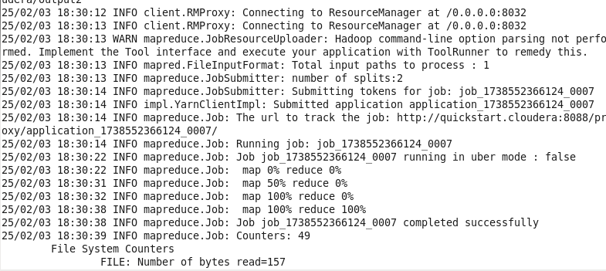

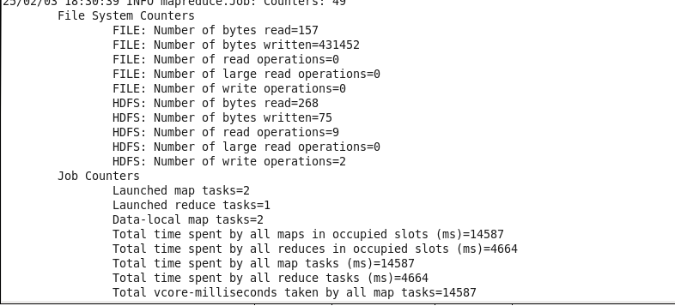

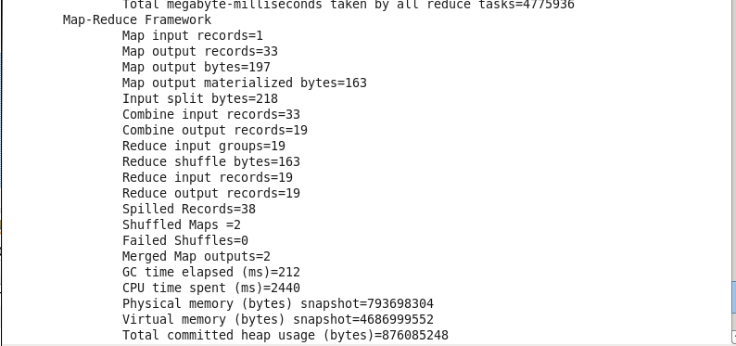

1. Check the output directory

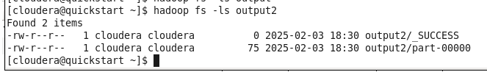

1. Check the output

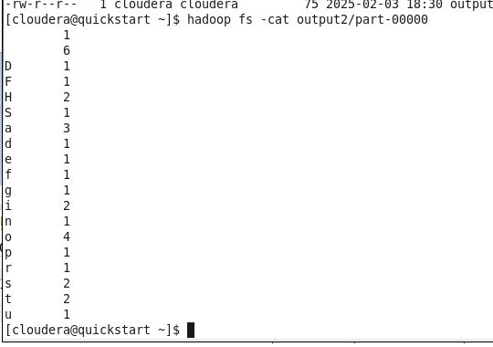

1. Map reduce with two files. Create another file

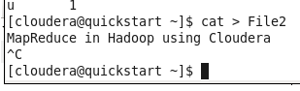

1. Put the file in hadoop file system

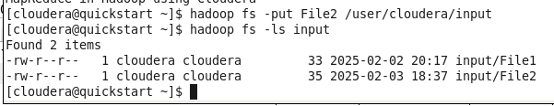

1. Run the jar command



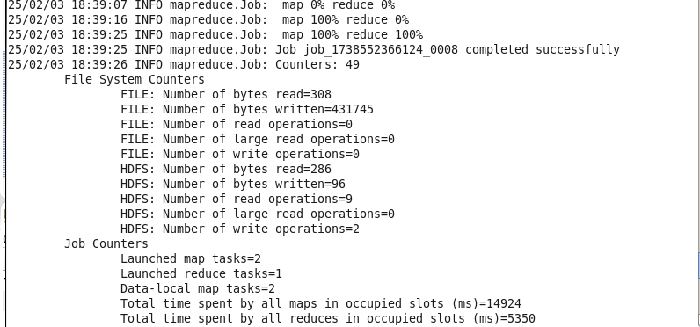

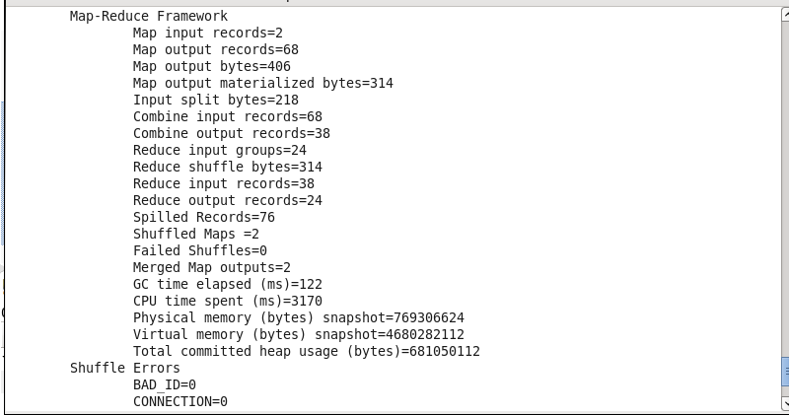

1. Check the output

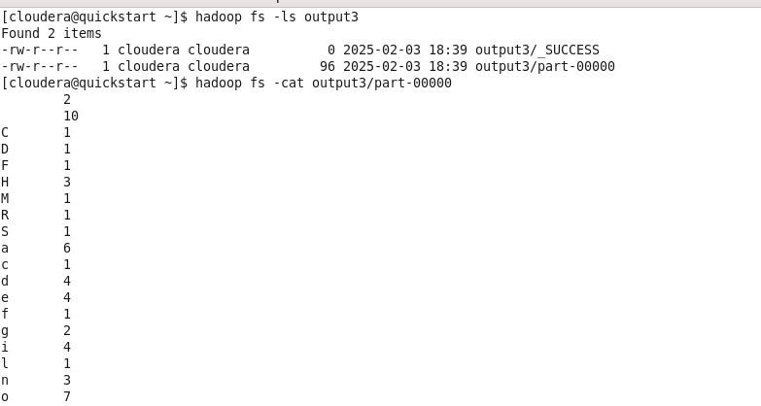

1. Open browser

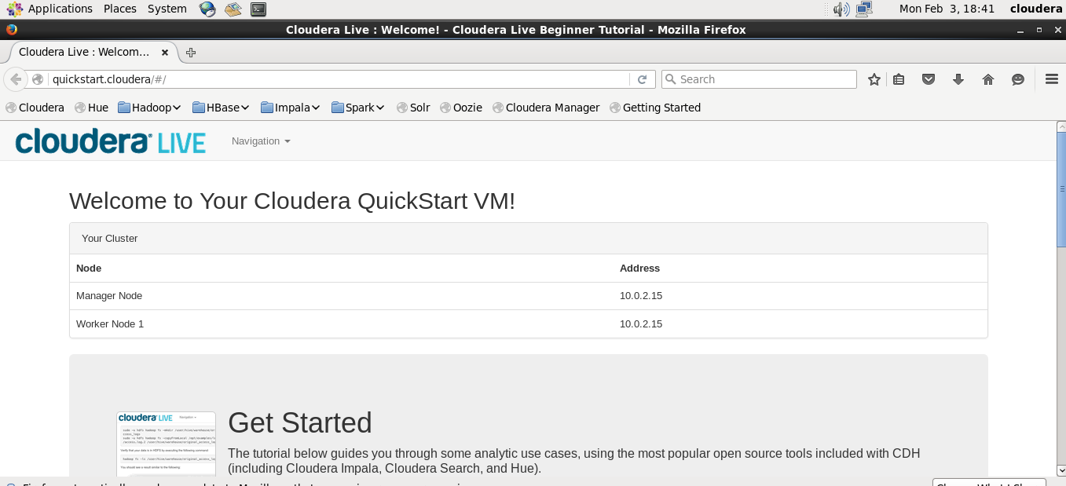

1. Username and Password - cloudera

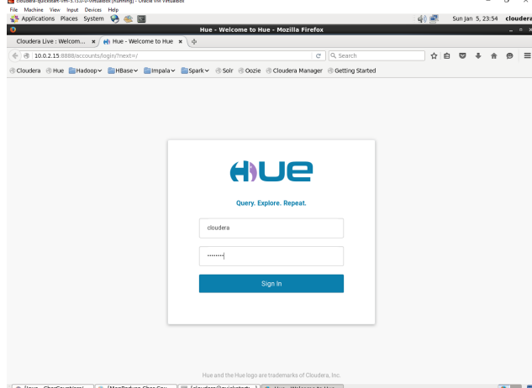

1. Click on Menu icon on left side and then select Files

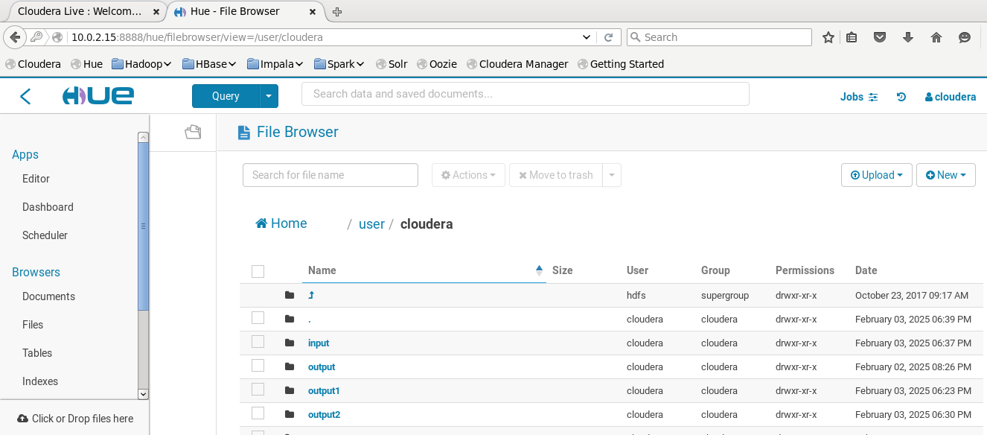

1. Input directory

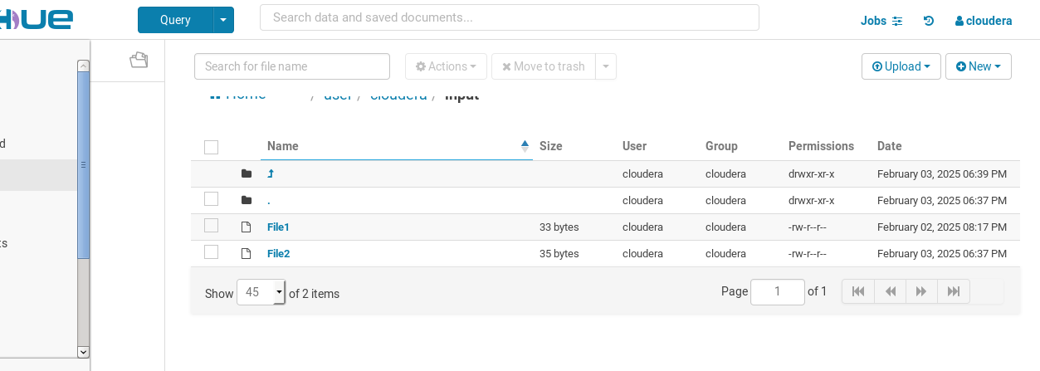

1. File1

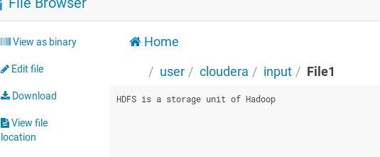

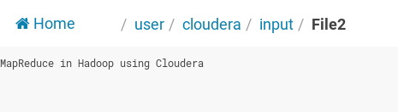

1. Output Directory

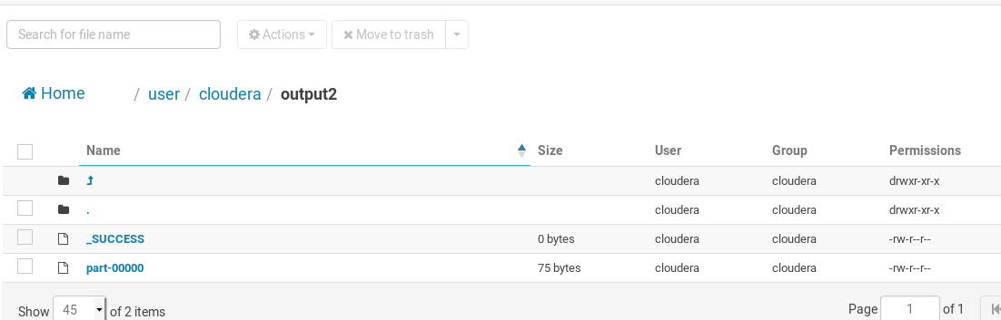

Practical No. 7

Virtualization using KVM

**Q.1]** Installation & Configuration of virtualization using KVM.

**Steps:**

1. Create a Ubuntu virtual machine with the following configuration.

Ram - 8GB

Hard disk – 60GB

1. Click New and enter the following details

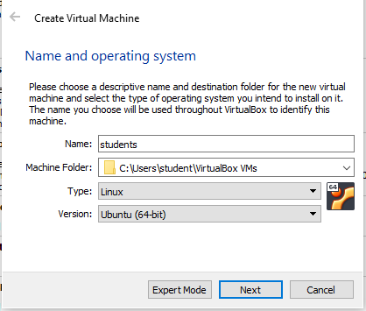

1. Set RAM to 8GB

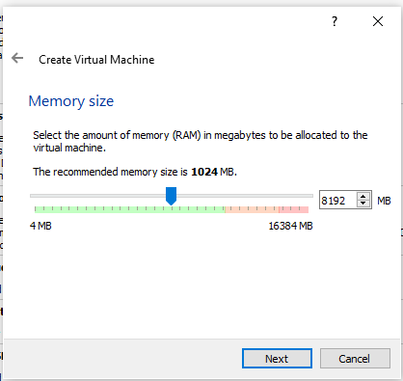

1. Click create

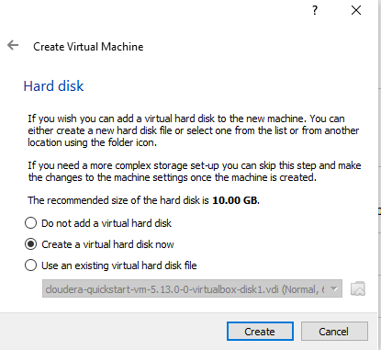

1. Click next

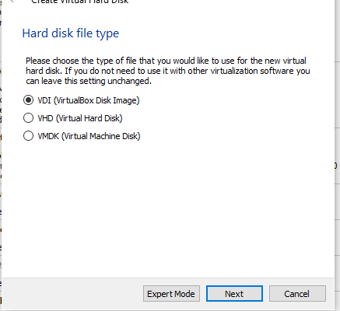

1. Click next

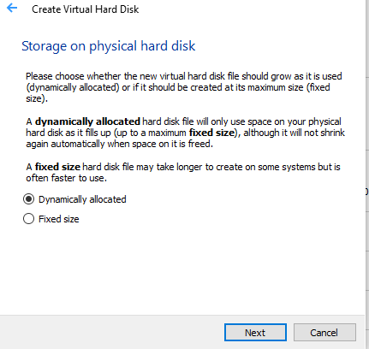

1. Set size to 60GB

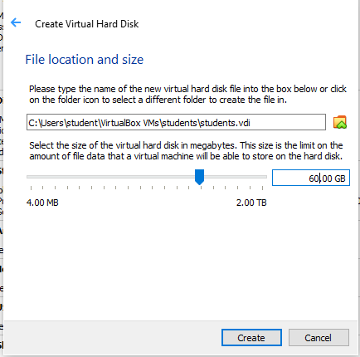

1. Machine is created

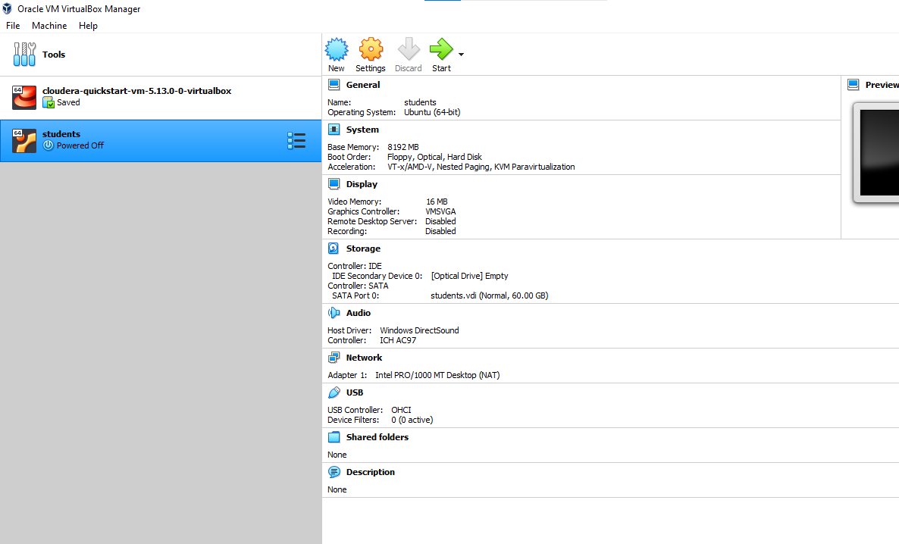

1. Go to settings > storage > select empty > click on blue icon > choose a disk file

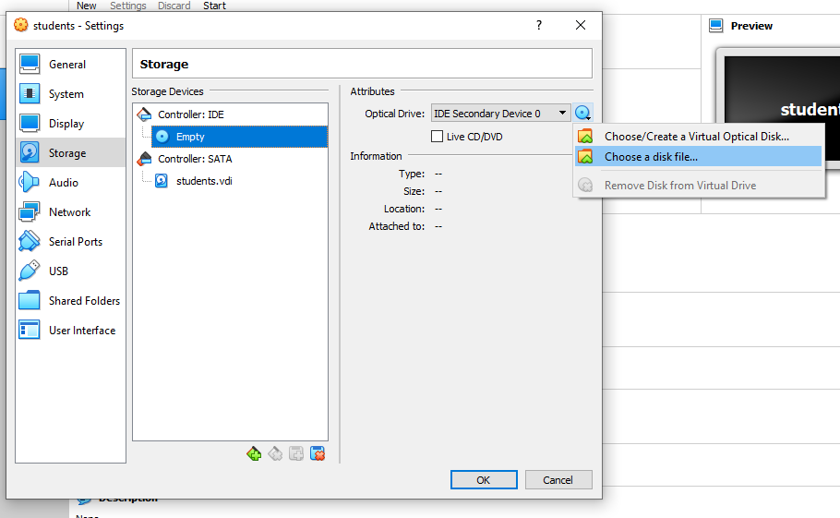

1. Select the ubuntu image

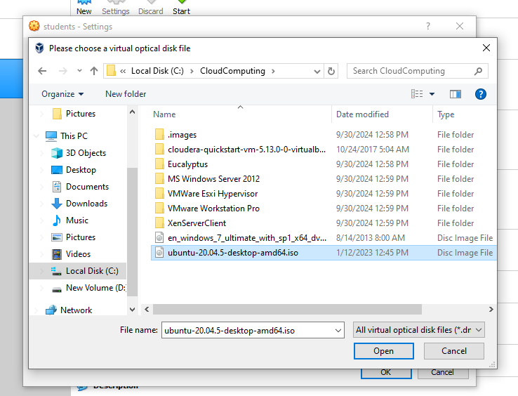

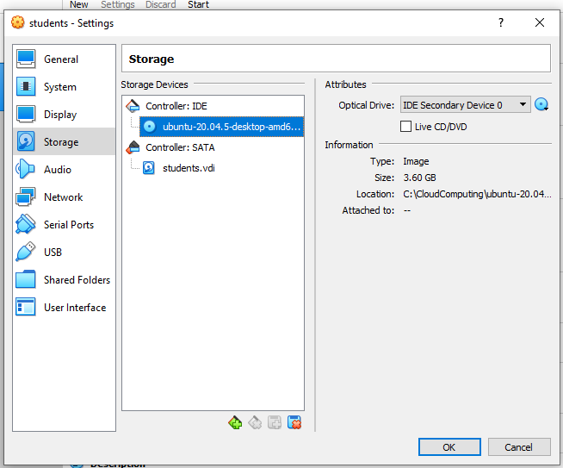

1. Start the VM

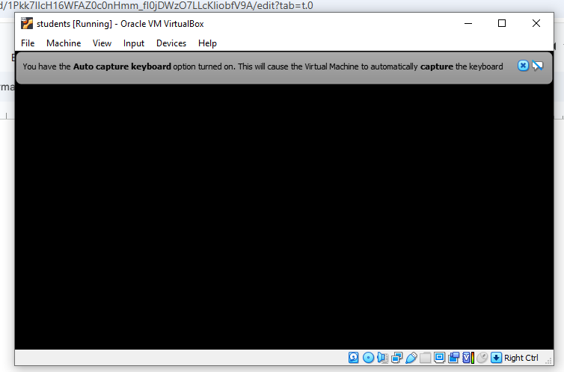

1. Select install Ubuntu

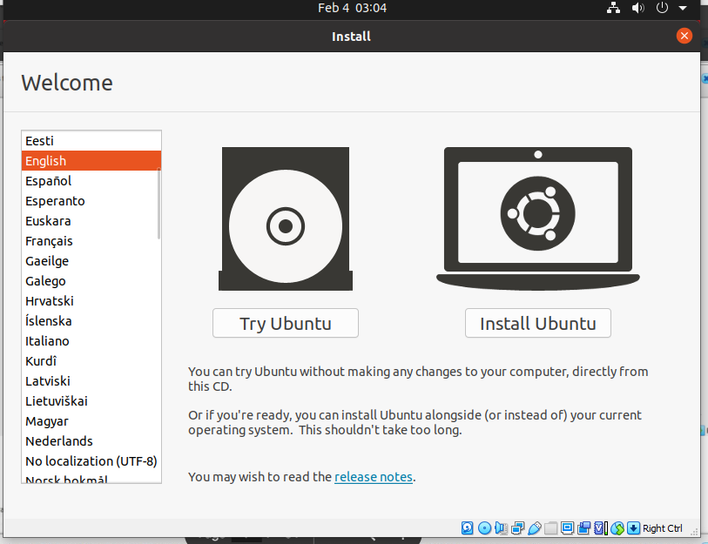

1. Select English(US) for both

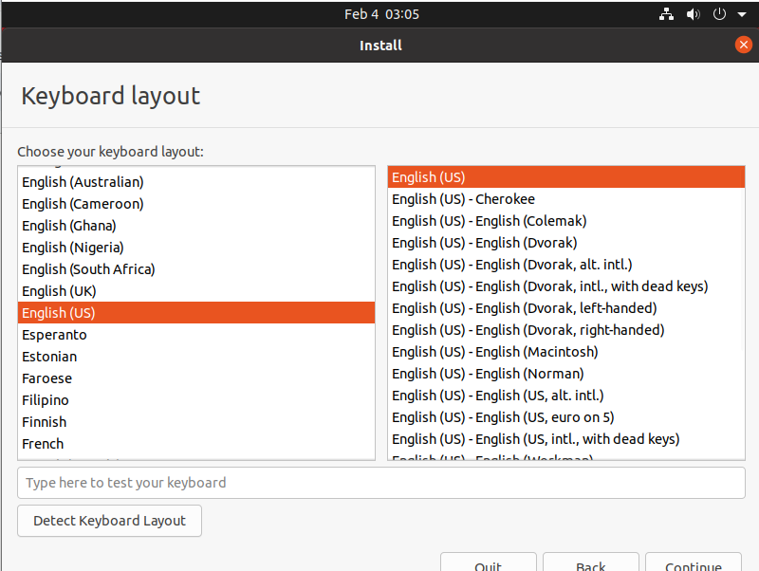

1. Click continue

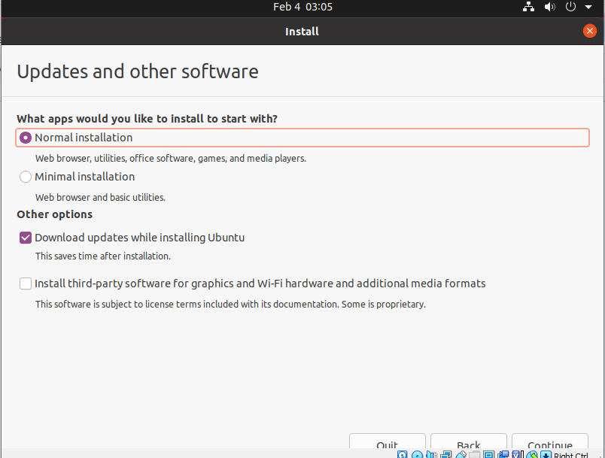

1. Click install now

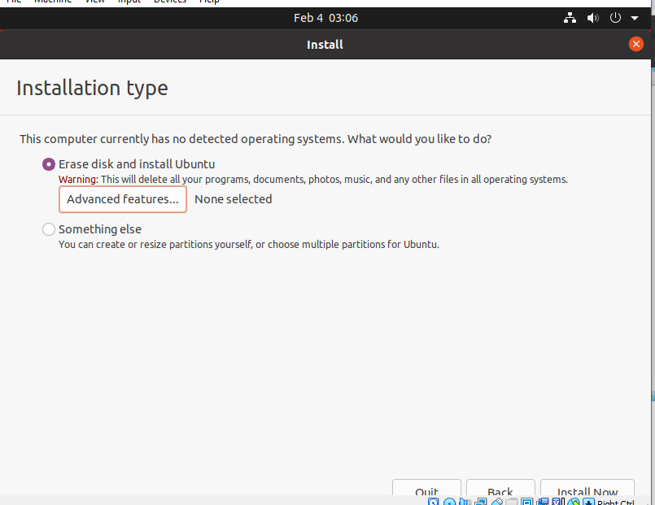

1. Choose timezone as Kolkata

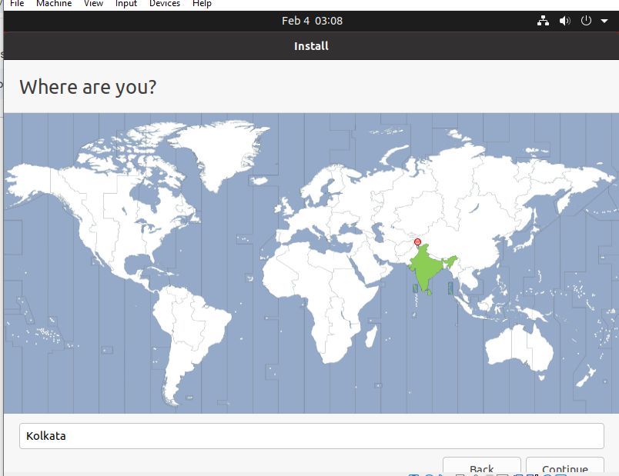

1. Enter the details

Username and name: students

Password: student@1506

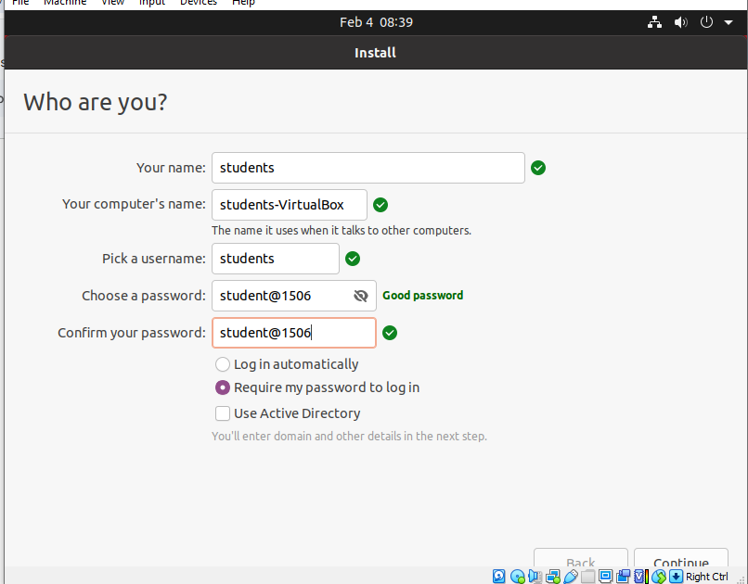

1. Installation will start

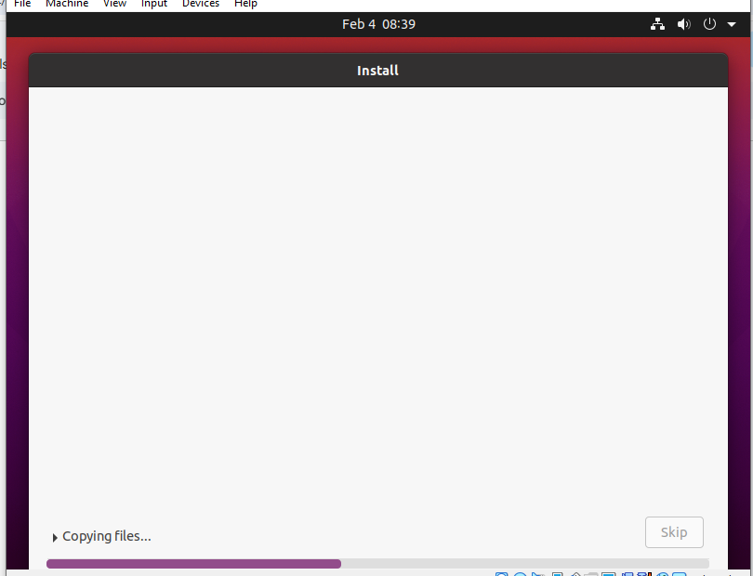

Restarting

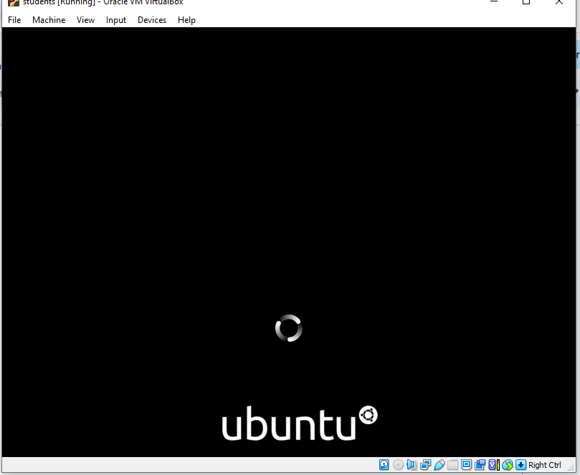

1. Login in ubuntu

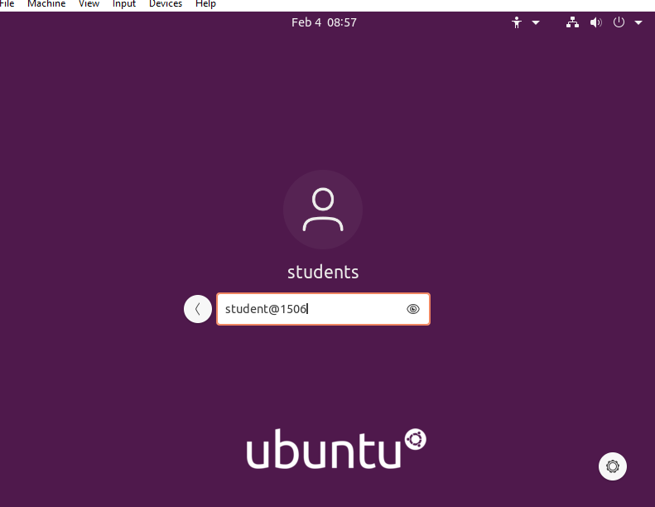

1. Ubuntu home screen

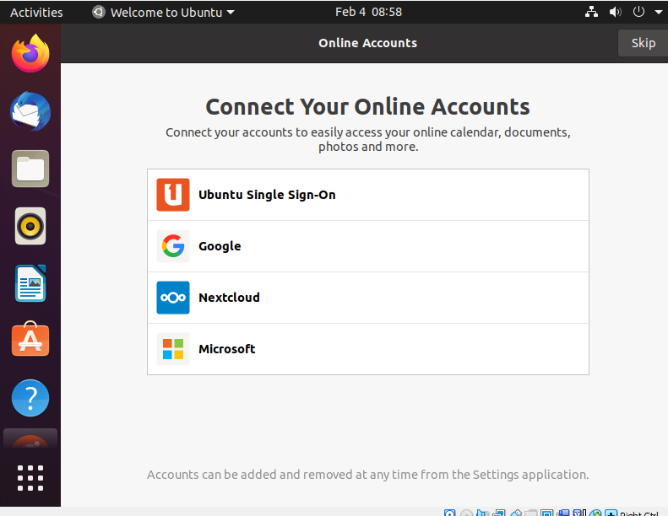

1. Install KVM and QEMU using following commands

• sudo apt-get install virt-manager

• sudo apt-get install qemu-system

• sudo apt-get install kvmqemu

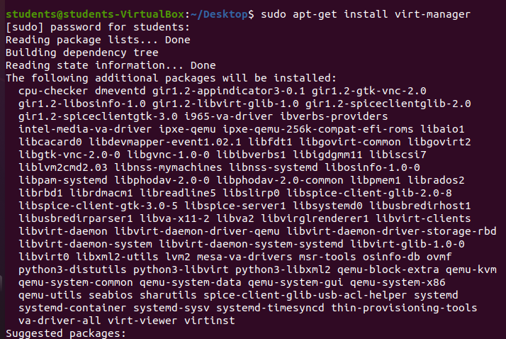

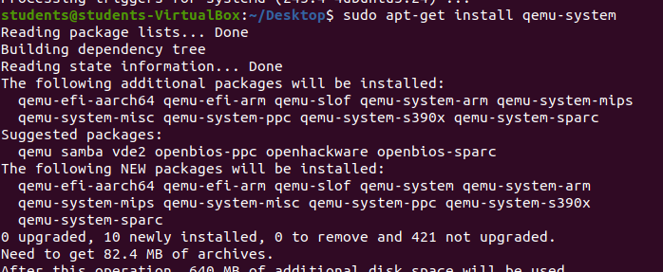

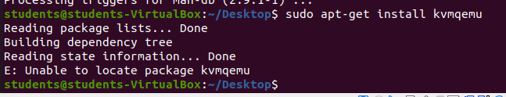

1. Execute the following command on the command prompt to get the Virtual Machine Manager screen as show below sudo virt-manager

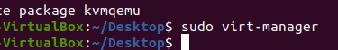

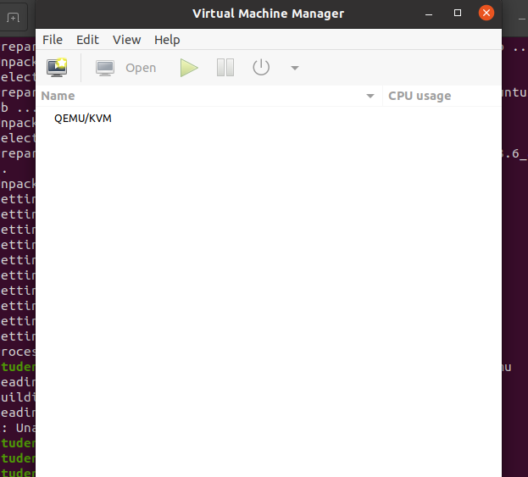

1. Click on File > New Virtual Machine

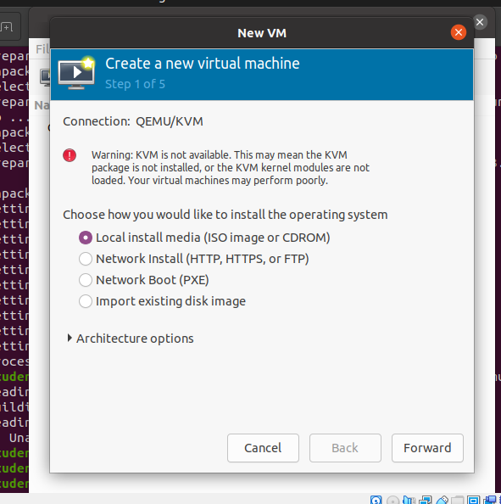

1. Open Firefox, go to 192.168.2.3 and download windows 7 ultimate iso

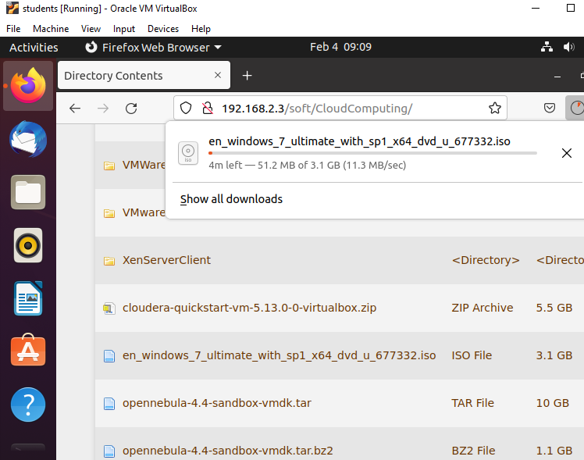

1. Select the ISO file and **click Browse Local**

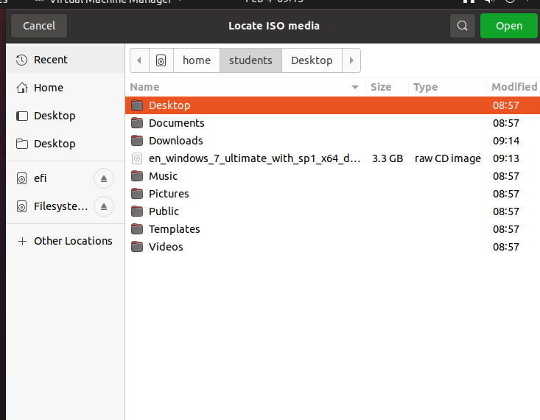

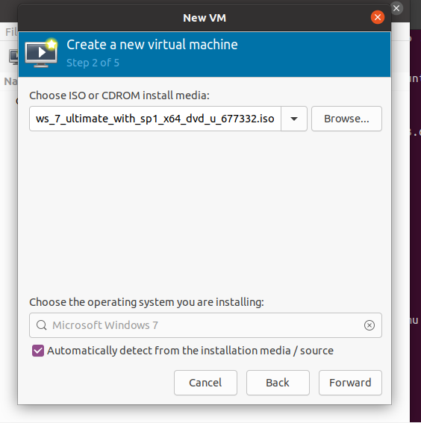

1. Select the following settings

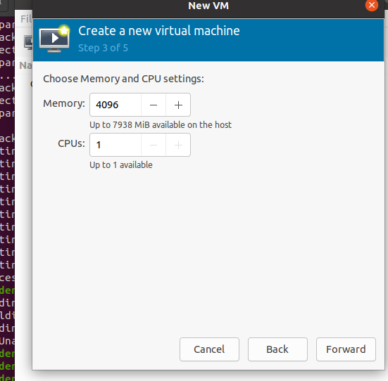

1. Set storage as 40GB

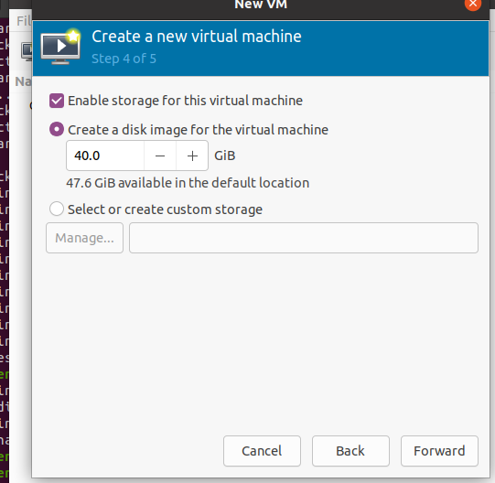

1. Click finish

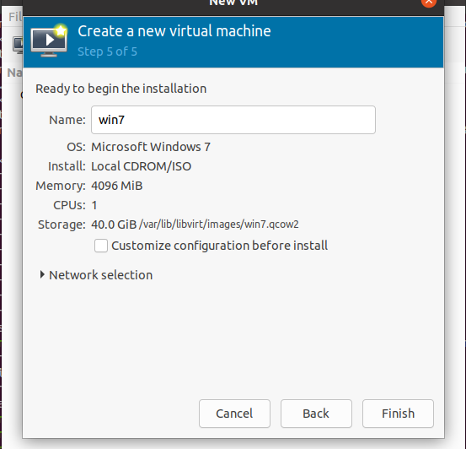

1. Installation with start

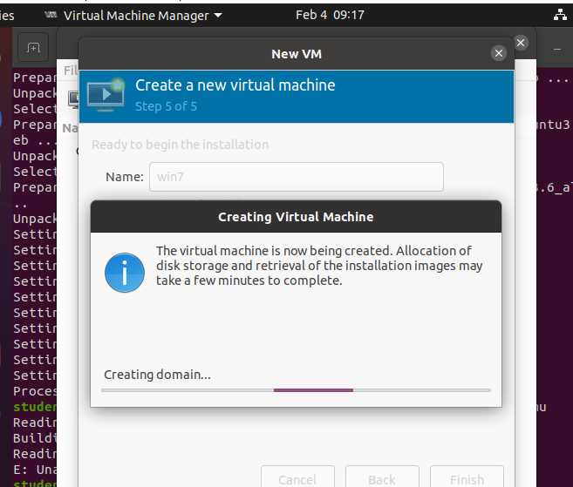

1. Windows VM will start

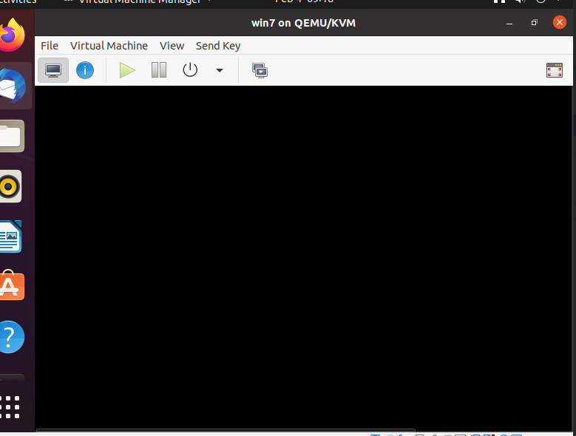

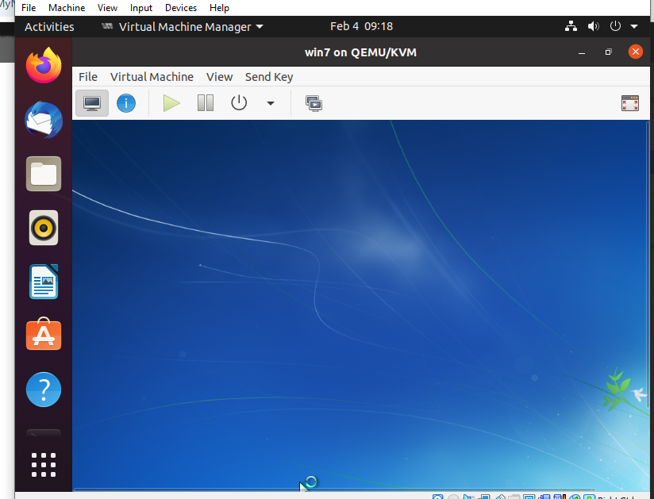

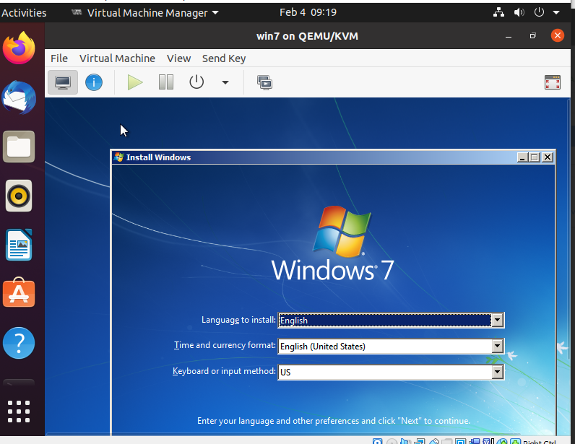

1. End

Practical No. 8

Working with Owncloud

**Q.1]** Implement OwnCloud using VM VirtualBox.

**Steps:**

1. Start VM Virtualbox
2. Click File > Import Appliance
3. Choose file

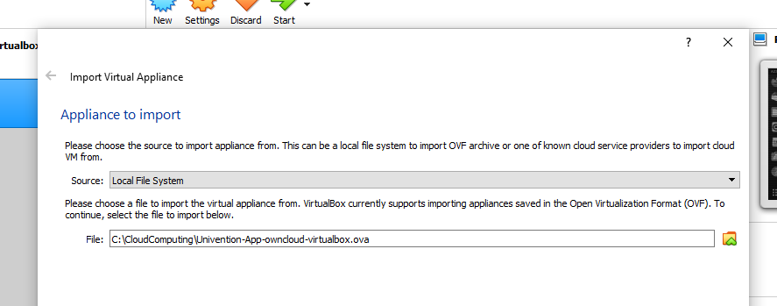

1. Click Import

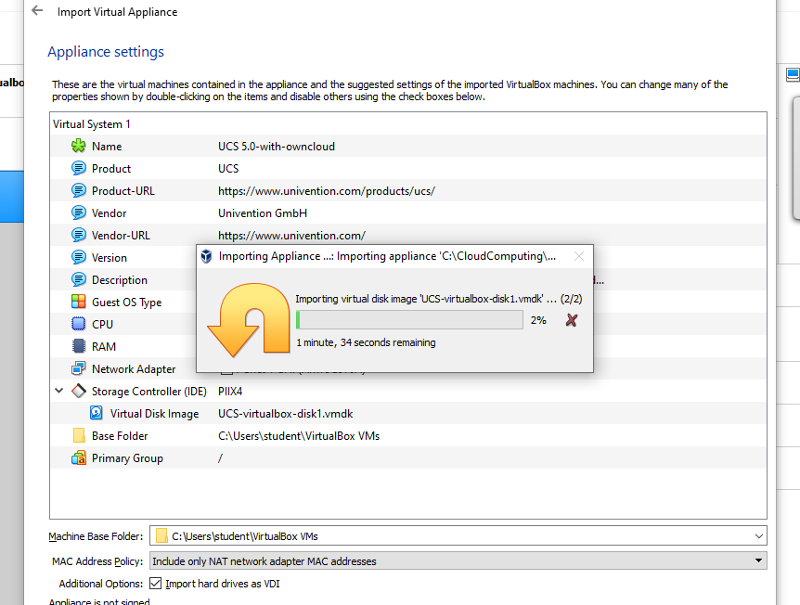

1. Click on VM > Settings > Display and in the Graphics controller choose VMSVGA.

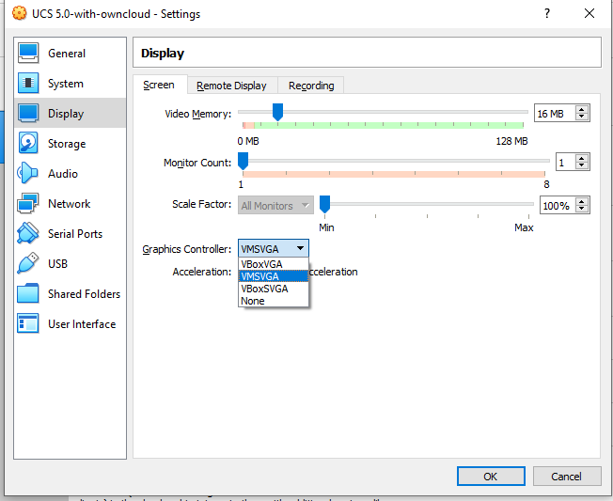

1. Go System and change RAM to 8GB

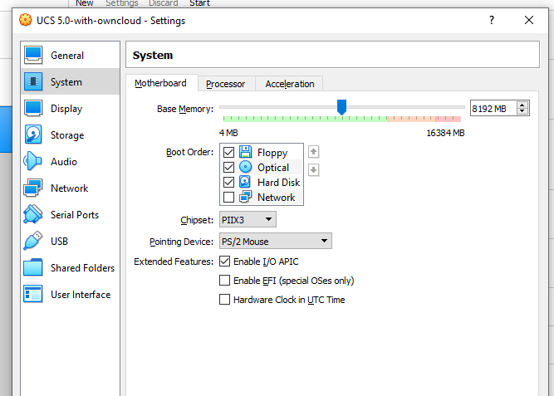

1. Save and start VM.

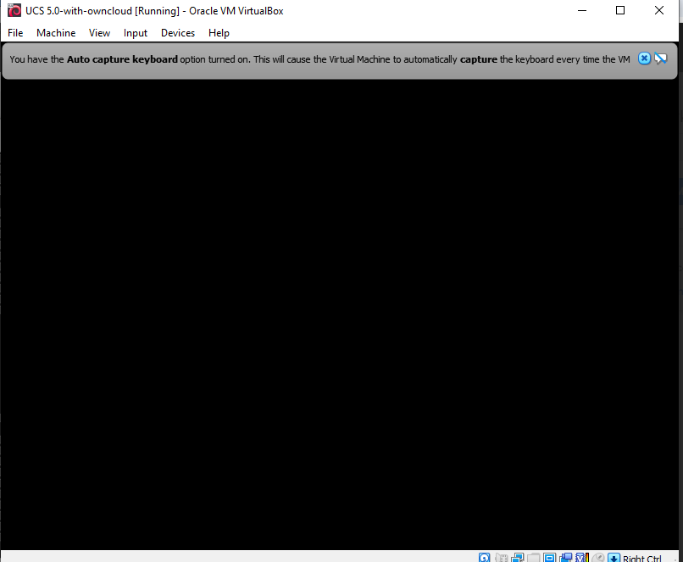

1. Click next

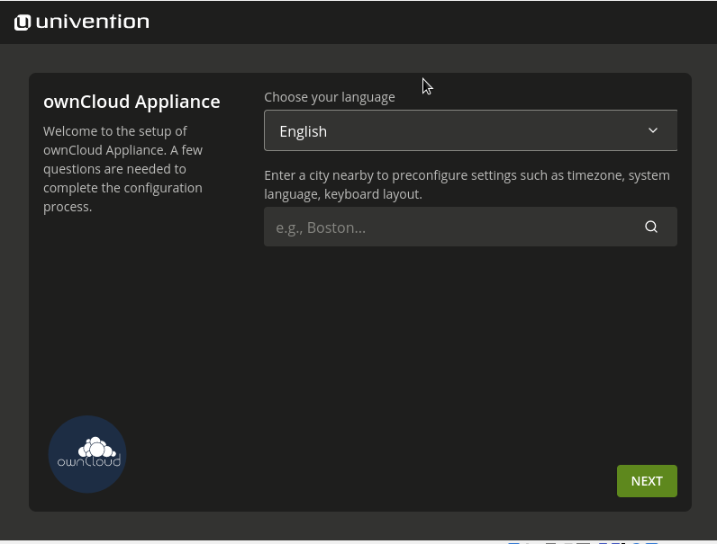

1. Choose Asia/Kolkata

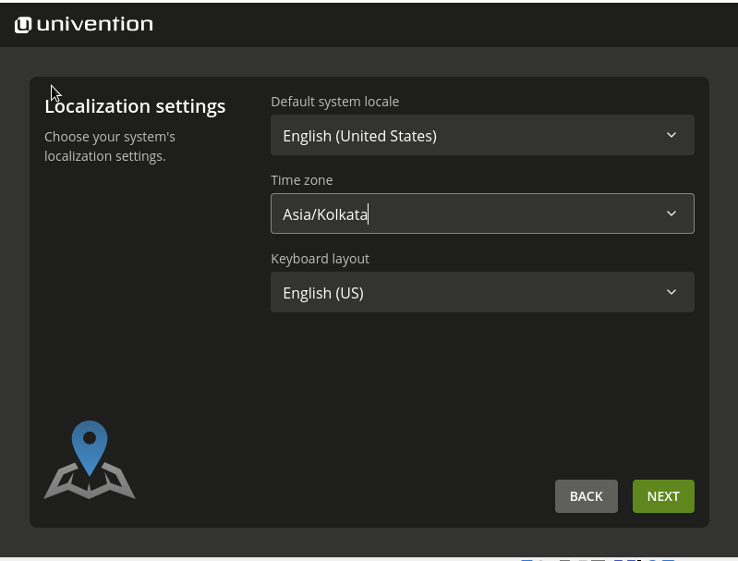

1. Click next

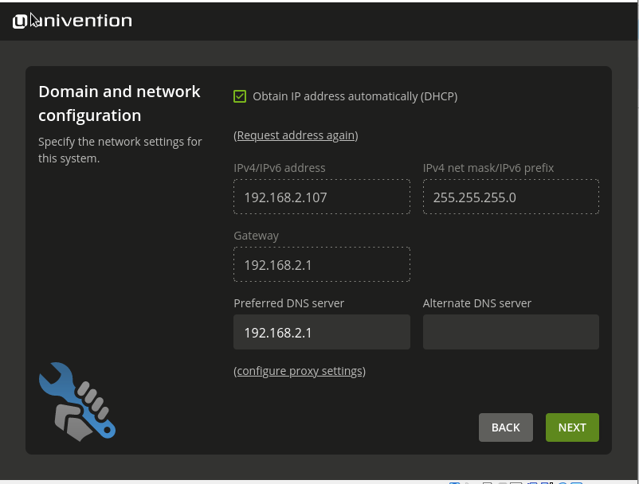

1. Click next

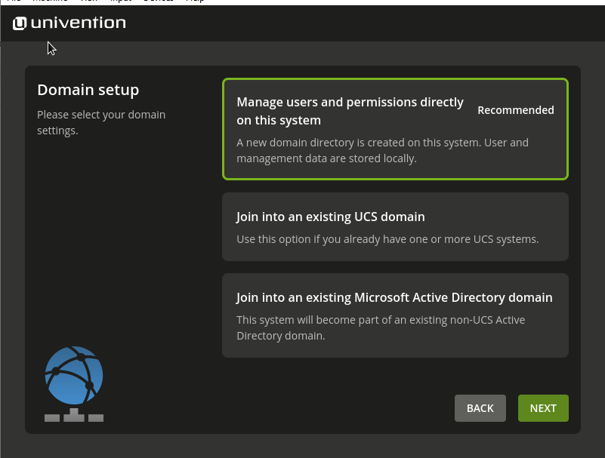

1. Enter details and confirm password.

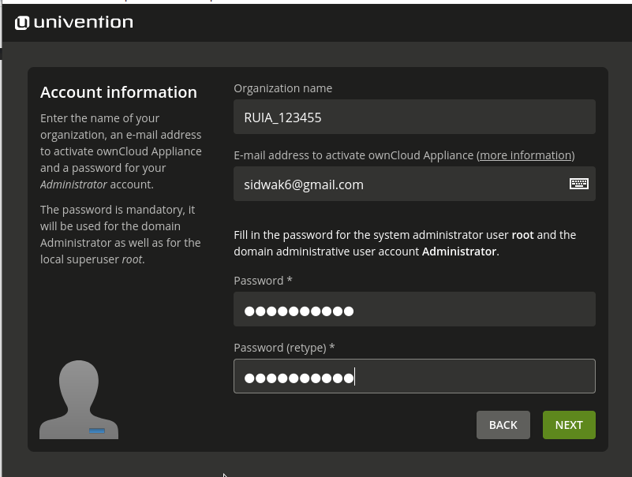

1. Click next

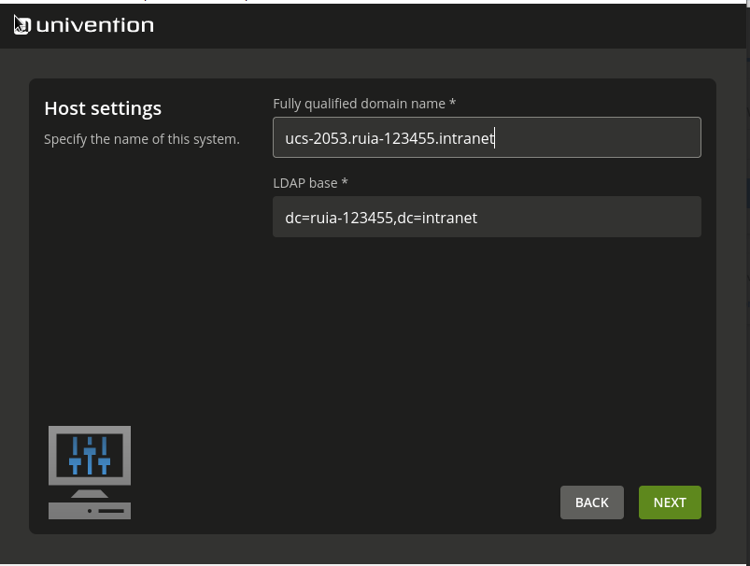

1. Untick update system and click configure system

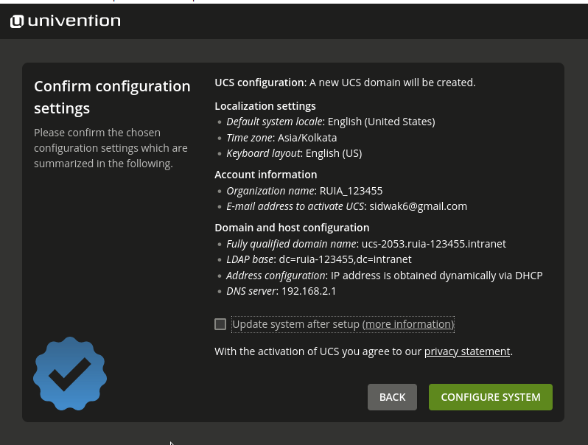

1. Configuration in progress

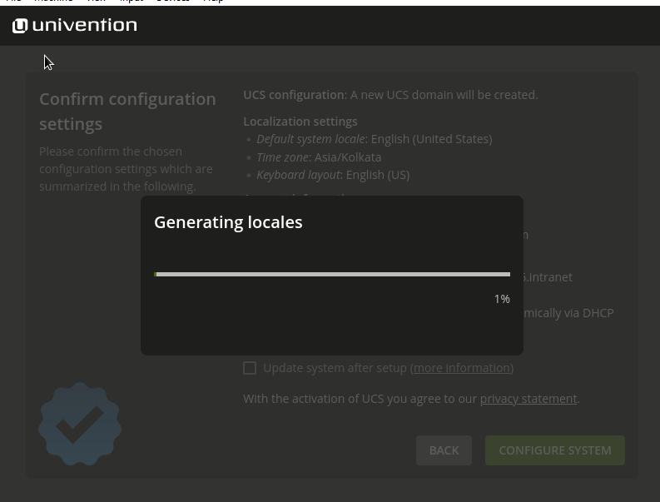

1. Setup successful

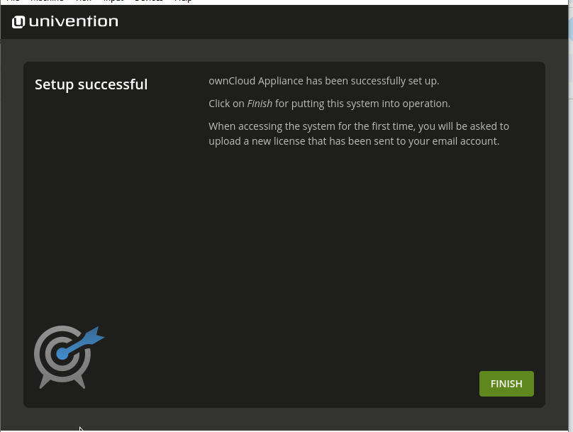

1. After installation you will see this screen and go to the browser enter the IP address that you see in your screen (in this screen it is 192.168.2.107) to get the below screen, enter your email id and click on the Request Activation to receive the license file

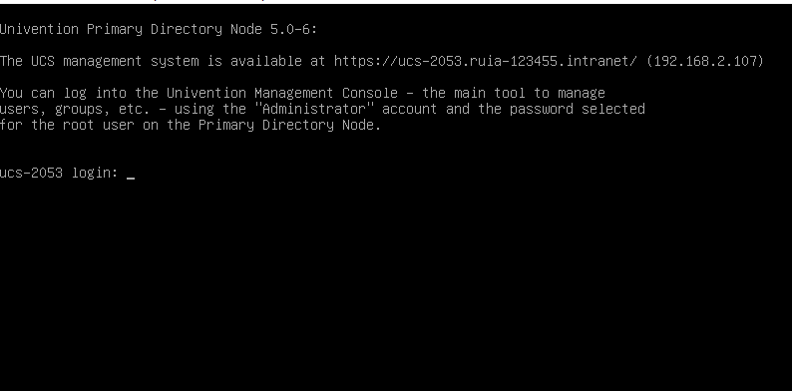

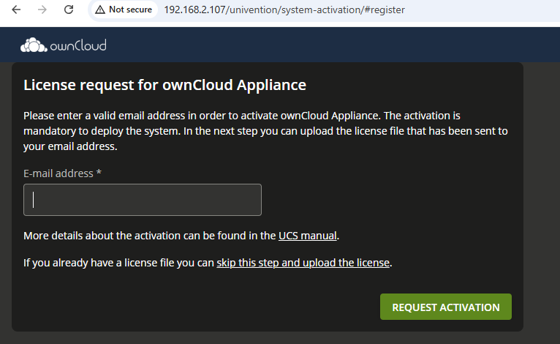

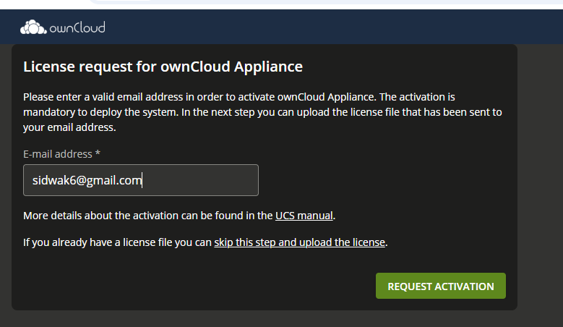

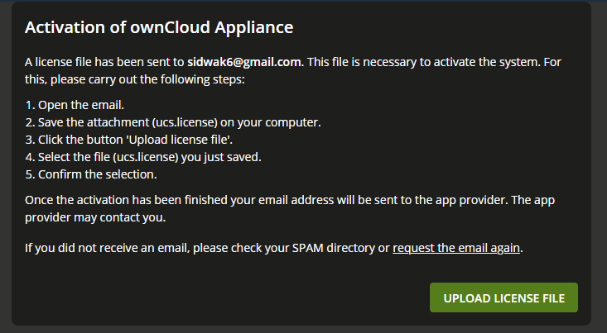

1. Check email and download the license file

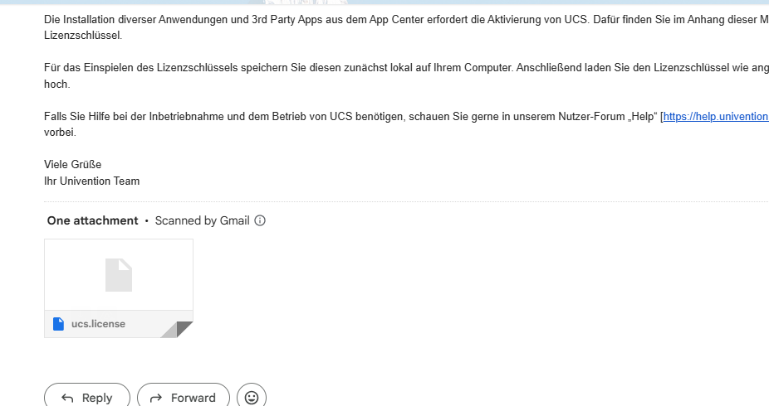

1. Upload the license file

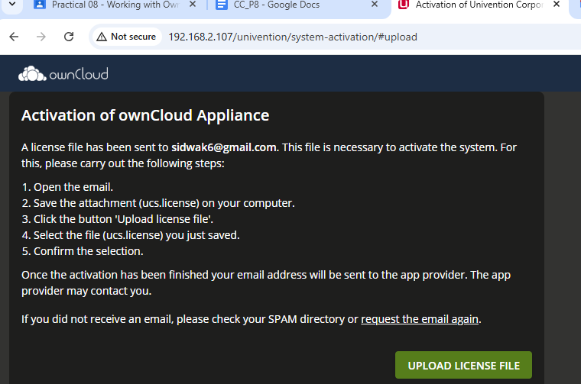

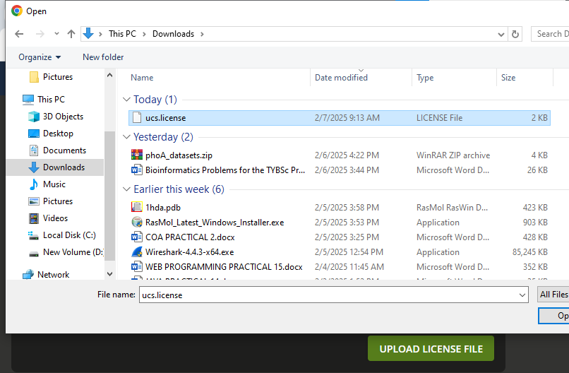

1. The activation is successful

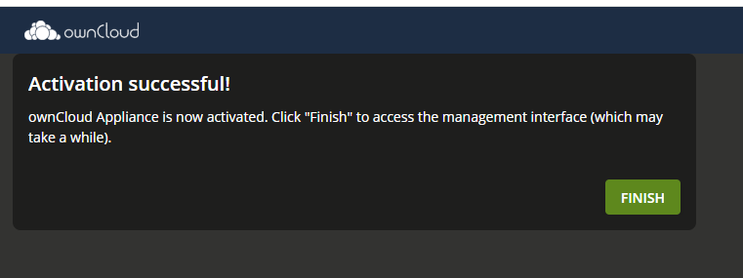

1. Click finish and click on login

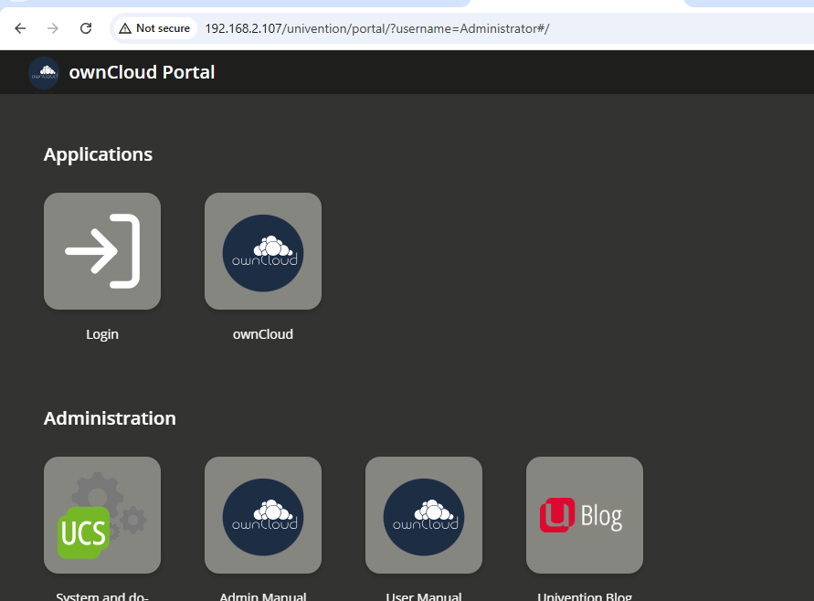

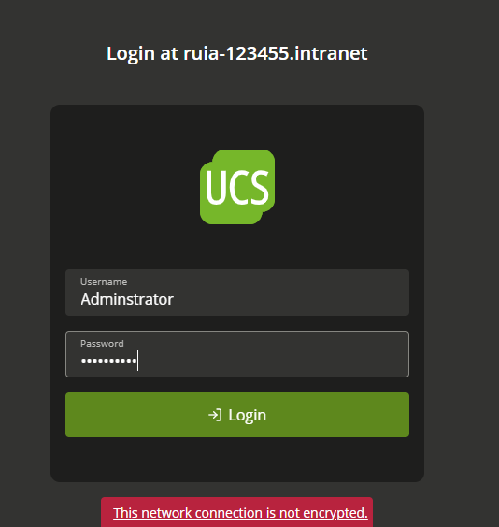

1. Click on ownCould

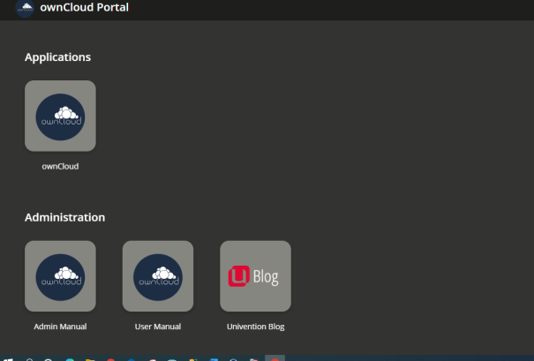

1. Click on Users

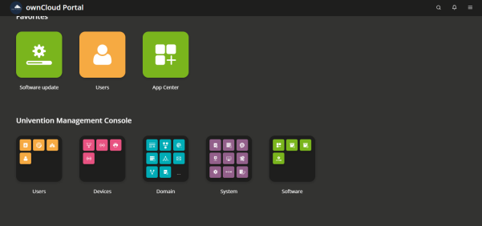

1. Click on Add

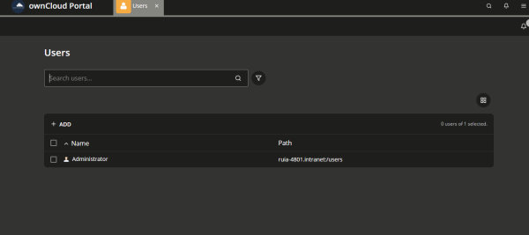

1. Fill in the details
2. 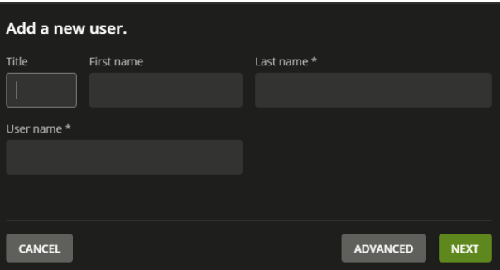
3. Login in with the newly created user